**SpringBoot and Microservices**

**Youtube link: <https://www.youtube.com/watch?v=hVCR4HvdmLM>**

<https://github.com/maheshashokit/47_SBMS_Workspace> --GITHUB

**Ctrl+Shift+T ==shortcut to open predefined classes.**

**What is Persistence Logic?**

**The logic that is used to interact with database is called Persistence logic.CRUD operations logic is called Persistence logic.**

**Initially people used JDBC to develop such Persistence logic.Later people used Hibernate to develop such persistence logic.After the introduction of Spring Framework, people started using Spring ORM or Spring Data JPA to develop persistence logic.**

**Hibernate is advanced thing of JDBC.Spring ORM is advanced thing of Hibernate.Industry people noticed some drawbacks in Spring ORM and then they came up with Spring Data JPA with which you can develop persistence logic very easily.**

**By using Spring Data JPA, we can focus more on developing persistence logic for both SQL and NOSQL databases.**

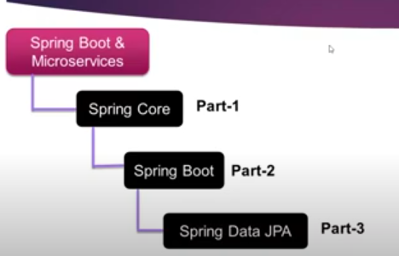

**Spring Boot Web MVC**

**Before Spring Boot Web MVC, we had Spring MVC module.**

**When we develop web applications using JSP and servlets, developers need to take care of lot of things.Programmer need to create a servlet program, that servlet need to be configured in web.xml file, whenever any changes made in servlet program, redeployment is required.**

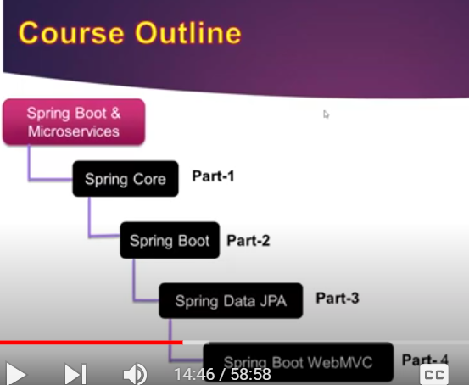

**Spring Rest**

**In order to develop microservices, programmer needs to have good hands-on with RESTAPI.**

**RESTAPI development is called Web services.We have two kind of web services in the market.**

**SOAP based web services and Restful Web services.**

**Microservices**

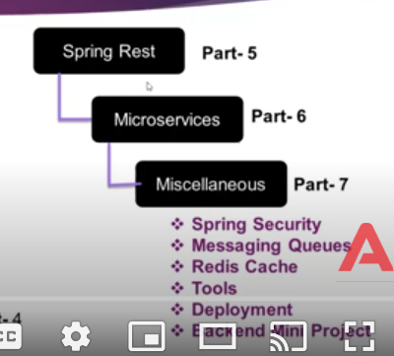

**Spring Framework**

**POJO class: You are developing a simple Java class without extending or implementing any third party classes or interfaces.**

**In spring the classes which we define does not extend or implement ant third party related classes or interfaces.**

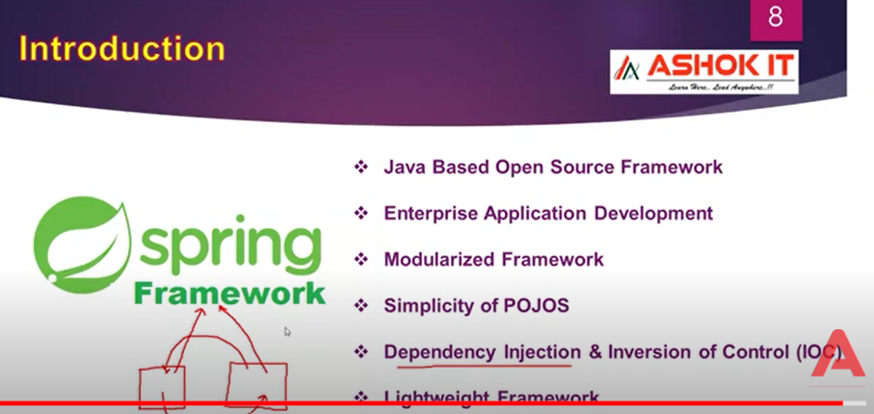

Dependency Injection: One class requires the services of another class.

For ex: When you withdraw money, you should get an email notification about how much money got withdrawn.Withdraw money is one class and sending email notification is another class.

Dependency Injection: The process of injecting dependent object into main object with the help of Spring Framework

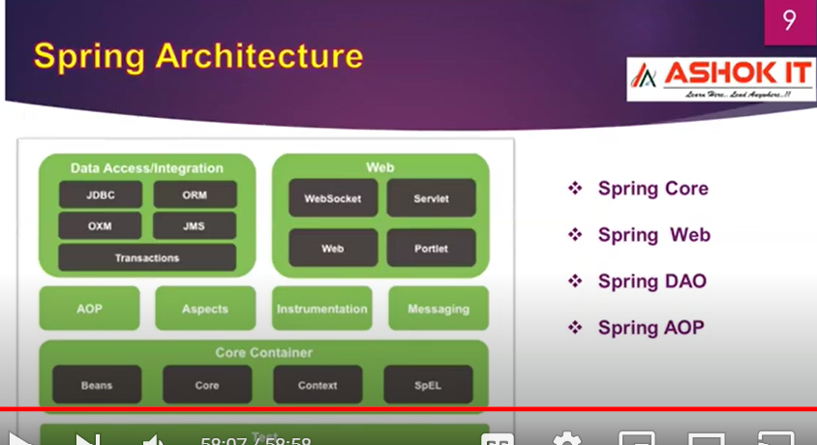

**SESSION-2:**

**Youtube link: https://www.youtube.com/watch?v=1pPy2j7tMng**

Spring Data JPA supports both SQL and NOSQL databases. Spring Data JPA has separate independent modules for both SQL and NOSQL databases.

Spring Boot Web MVC module is an extension of Spring MVC module.

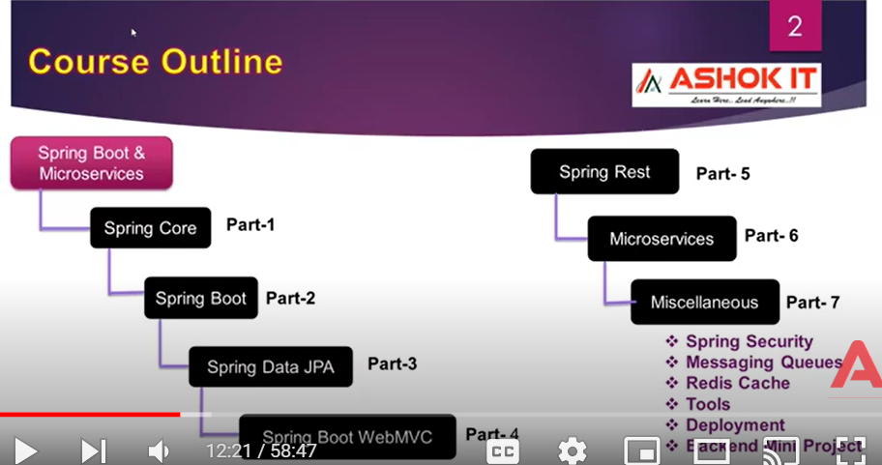

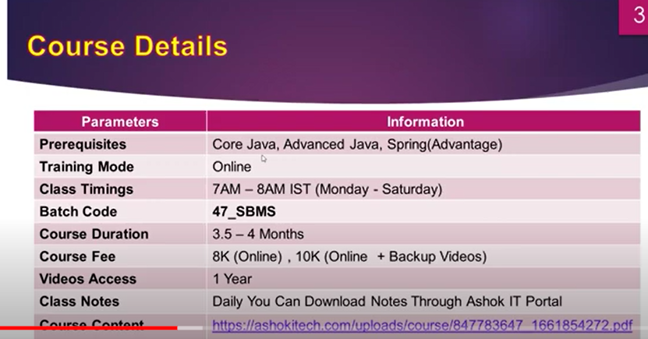

**Java based open source framework:** You can download software for free and its is open source.Source code is visible to us.

**Enterprise Application development:** Spring comes under category of Application framework or Enterprise Application development.

**Modularized Framework:** Spring has lot of modules such as Spring Core,Spring AOP,Spring JDBC,Spring ORM,Spring MVC,Spring Transactions.

**Simplicity of POJOs:** When you are creating classes in spring framework, those classes cannot extend or implement any third party classes or interfaces.

This is the reason for simplicity of POJOs as well as loose coupling of Java objects.

**Dependency Injection and Inversion of Control:** The process of injecting dependent object into main object at run time by Spring is called Dependency Injection

Inversion of Control is a design pattern.

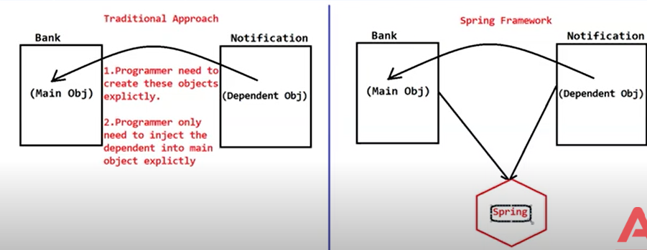

**Lightweight Framework:** Lightweight because of POJOs.Loose coupling between objects exists because of POJOs.

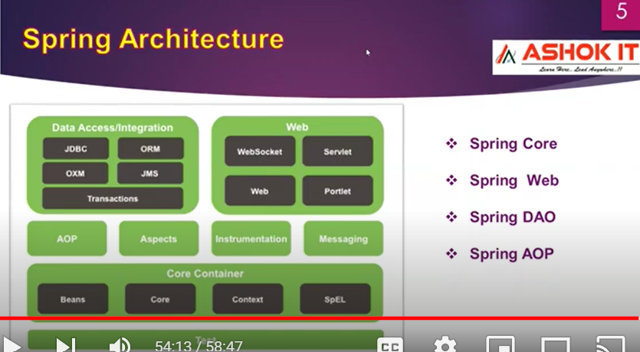

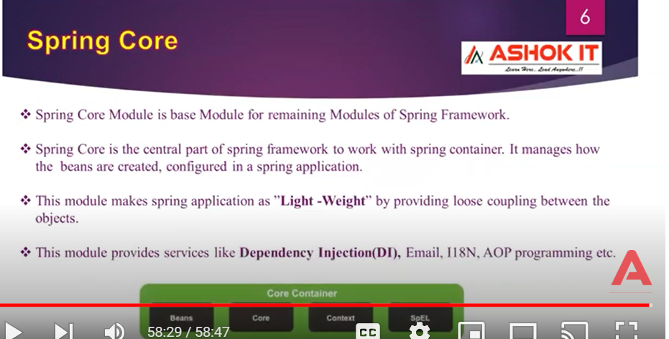

**SESSION-3**

**Youtube link:https://www.youtube.com/watch?v=LUVLJfp9QUc**

**Spring core:** It is the base module**.**

**Spring Web:** Used for developing web applications

**Spring DAO:** Used for developing persistence logic. Spring DAO contains Spring JDBC and Spring ORM

Spring JDBC is an extension of JDBC.Spring ORM is an extension of Hibernate and JPA.

**Spring AOP:** AOP means Aspect Oriented Programming

For any kind of application, we will be having some business logics and secondary services logics.

When we execute business logics, definitely we require some secondary logics services to execute such as Security service, logging service, email service and transaction management service.

Spring AOP provides lot of flexibility for the programmer to enable security services when business services are executed.

Secondary services are not always required for every business logic.

**Spring Core**

**Spring container is the one which takes care of creating objects and injecting dependent class objects into main class objects**

**Spring container gets to know which beans to be created and which beans to be destroyed based on configurations in your spring application.Configurations means you will be supplying some information to container via metadata in the form of XML document.**

**SpEL: Spring Expression Language.**

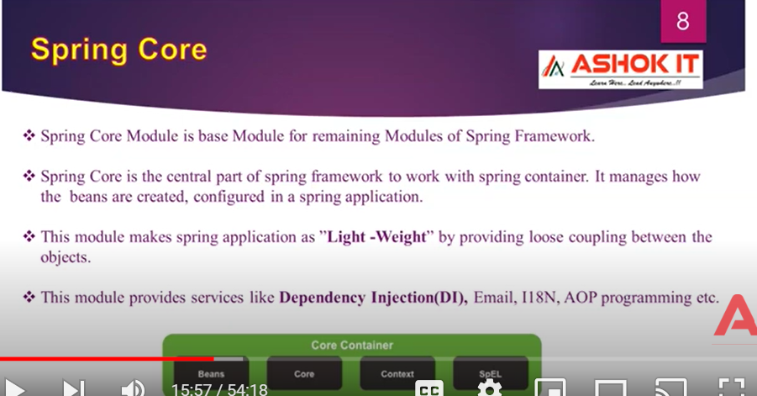

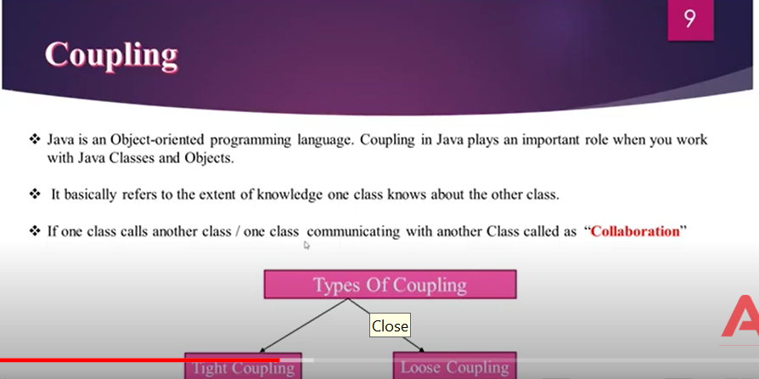

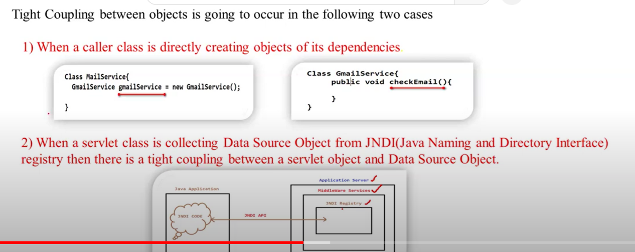

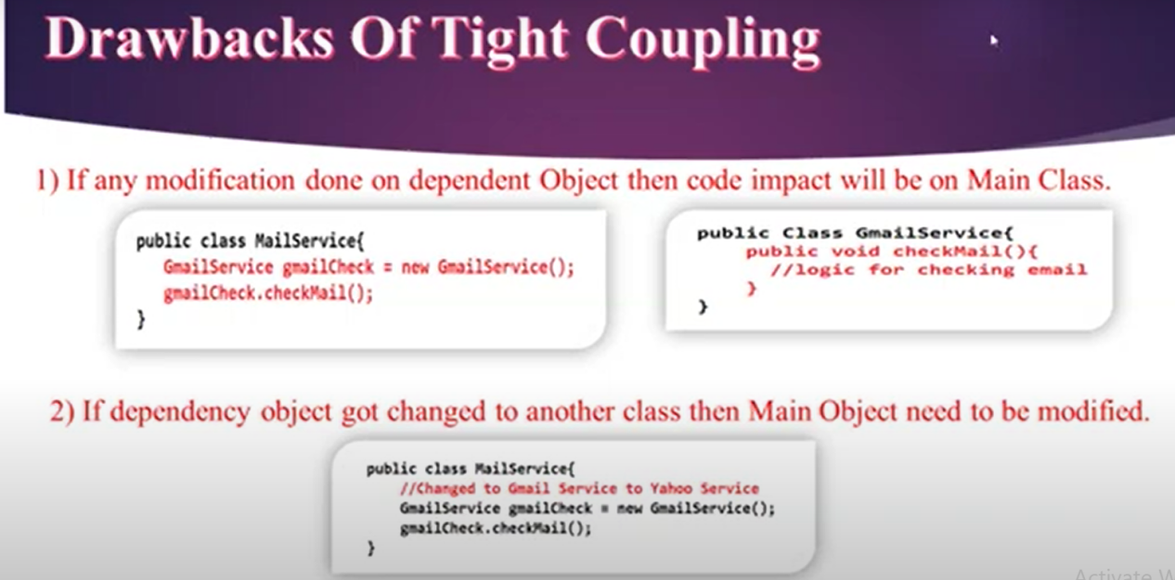

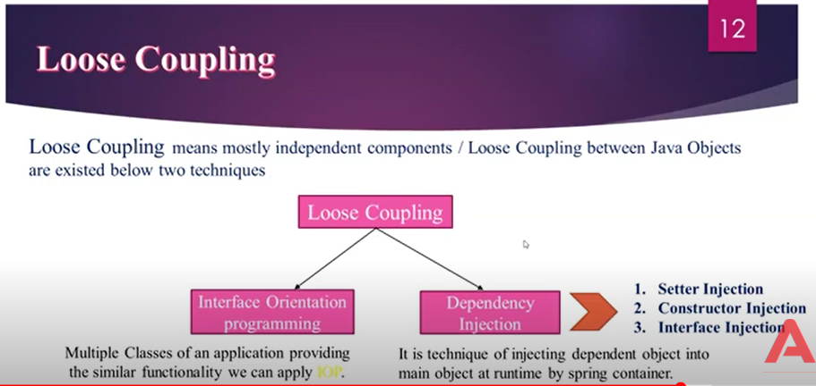

**Setter Injection**

**Constructor Injection**

**Interface Injection**

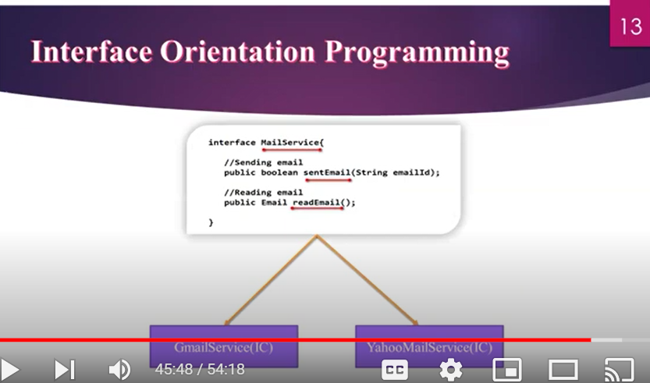

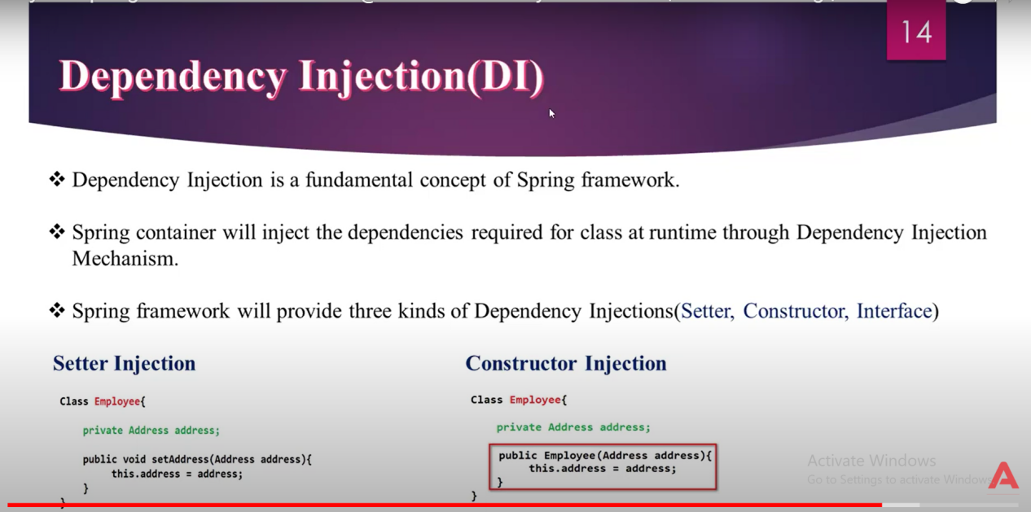

This keyword is used to differentiate between Instance variable and local variable when they both have same name.

But if they have different name, then we don’t have to use this keyword

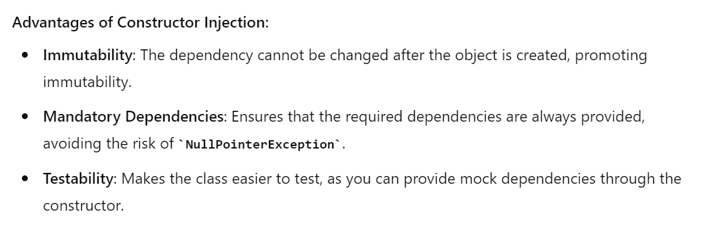

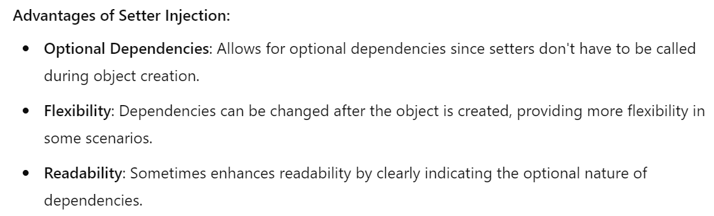

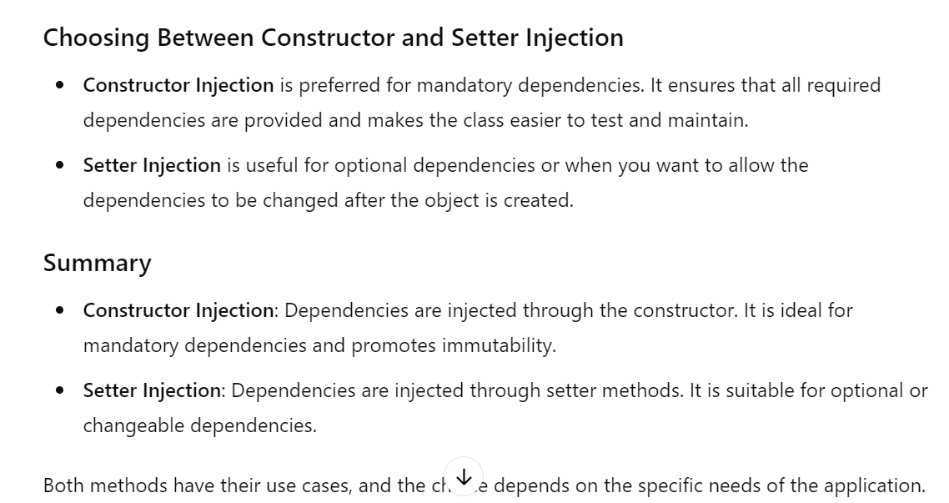

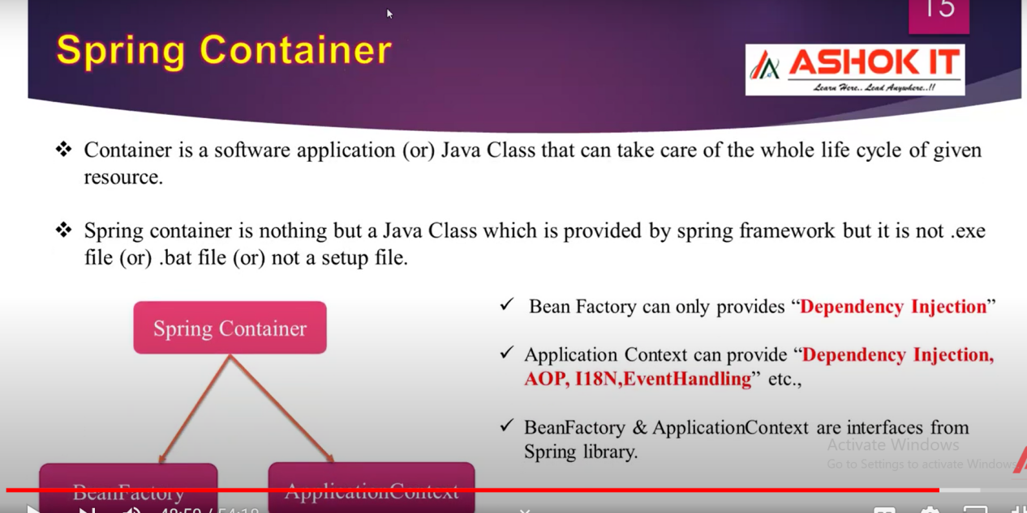

**SESSION-5**

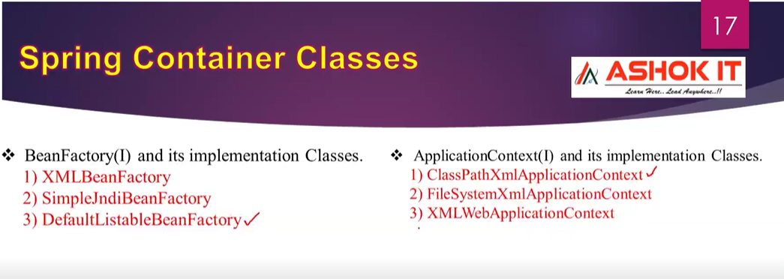

**Activating the Spring Container in spring application is nothing but creating object of an implementation class for either of any spring containers.**

**Most frequently used implementation class are “DefaultListableBeanFactory”, “ClassPathXmlApplicationContext” in spring application development.**

**We cannot activate the Servlet container, JSP container by creating objects for certain classes so they are heavy weight containers, these containers will activate during server start up time itself.**

**Spring container creates spring bean object, performs life cycle operations, inject dependencies and finally destroys spring bean object.**

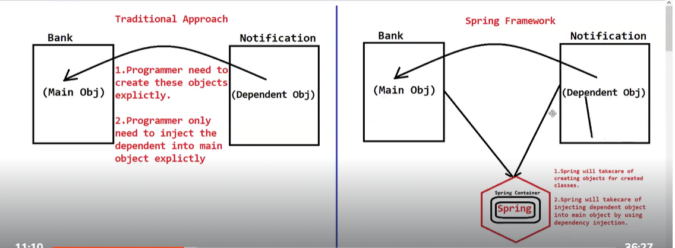

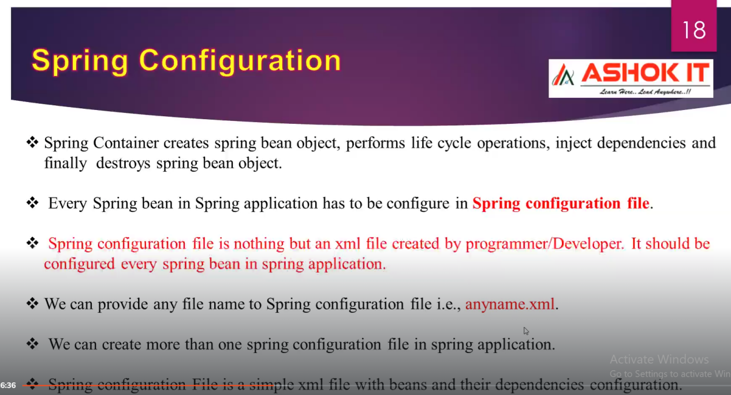

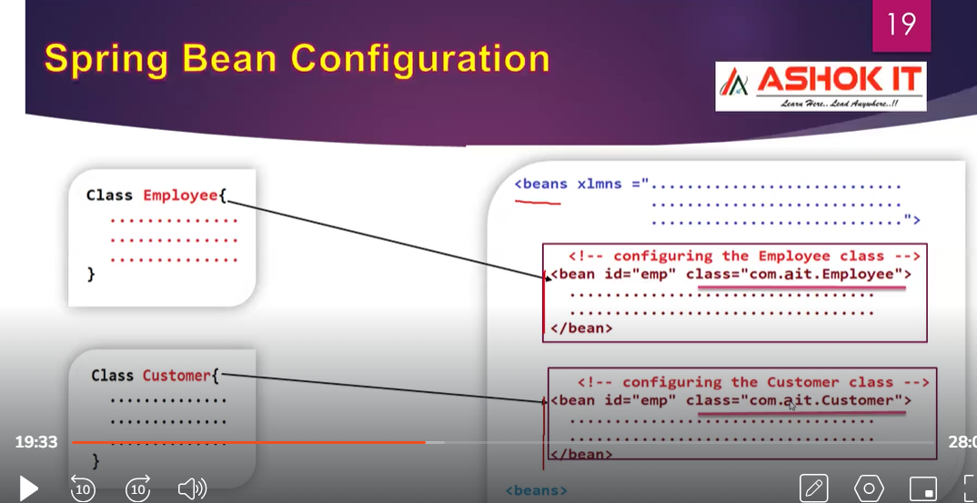

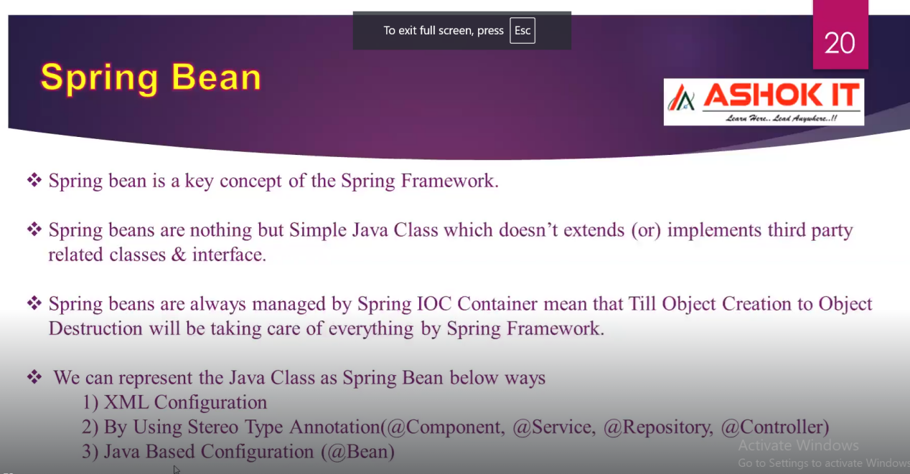

**Every Spring Bean in Spring framework represented as “Singleton” by default.**

**SESSION-6**

**https://spring.io/projects/spring-framework**

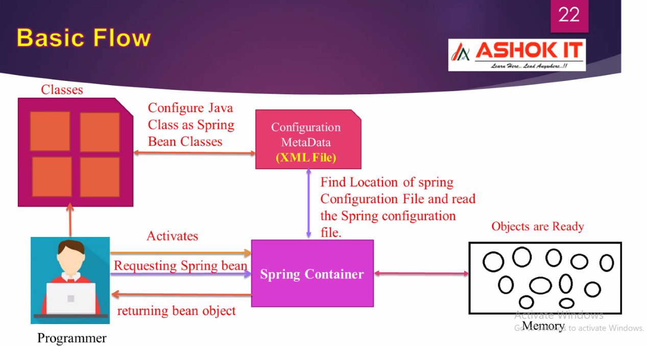

Objects always get resided in Heap memory.

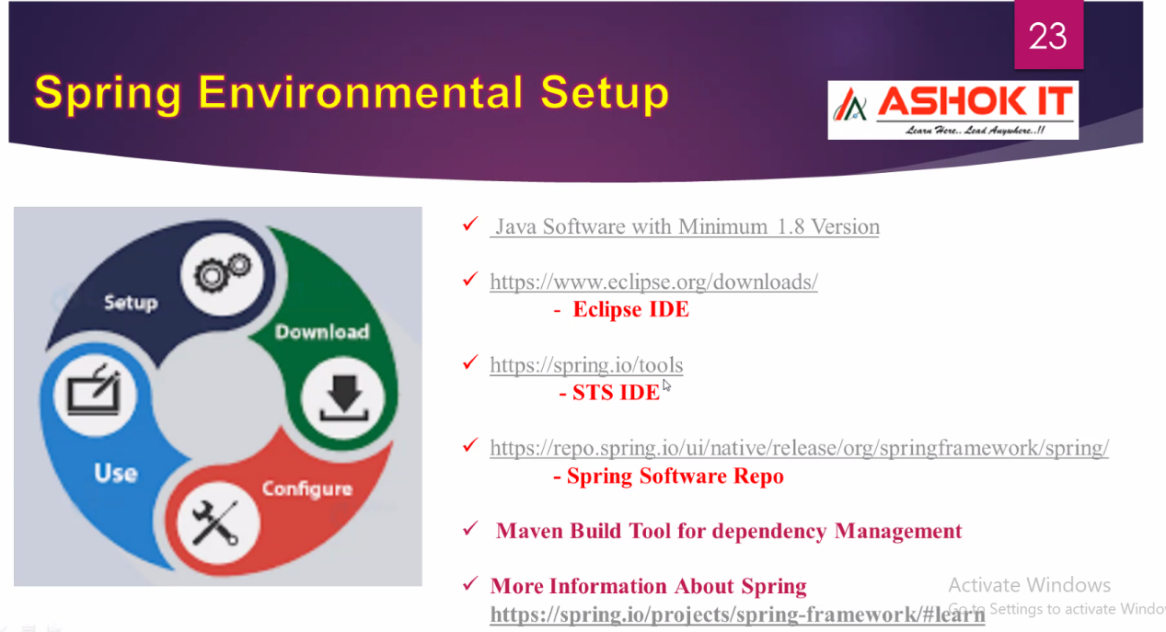

**MAVEN is a build tool.**

Companies will build their own artifacts.**JFrog is one of artifacts related platform where you can host your jar files.**

Apart from pom.xml file , we will have one more configuration file related to Maven where it is configured like from where to download artifacts from Central repository or from JFrog.

**<https://spring.io/projects/spring-framework>**

**While creating Maven project in STS, GroupId should always be company name.Artifact Id should be module name or project name.**

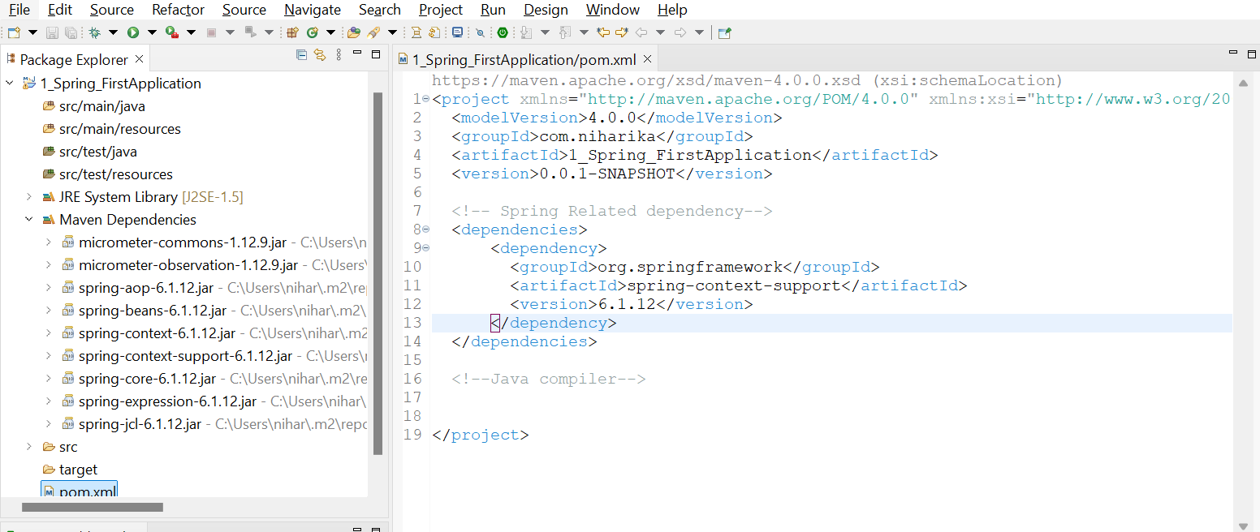

As soon as you add dependencies in pom.xml file, Maven Dependencies Folder gets generated.

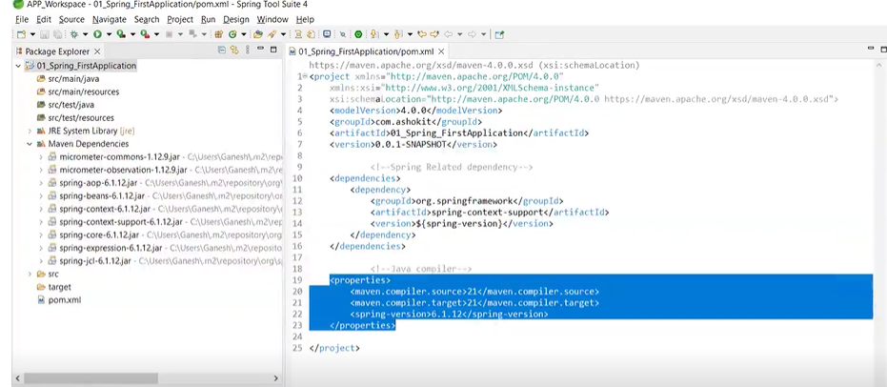

**SESSION-7**

**Ctrl+alt+down arrow === shortcut for duplicate lines**

**<https://docs.spring.io/spring-framework/reference/core/beans/basics.html> == Container overview**

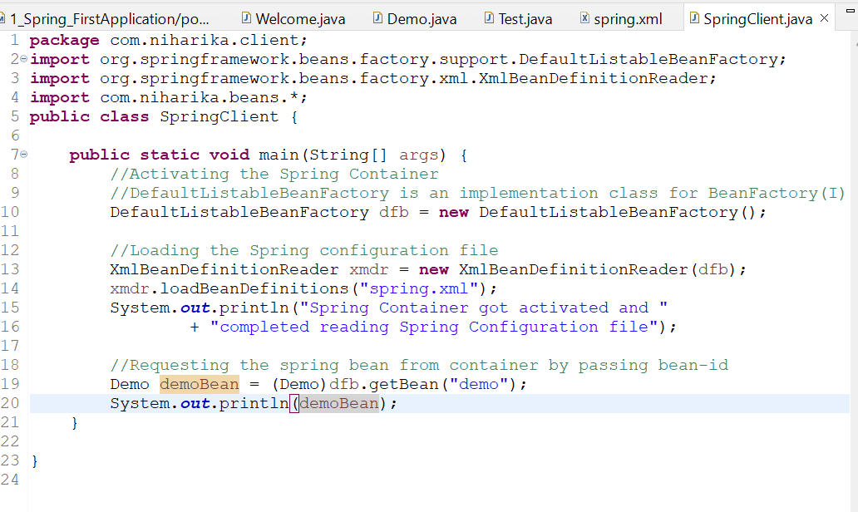

Whenever you make changes in pom.xml file, you must and should update Maven project

When you are working with Bean Factory container in Spring Framework, it will create objects for Spring Bean classes on demand only.On Demand means when you request for a particular bean, then only that particular object will get loaded into memory.

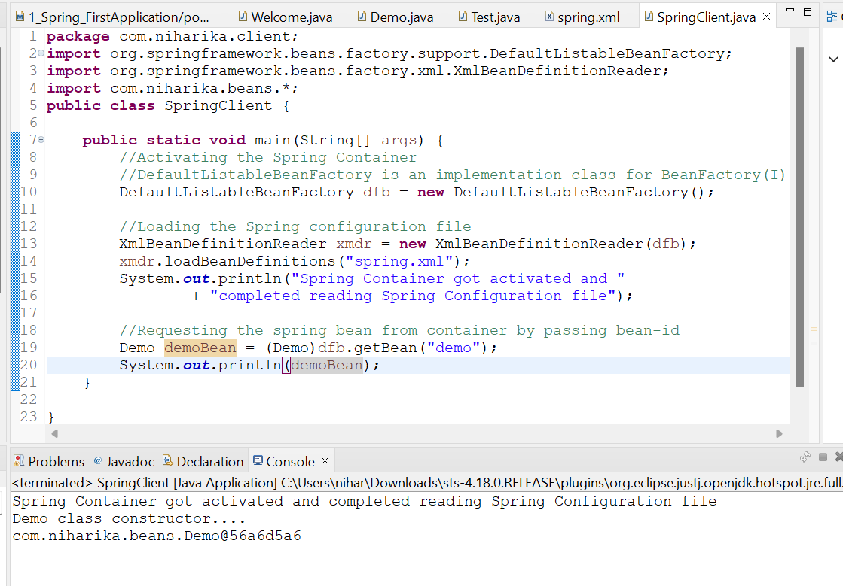

In the above screenshot, we can see that only Demo class constructor called although we have configured Welcome,Demo,Test classes as spring beans in spring.xml file.

The reason why constructor of Welcome and Test is not called is because we are requesting only for objects of Demo.The nature of SpringBean Factory container is it will create objects only on demand.

Spring Beans are singleton in nature.

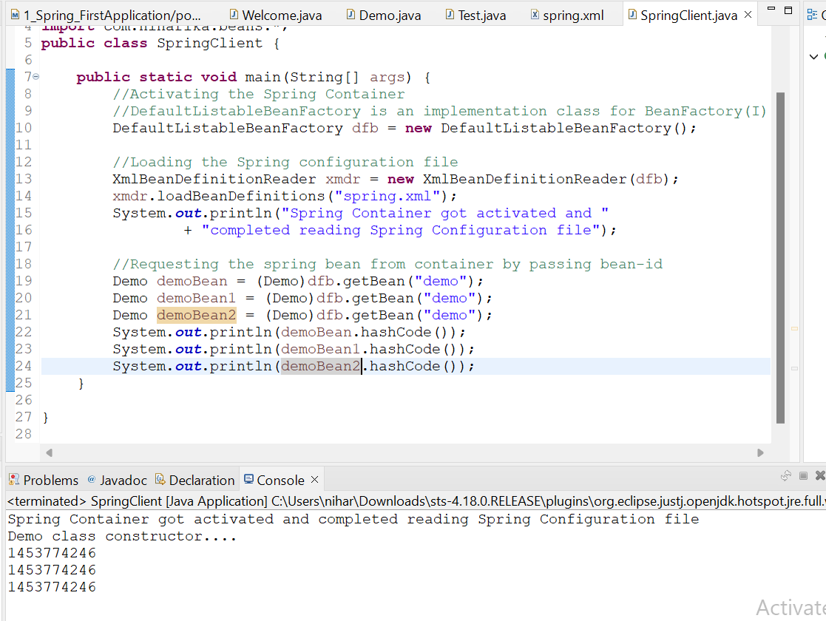

Container is returning same object for each request.By default, every spring bean in Spring framework is singleton in nature.Object will be created only once in Spring container.If you request multiple times, it will return same object.If you see in above screenshot, Demo class constructor got called only once even though object is requested multiple times.

Singleton == means only one object will be created for entire application.

When you created a simple Java class and not yet configured in spring.xml configuration file,and if you request that bean in main program, you will get error as shown below

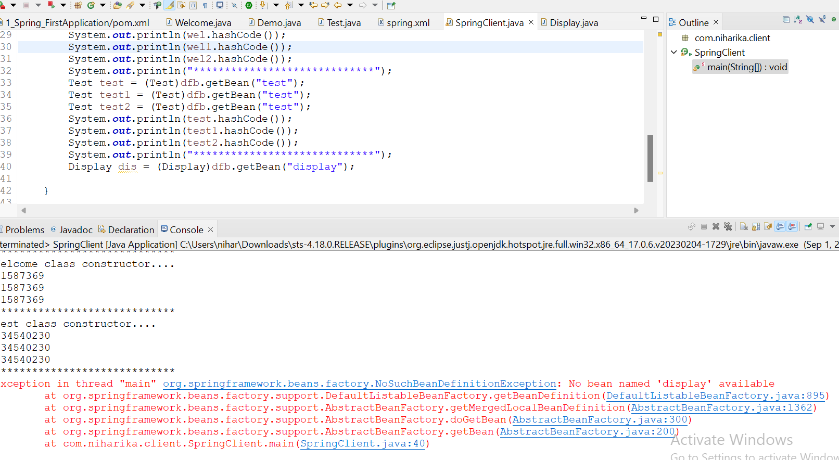

“Run as Java application” == this option will be present only for class that has main method in it.

**SESSION-8**

By default, spring beans are singleton in nature.

**Dependency Injection:** The process of injecting objects at run time by Spring Container is called Dependency Injection.

A)Constructor based B) Setter based C)Interface based

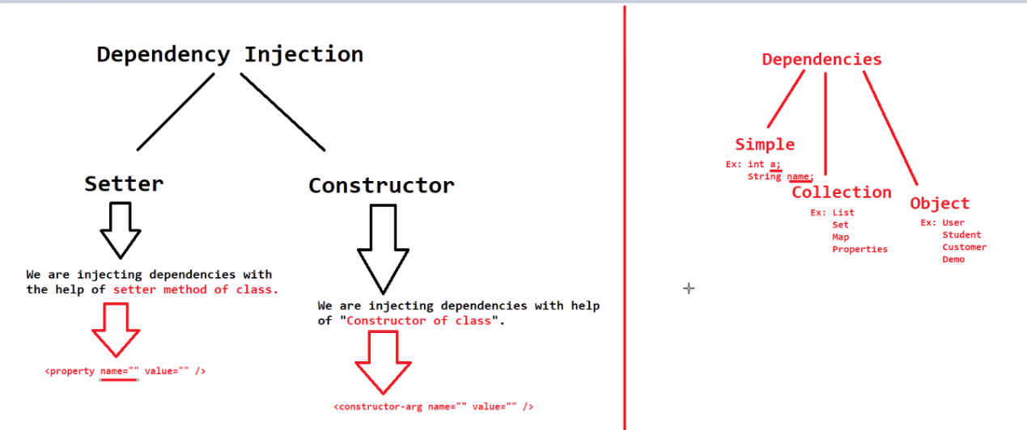

**Constructor-based: If you are injecting dependencies with the help of constructor.**

**Setter-based: If you are injecting dependencies with the help of setter method of a class.**

<https://docs.spring.io/spring-framework/reference/core/beans/dependencies/factory-collaborators.html#beans-setter-injection>

**Purpose of toString() method:** When you want to print an object, internally toString() method will be called.

**SESSION-9**

When you want to display objects of an array, then you have to use Arrays.toString()

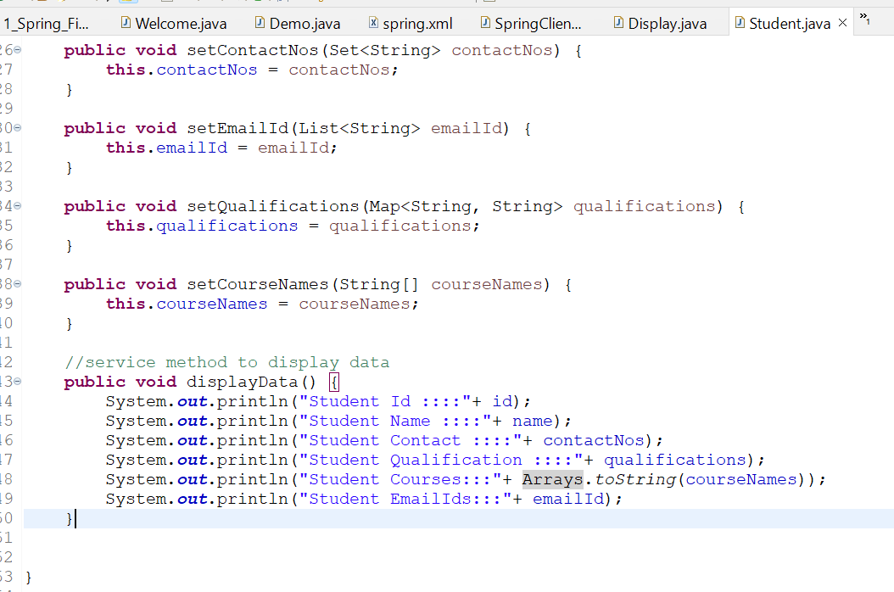

Under Collection dependency, we have List, Set,Map,Properties.

Difference between Map and Properties is

Map stores any type of objects in the Key-Value pair format.

Properties stores only String types in Key-Value pair format.

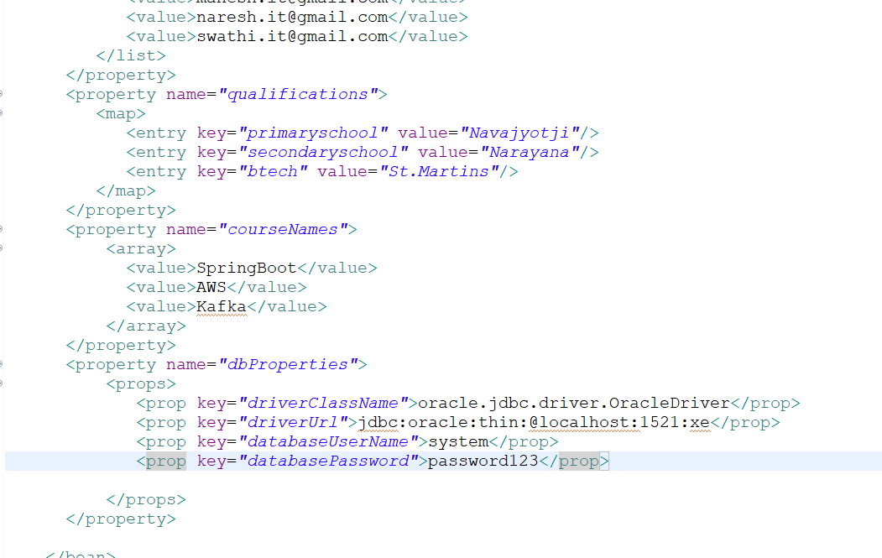

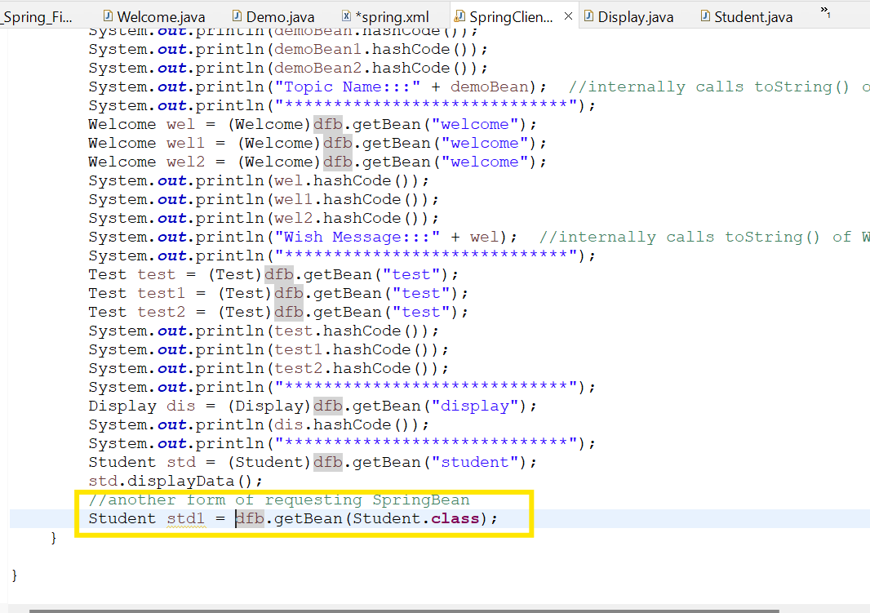

When you are requesting spring bean by using BeanId, we have to typecast because getBean() returns object.

When you are requesting spring bean by using beantype(class), we don’t have to typecast.

**Object Dependency**

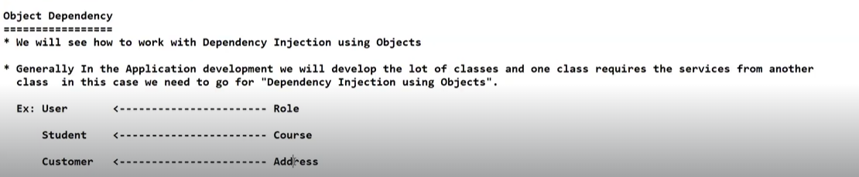

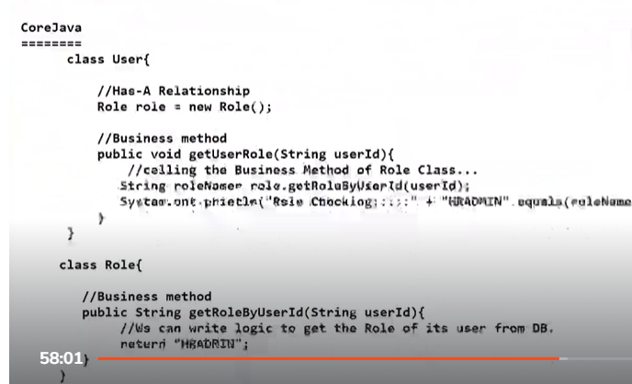

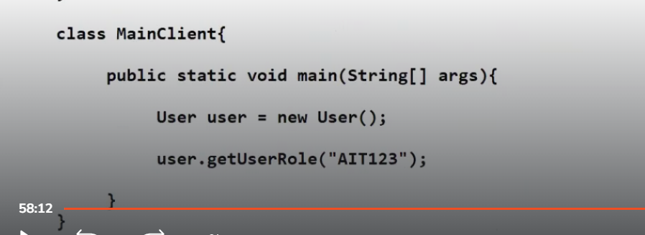

**Core Java level question**

**In below scenario, which object will be created first?**

**User class object or Role class object?**

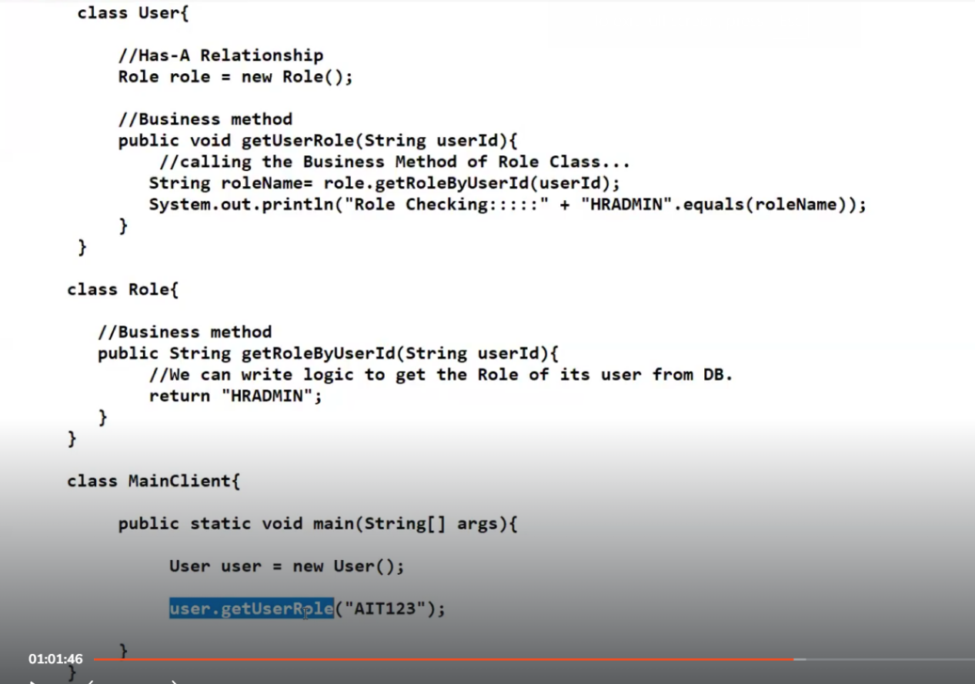

**In this scenario, in the MainClient program, JVM does not straight away creates User class object.It first checks if there are any dependency objects, and it creates those dependency objects first and then it creates User object.**

**Therefore role object gets created first followed by User object.**

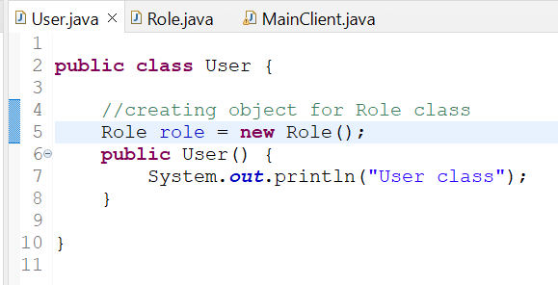

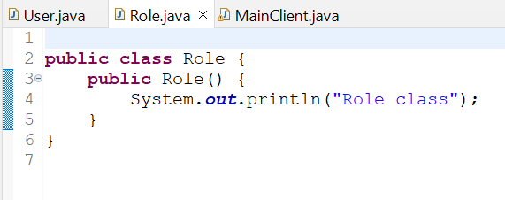

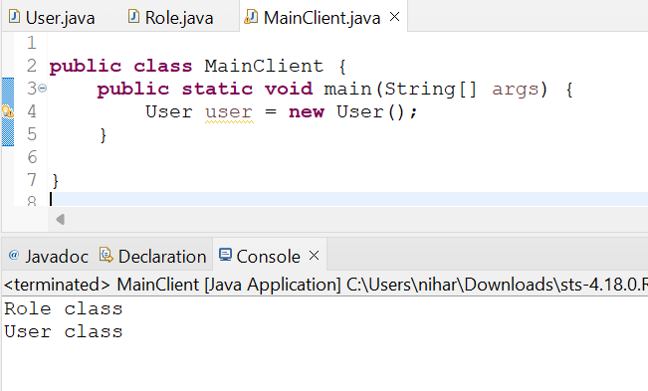

**Another scenario**

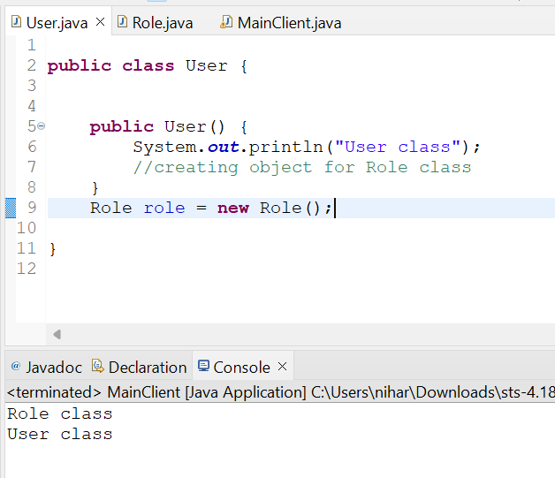

In this scenario, we are creating Role object at line no 9.In this case also, Role object gets created first followed by User object.

New keyword will not only call Constructor but it will also instatiate the instance variables present inside class.

Here role is an instance variable, so it instantiates the role variable first and then calls the constructor of User class.

**Check the same scenario in Spring Container**

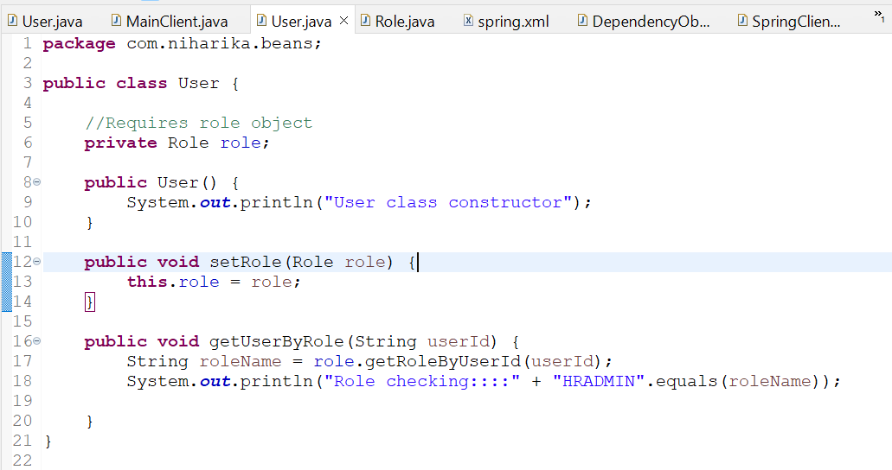

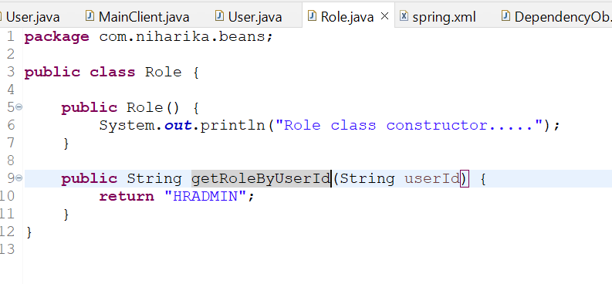

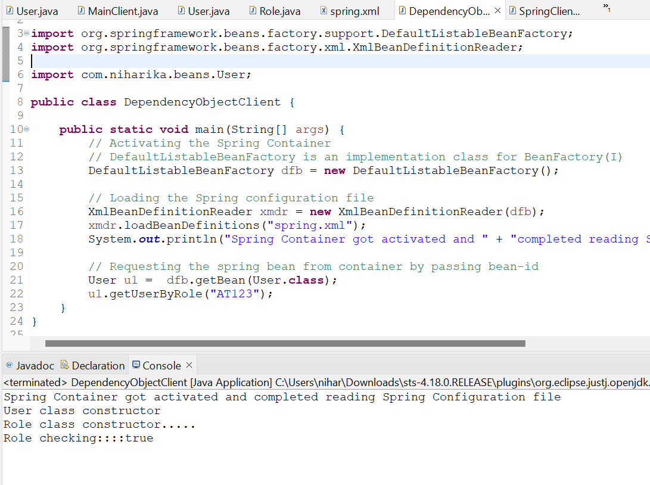

In Spring framework, Main class object is created first followed by Dependent class object.

User class object is created first followed by Role class object.This is quite opposite to Core Java.It is one of reasons for Inversion of Control.**Actual process of the reverse process is known as Inversion of Control.**

**SESSION-10**

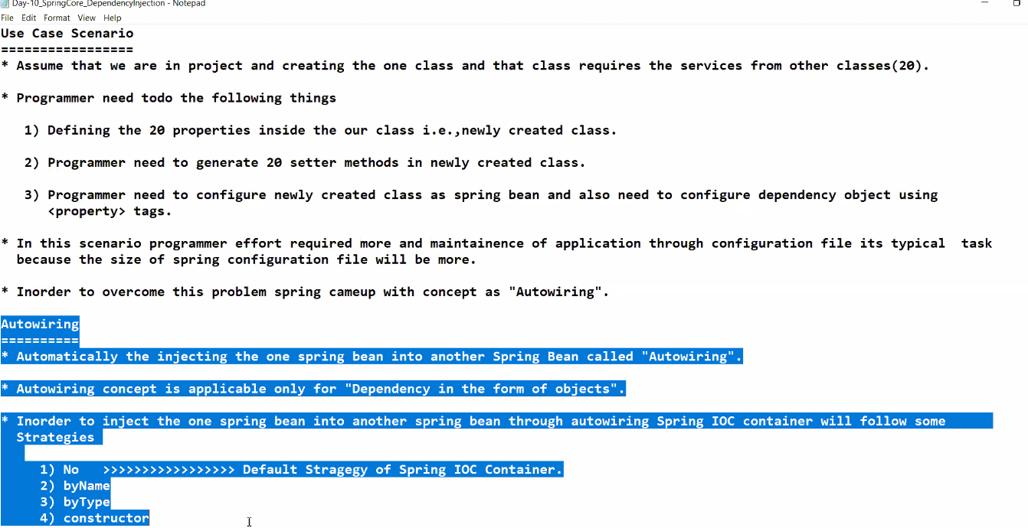

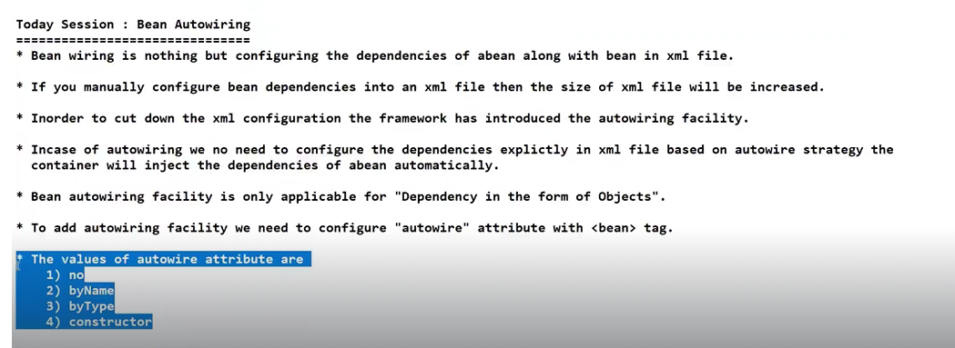

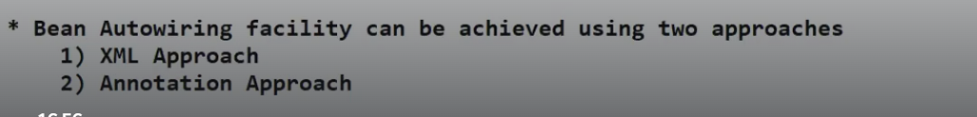



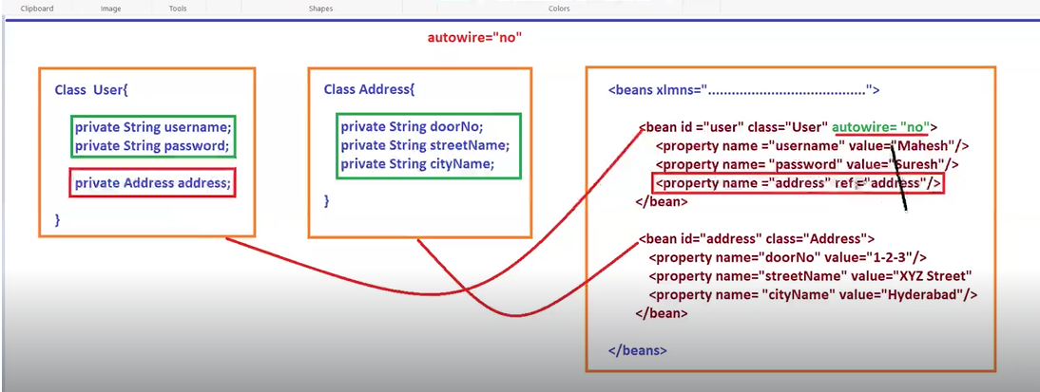

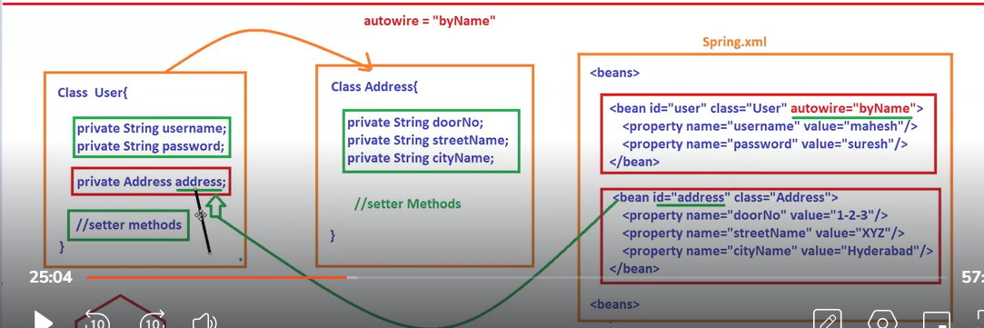

Bean id should always be unique in spring.xml file

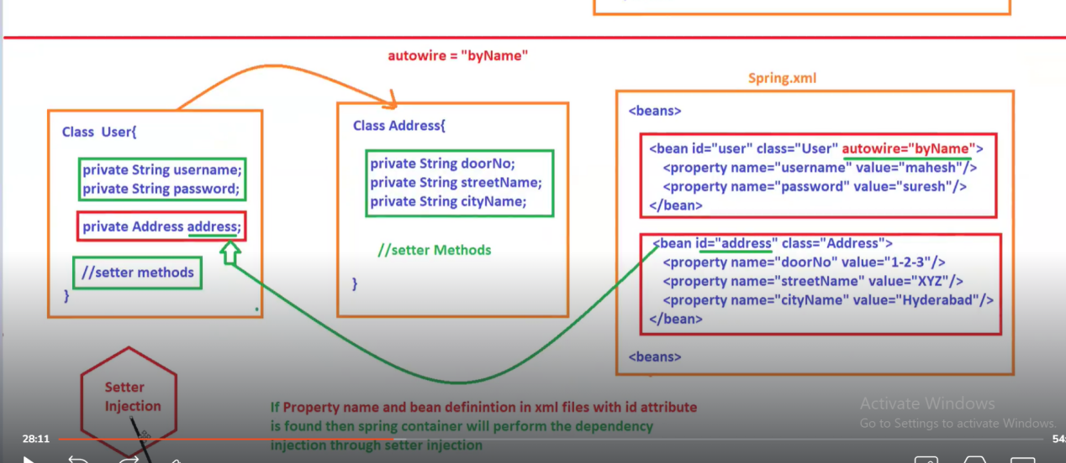

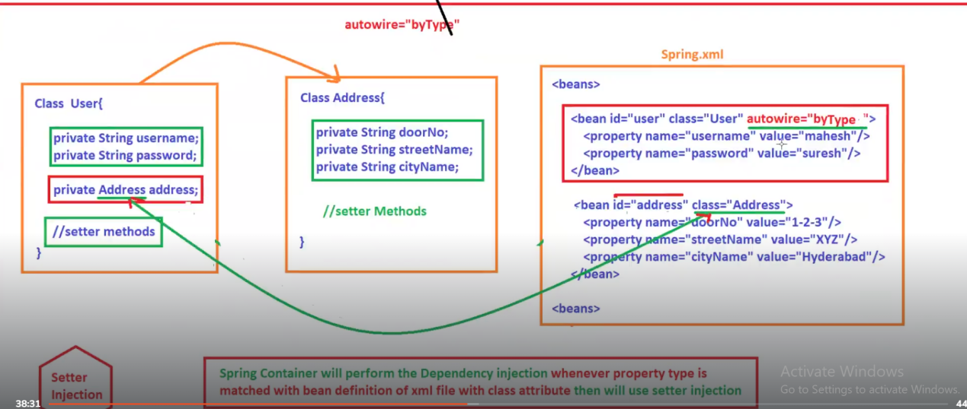

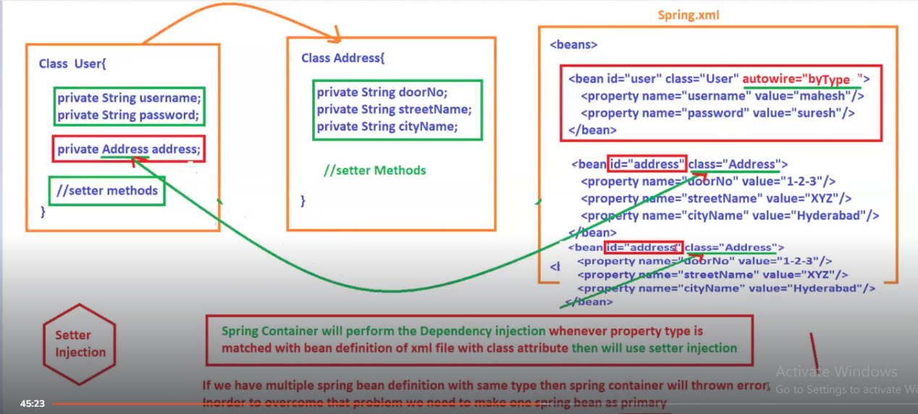

**SESSION-11**

**autowire= “constructor”**

**In spring.xml file, we give autowire=”constructor”**

**Spring container will perform Dependency injection whenever property type is matched with bean definition of xml file with class attribute then will use Constructor injection**.



Here in below screenshot, we have two beans qualified for Address. In this case, we get error.

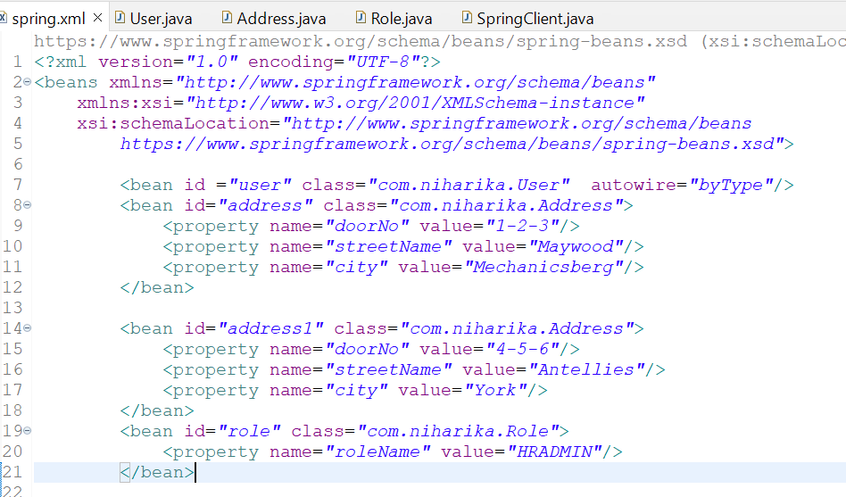

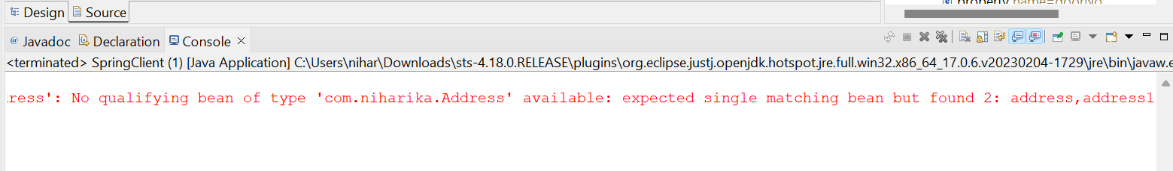

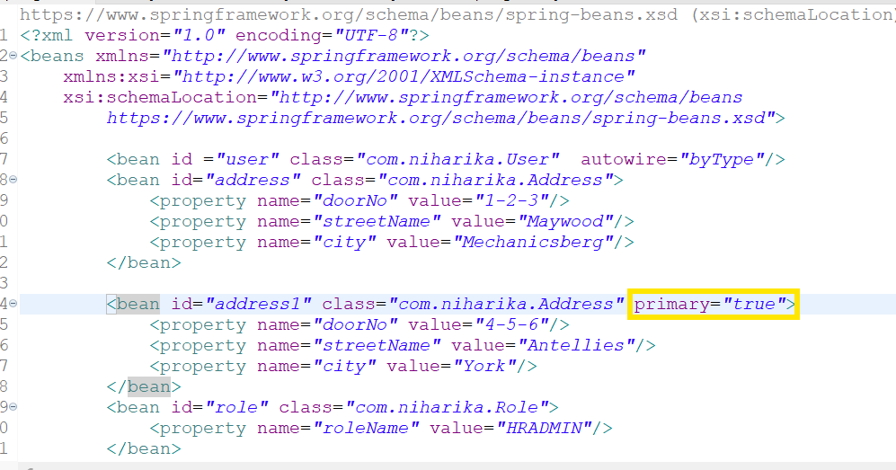

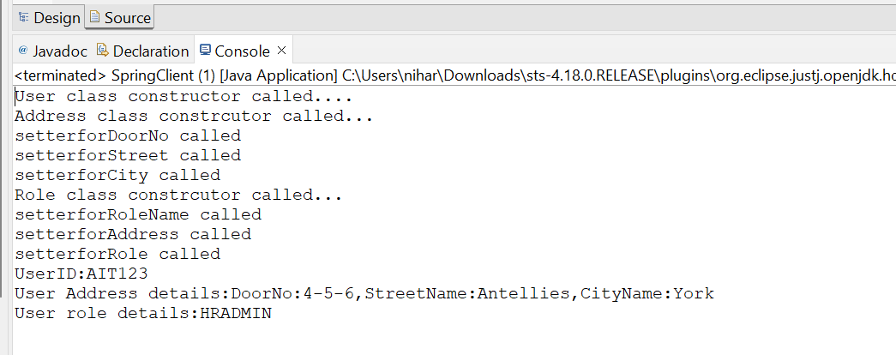

**SESSION-12**

**Differences between Setter based injection and Constructor based injection**

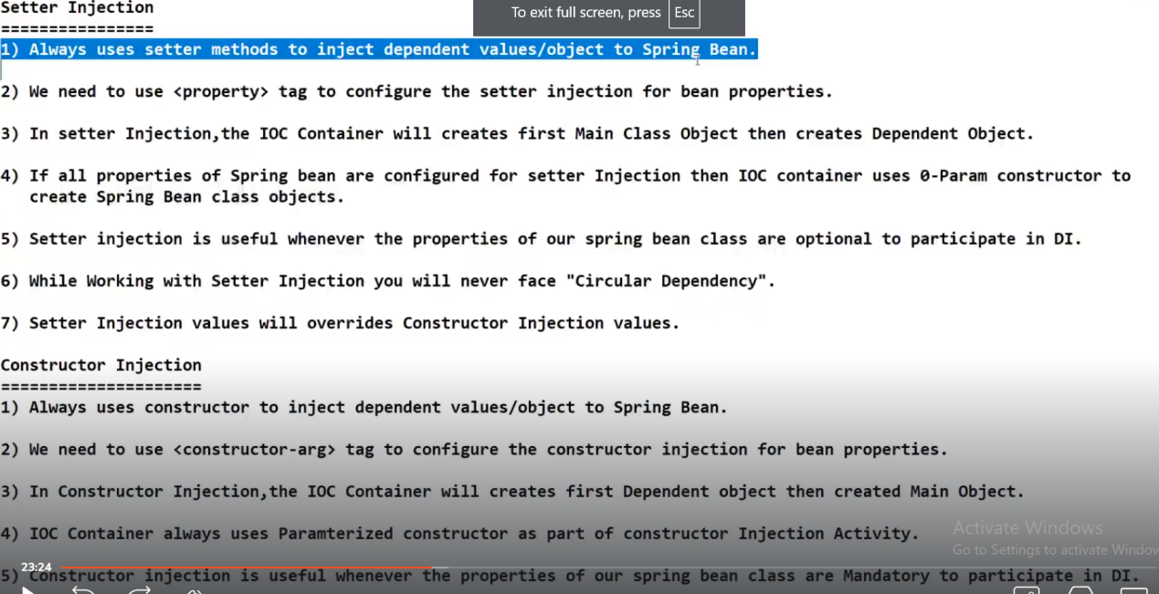

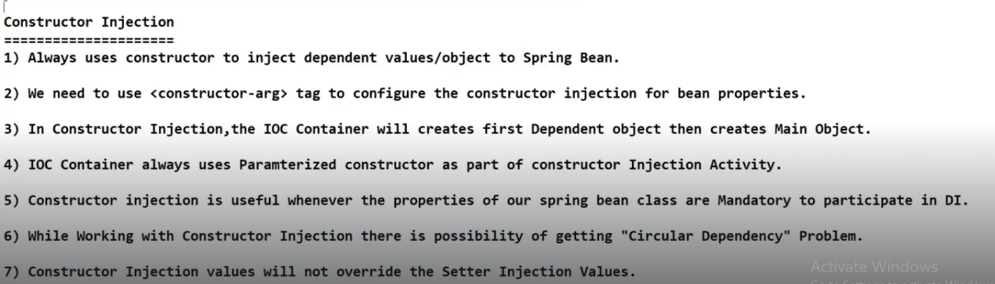

Constructor injection is similar to Core Java. Dependent objects are created first followed by Main objects.

When we are working with Constructor injection and in spring.xml file, if you are not configuring “constructor-arg” for dependent variables, then object creation will fail.

And if you are defining default constructor, then object will get created.

As per core Java rules, if you are defining a parameter constructor in a class, then default constructor will not get called.Basically we are overriding the default constructor with parameterized constructor.

At core Java level, every class will have a default constructor.Compiler will add that default constructor through bytecode to create an object at runtime by JVM.

When we are working with Constructor injection, we never recommend to use default constructor.

**Circular Dependency:**

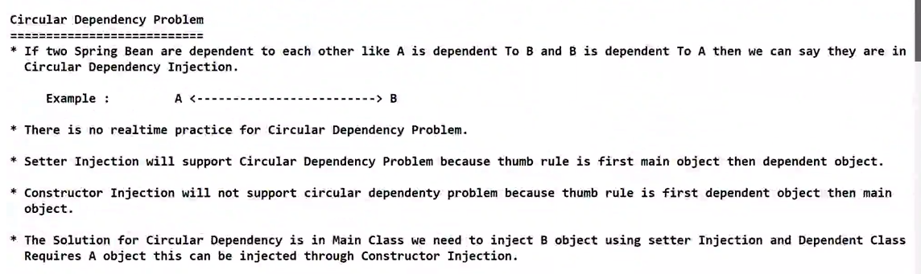

**Both A and B are Spring Beans. Bean A is dependent upon Bean B and Bean B is dependent upon Bean A.This is Circular Dependency.**

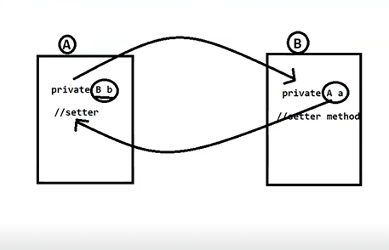

In case of setter injection, for the above scenario, objects get created in the following order and the program gets executed successfully.Therefore you will never face problems with Circular dependency in Setter injection.

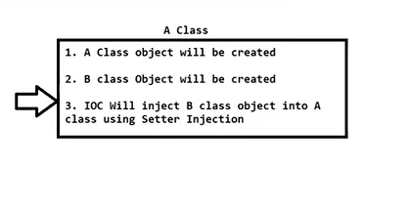

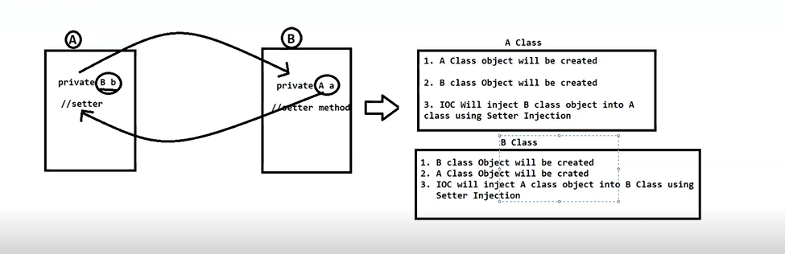

Where as in Constructor injection, the above scenario fails.It faces the issue with Circular dependency.

Thumb rule of constructor injection is Dependent objects get created first and for Bean A ,bean B is dependent object.A cannot be created without B.

At the same time, for Bean B , Bean A is dependent object.B cannot be created with out A.

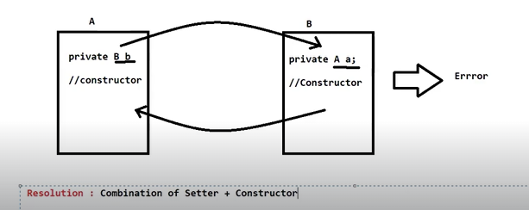

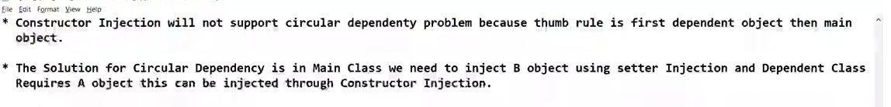

**Setter injection will override constructor injection values.**

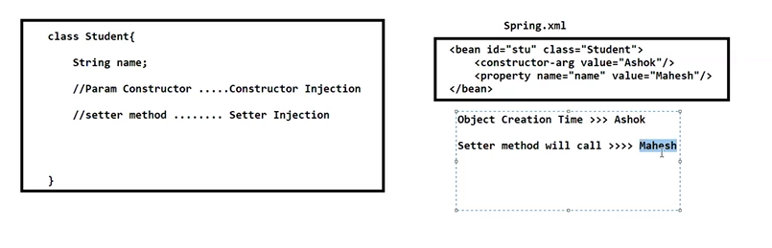

**SESSION-13**

ApplicationContext container is an advanced container than Bean factory container.It is because Application Context container is child interface of BeanFactory interface.

Bean factory container will provide limited services like Dependency injection,Bean instantiation and bean life cycle support.

In order to inject the secondary services into Bean services, AOP is better than OOPS.

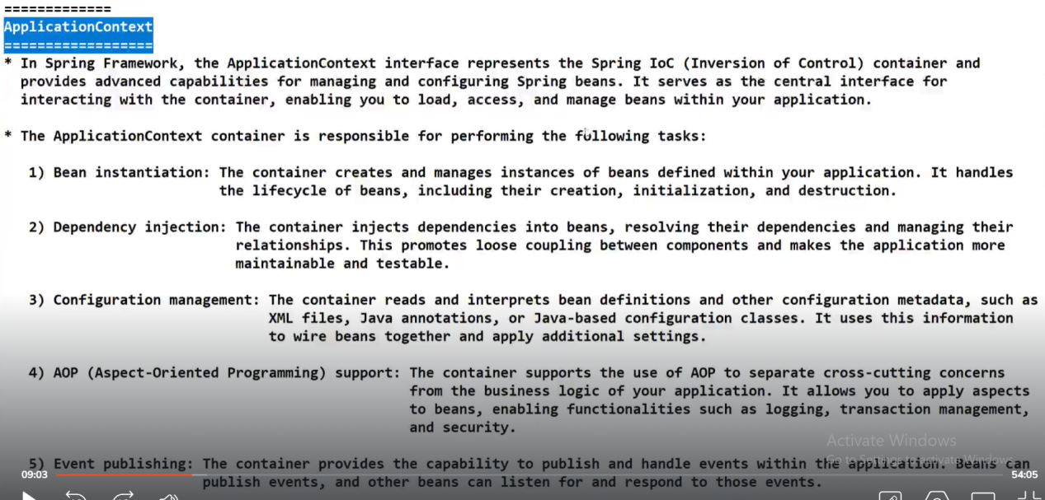

When user performs some action like clicking on button in GUI interface using AWT and swings in Core Java, internally JVM will generate one event.That event is called Action event.

Whenever Action event is generated in JVM, as a programmer if you want to handle that event, you can do it by using Event Listeners.Programmer needs to create Java class and implement the respective Listener interface.

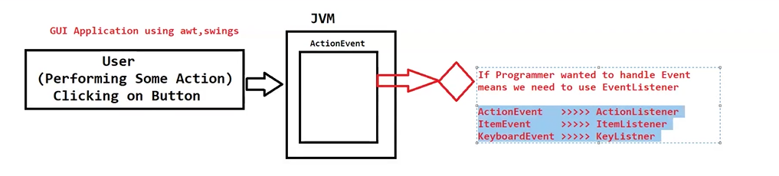

Therefore whenever some actions are occurred in application, automatically some events are triggered in JVM.If programmer is handling those Events, the logic of those Event listeners will get executed automatically without programmer intervention.This is the beauty of Event handling mechanism.

Best example is Thread class run () method. When you start a thread,, run() method gets executed automatically because some events are triggered inside JVM.

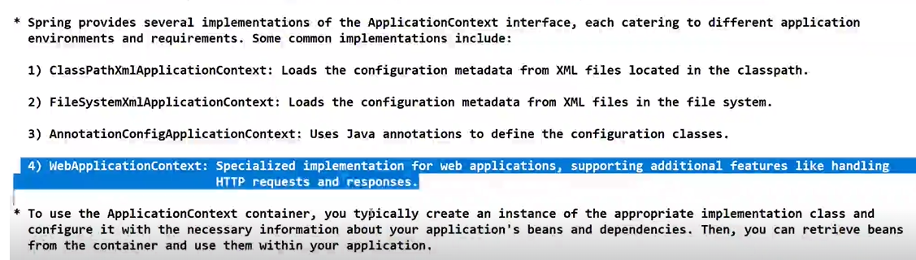

FileSystemXmlApplicationContext: When you place configuration file in local C or D drive.

Difference between BeanFactory and ApplicationContext with respect to Bean Creation

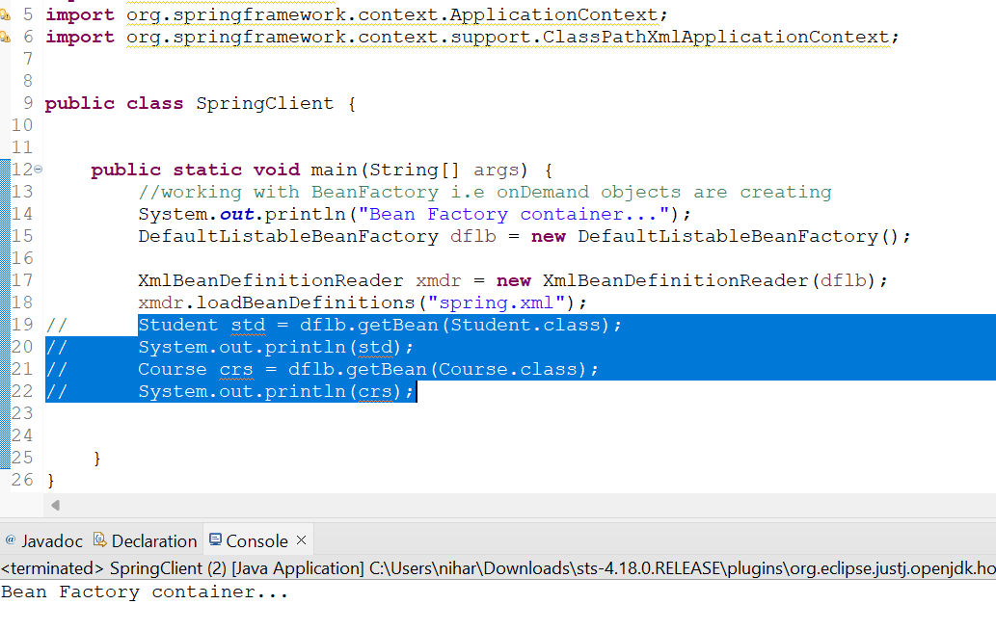

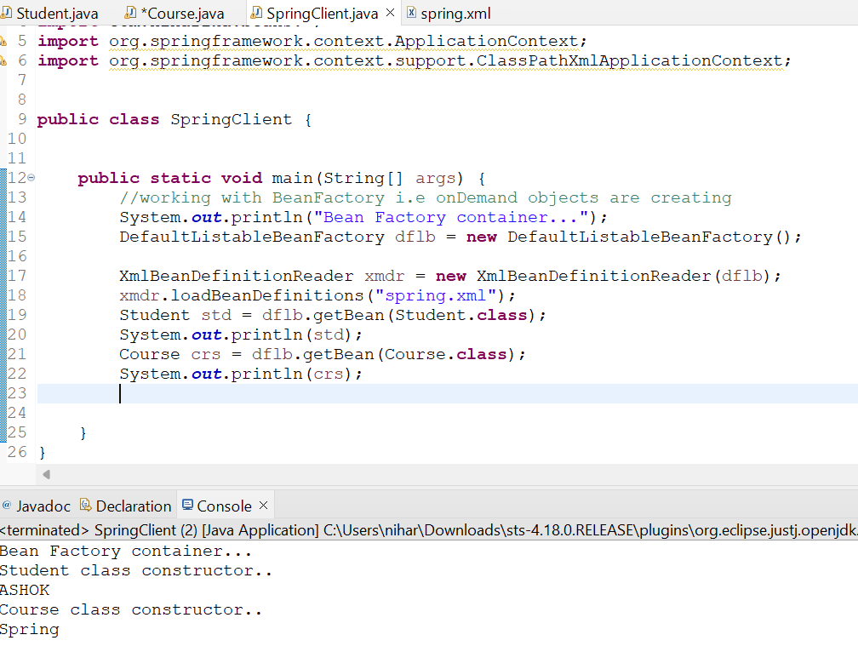

In case of BeanFactory, here we are requesting for objects of Student and Course.Only then constructor messages are seen.Otherwise constructor of student and course is not called.

**ApplicationContext**

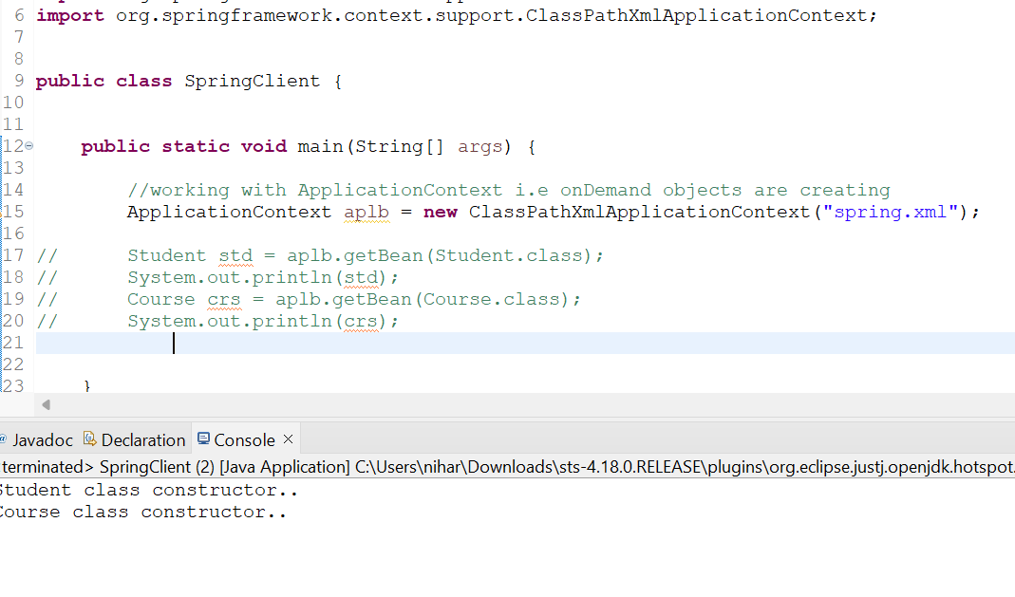

Here even though we did not request any beans, constructor of Student and Course is called.This is nothing but per-instantiating of Spring beans.When you activate ApplicationContext container, at that point of time itself, container will read spring beans information from spring configuration file and those beans will get created in the memory.

**Therefore Bean Factory is Lazy instantiation and Application Context is Early instantiation.**

**If you want to make some of the spring beans as Lazy initiate , we have one attribute support of Spring library lazy-init= ”true”**

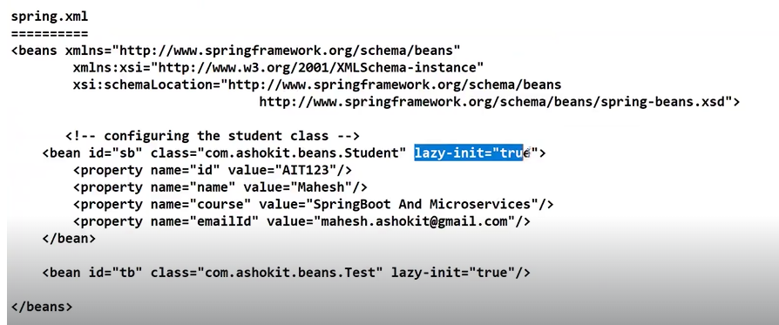

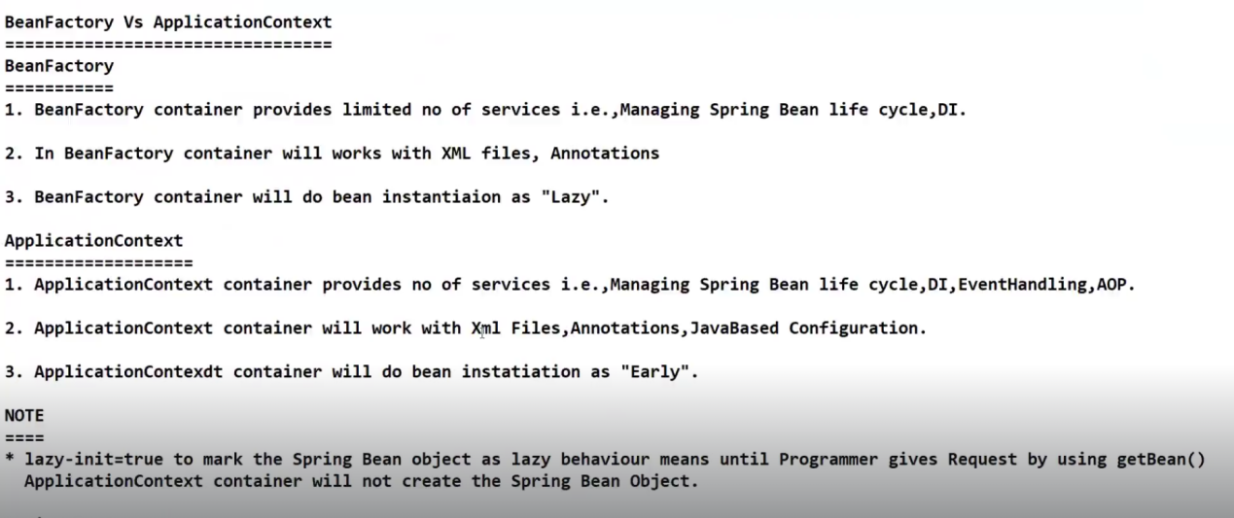



**SESSION-14**

**Java Based Configurations**

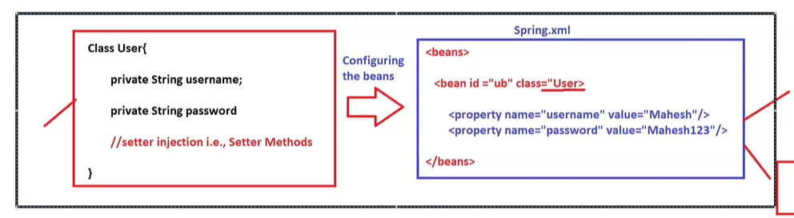

XML based application development is old style application development.It is used in Legacy projects.

Java Based Configuration: Replacing the spring.xml file with Java based configuration class.We are maintaining configurations of a spring application with the help of Java class.

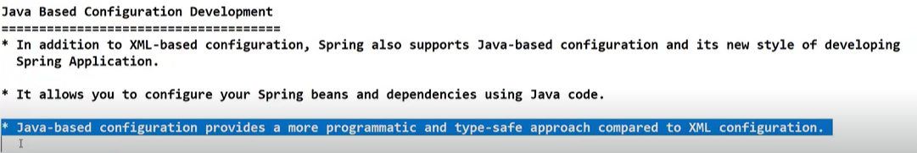

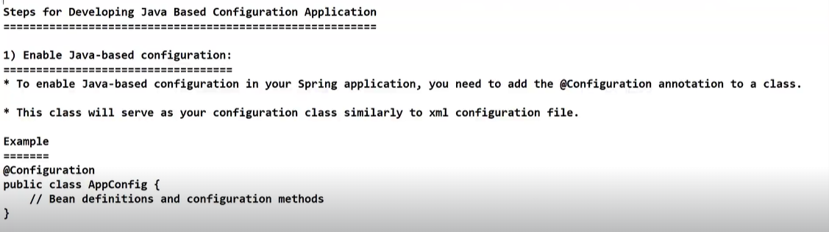

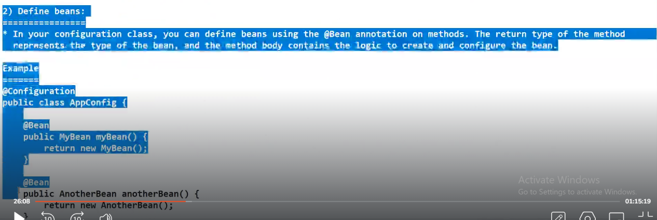

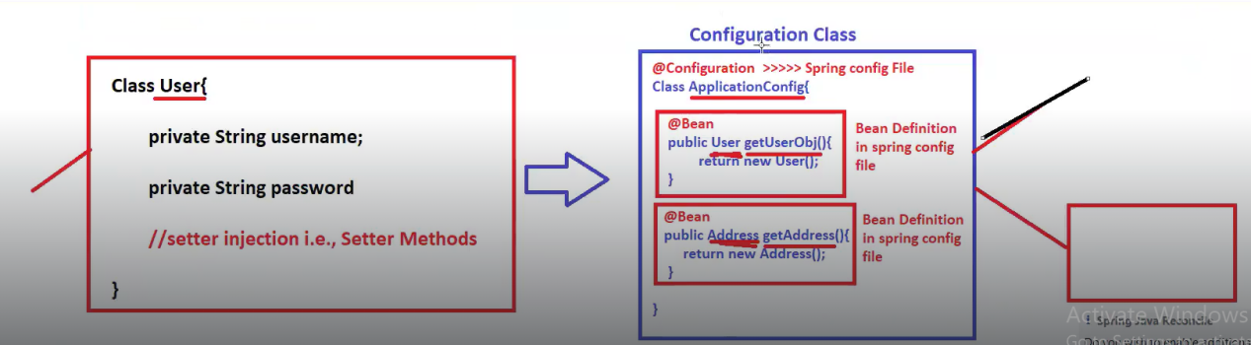

**Purpose of @Bean annotation:** To represent a Java based method as spring bean definition equivalent to xml based configuration.

**Purpose of @Configuration annotation:** To represent a Java class as Spring configuration class.

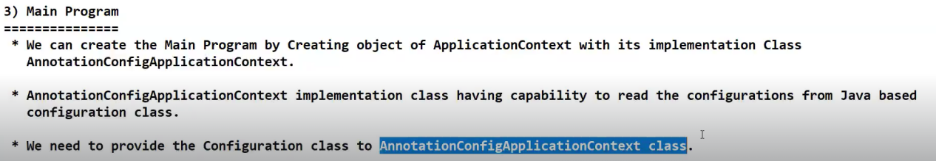

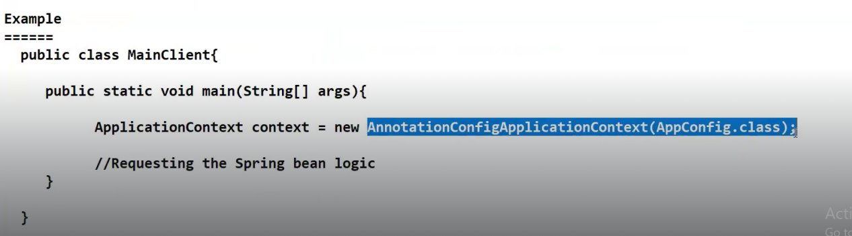

Spring container will take care of creating object for ApplicationConfig class.Programmer does not create object explicitly anywhere in application.

When we are working in Real time, we will be having multiple configuration classes.Every project is built on some sort of technologies and as part of that we do have database configurations, we do have messaging queue related configurations, we do have Redis cache related configurations, we do have applications specific configurations.All these configurations needs to be maintained in Configuration classes.

Lets suppose that your application contains database related configurations and email related configurations.We cannot club all configurations into a one single class.We will partitionize these configurations into sub classes.We cannot maintain all configurations into single class.We will create multiple configuration classes.

**We cannot supply more than one configuration class to Spring container.**

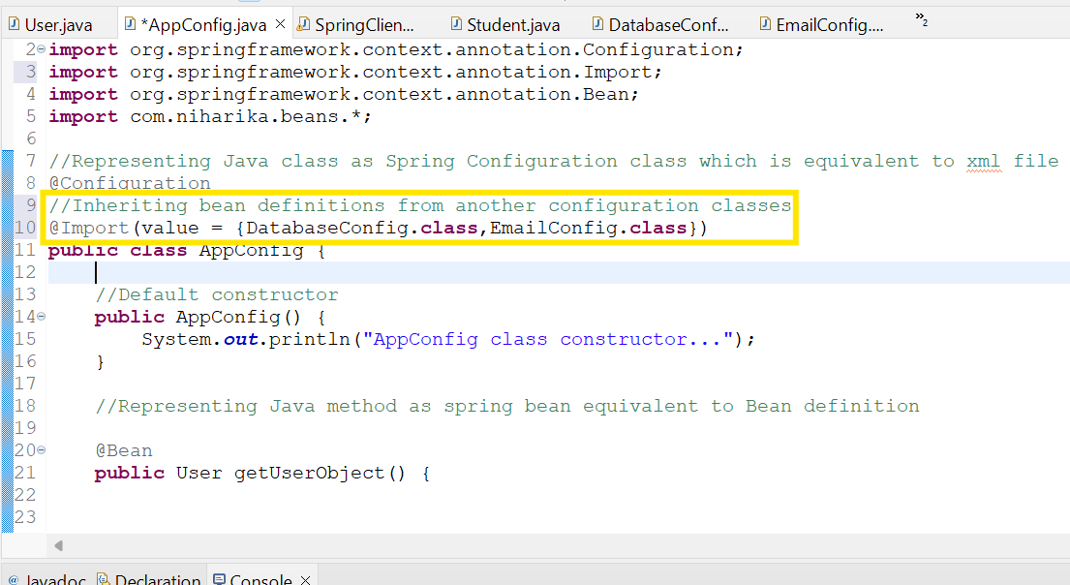

Whatever bean definitions present in DatabaseConfig and EmailConfig will get inherited into AppConfig class.

**How can we import Legacy configuration file into Java based configuration file?**

By using **@ImportResource** annotation

@Import(value={DatabaseConfig.class,EmailConfig.class}) == used for inheriting spring bean definitions from other configuration classes.

@ImportResource === Inheriting spring bean definitions from xml configuration file(old style of spring application development)

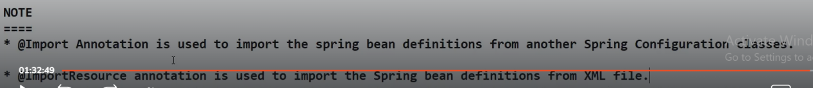

**SESSION-15**

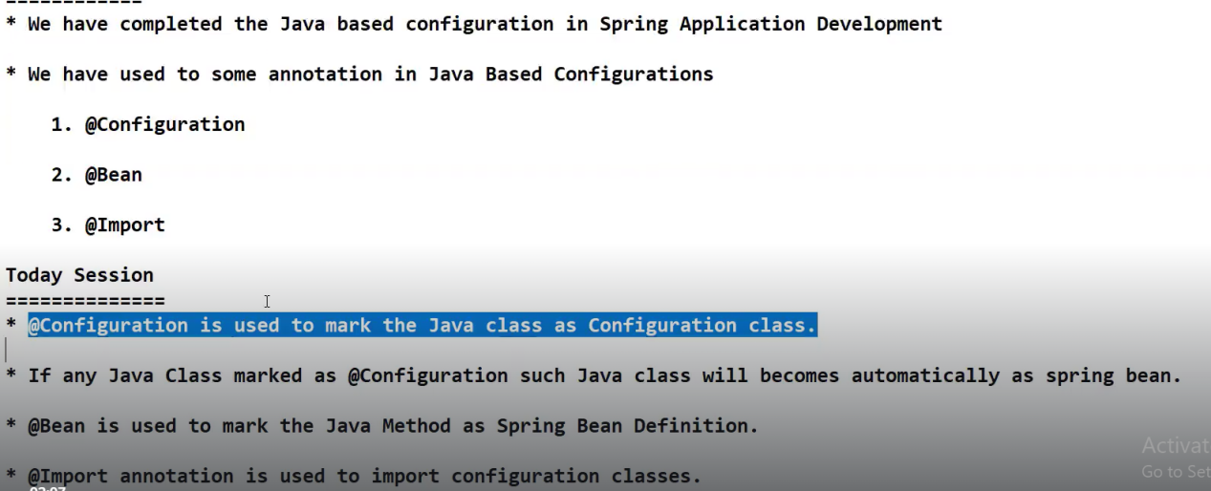

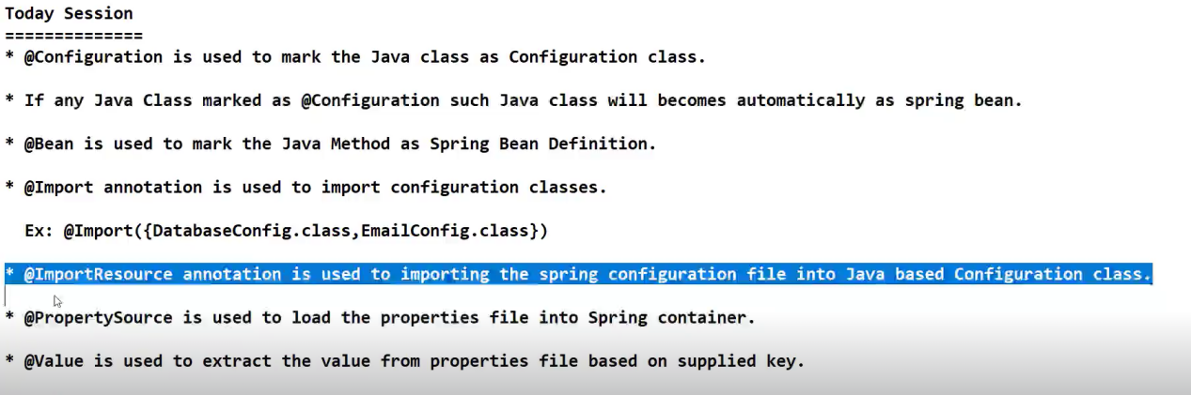

**When we use @Configuration annotation on top of a Java class, that class automatically becomes a Spring Bean**

**Application.properties is a text file with an extension of .properties or .props**

**In Spring Boot we have flexibility to import yaml files into Java based configuration class where as in spring we don’t have that flexibility.**

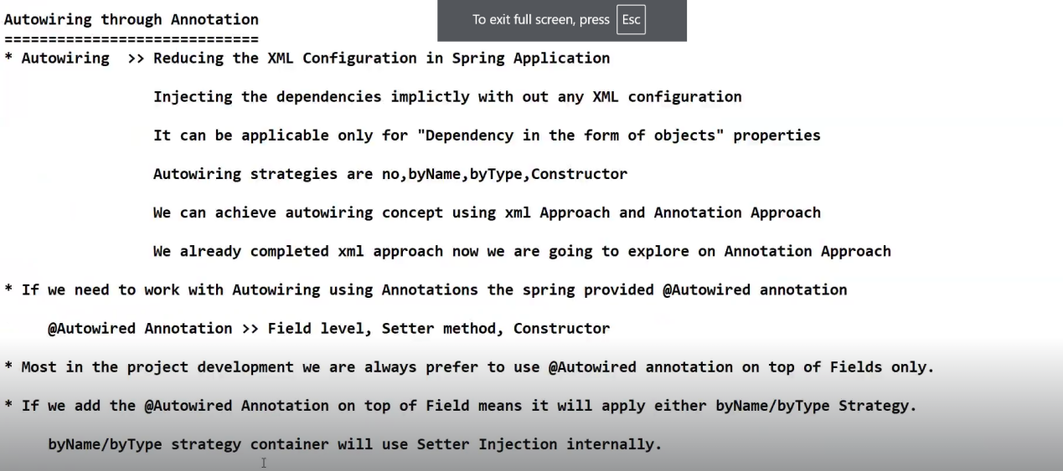

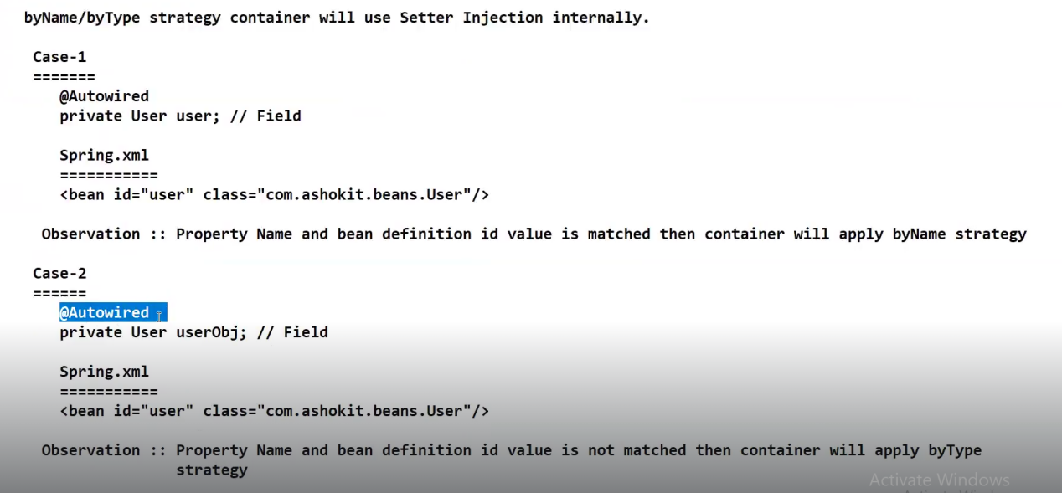

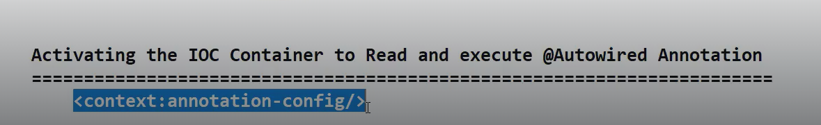

xmlns:context=*"http://www.springframework.org/schema/context"*

*http://www.springframework.org/schema/context*

*https://www.springframework.org/schema/context/spring-context.xsd"*

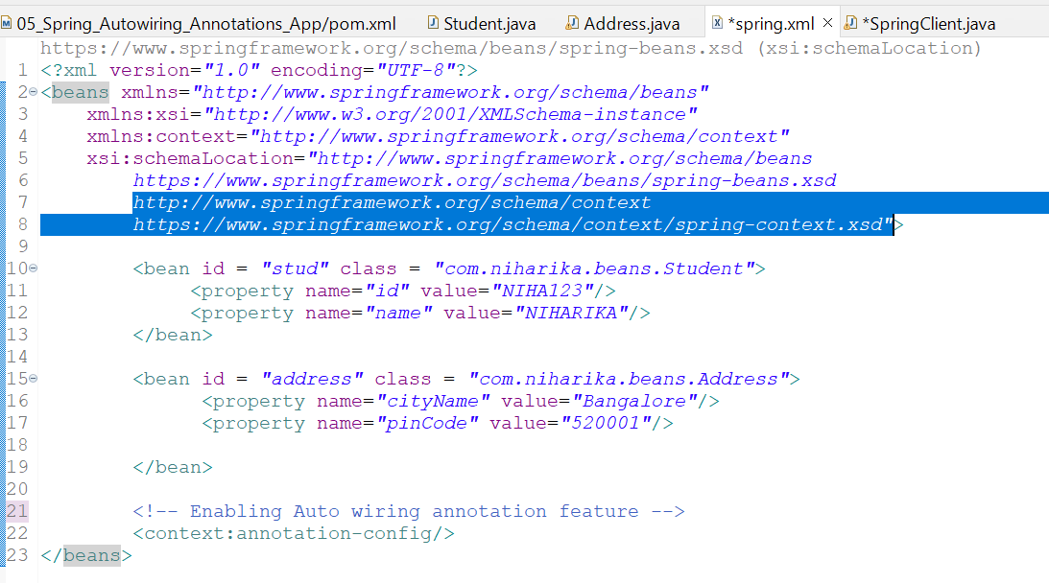

**Purpose of @Qualifier: Used to qualify a particular bean from multiple bean definitions.**

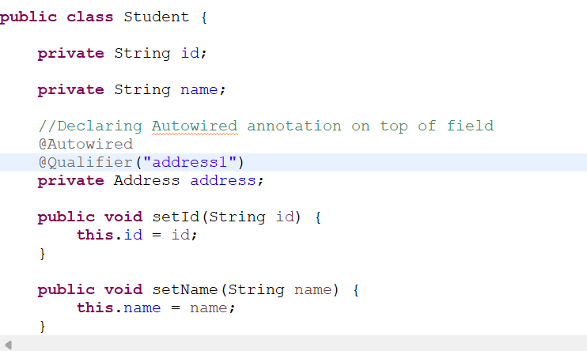

**When we use both @Primary and @Qualifier, bean with @Qualifier annotation gets injected.**

**Refer below screeshot**

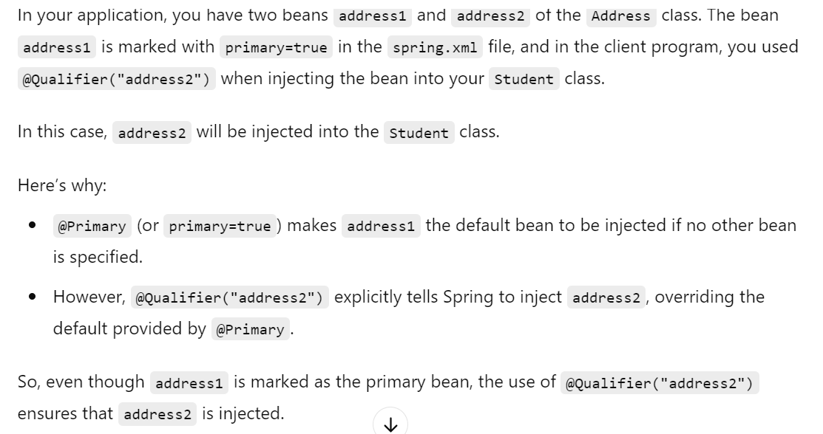

**Can we configure a pre-defined Java class as Spring Bean in configuration file or not?**

**Pre-defined classes ex are ArrayList class,DateandTime class.**

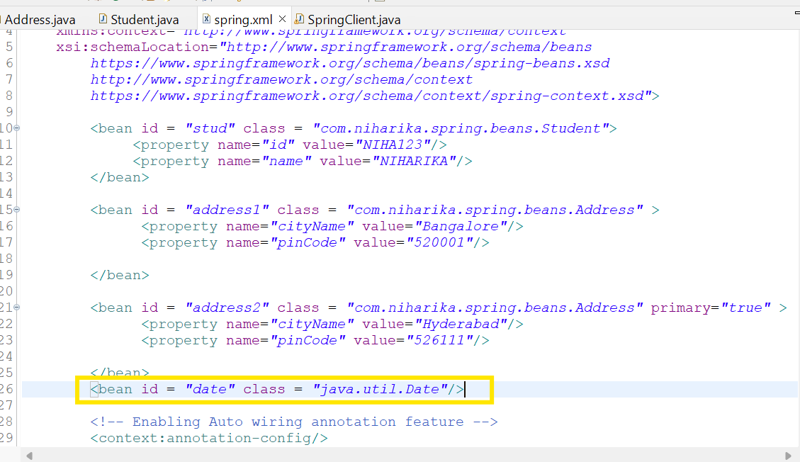

Yes we can configure and once you configure as Spring Bean, it will be managed by Spring container

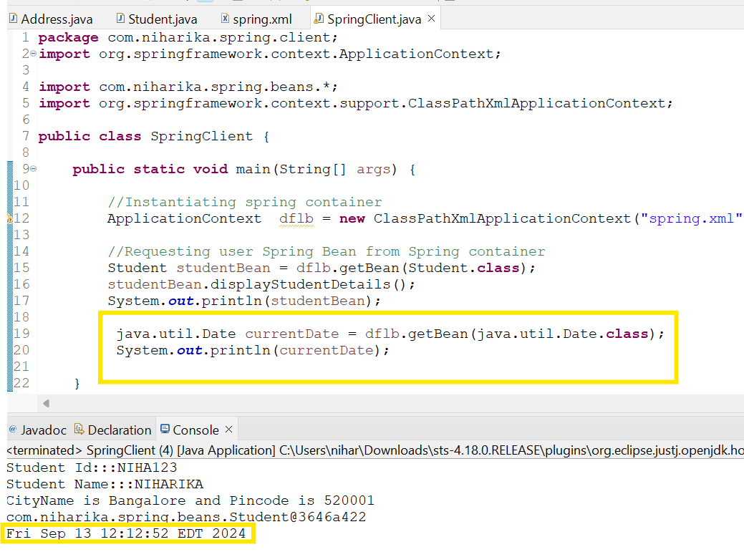

**Note: When we are working with JDBC, we will be configuring certain predefined classes as Spring beans**

**DriverManagerDataSource is one of pre-defined classes from spring JDBC library that has to be configured as spring bean**

**For a class, we can create n number of objects as we want.But if you configure the same class as Spring Bean, spring container will take care of it and will create only one object.**

**SESSION-17**

**Component Scan**

**Earlier in the spring applications that we created programmer has to mandatorily configure spring beans in xml file.But in the project as no of developers gets increased, they keep creating new Java classes and they will configure those Java classes as spring beans in xml file.Due to this length of spring.xml file gets increased and it becomes difficult to manage the xml file.**

**To overcome this problem,spring has introduced component scan feature.What does component scan feature tells is whatever the Java classes the programmer wants to represent as Spring Beans, programmer has to use certain annotations and Component scan will take care of creating beans and there is no need of configuring those Java classes as beans in any xml file.**

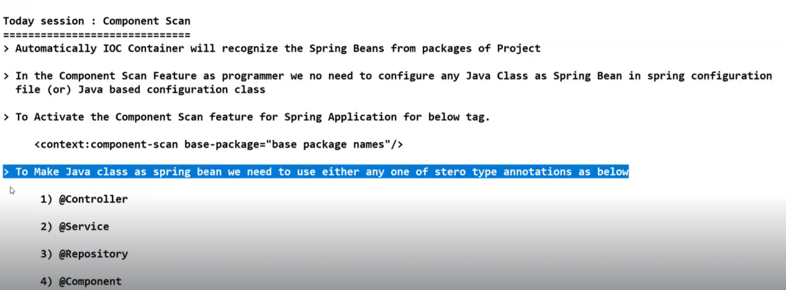

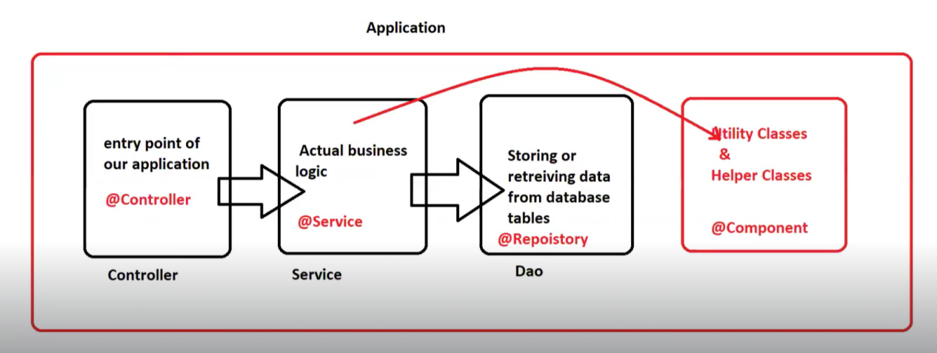

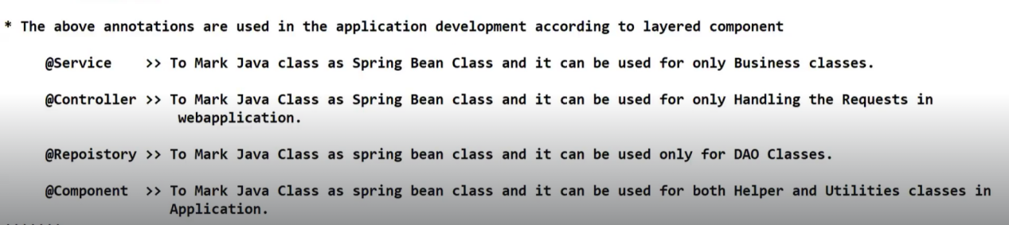

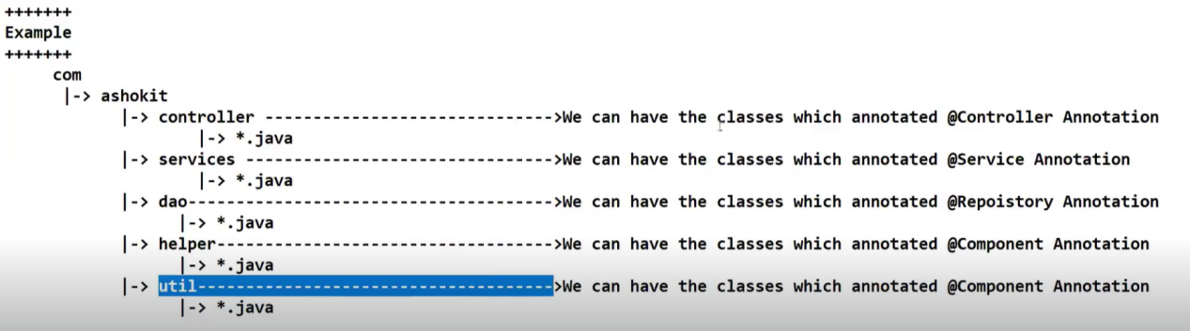

**The IOC container will start scanning from com.ashokit along with sub packages as well.**

**Controller, dao,services,helper,util…all these will come under sub-packages**



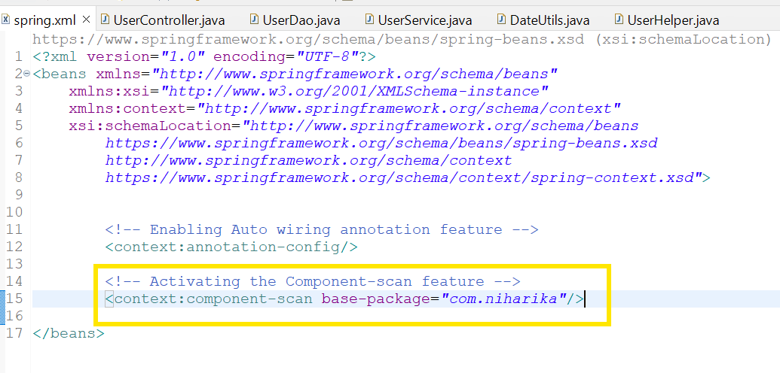

**@Controller, @Service,@Repository** and **@Component** == these annotations are present in **org.springframework.stereotype** package

Parent annotation for these annotations is **@Component** annotation

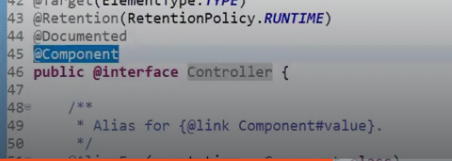

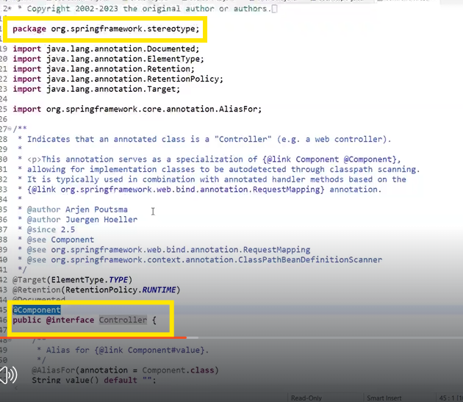

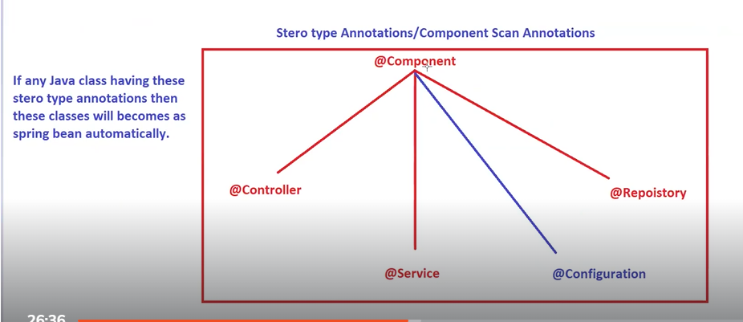

**Note: @Configuration annotation**  == comes under **org.springframework.context.annotation.**Parent annotation for this annotation is **@Component** annotation

**Interview question: Is @Configuration annotation comes under stereotype annotations or not?**

**Answer: No, annotations that comes under stereotype package are called Stereotype annotations. @Configuration does not comes under Stereotype annotations.**

**@Component is a generic annotation.It represents Java class as spring bean.If you want layer specific annotations, then you can go for @Controller, @Service,@Repository**

**Functionally working of all these annotations is same**

**Question: If any Java class is not configured with any stereotype annotation, then will it come under spring beans or not?**

Answer: No

**Question: Can we interchange annotations for layered components?**

**Answer: Yes we can. We can give @Service for Controller class and @Controller for Repository class and @Repository for any other layered class.**

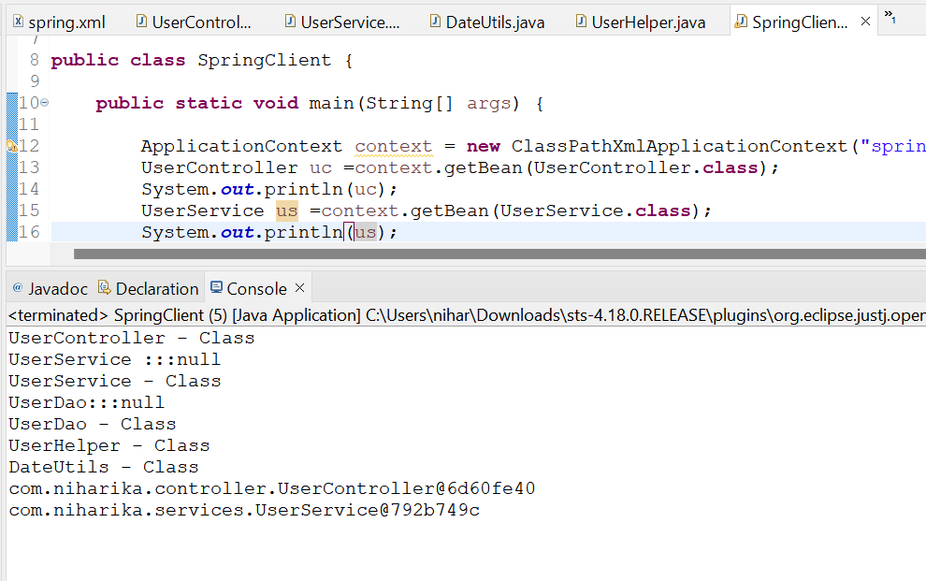

**In the above screenshot, service layer object not injected into Controller class. Dao class object not injected into Service class.**

**This is because we did not add the following annotation in our spring.xml file**

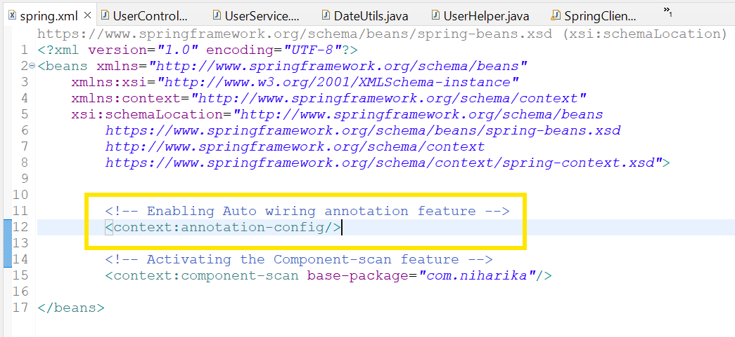

In real world base packages will be like com.hdfc, com.icici, com.illinois

**SESSION-18**

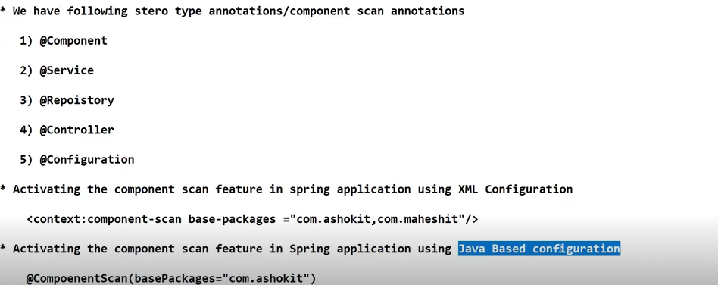

**@ComponentScan : Enabling the component scan feature to identify spring beans from base package**

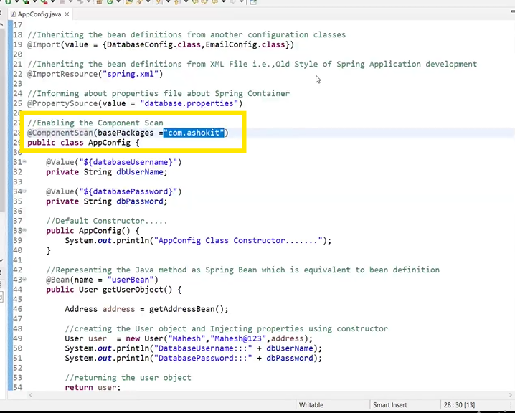

**Layered Architecture:**

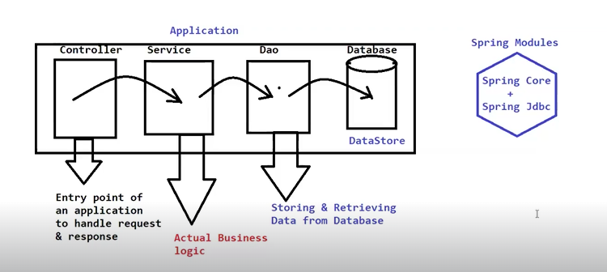

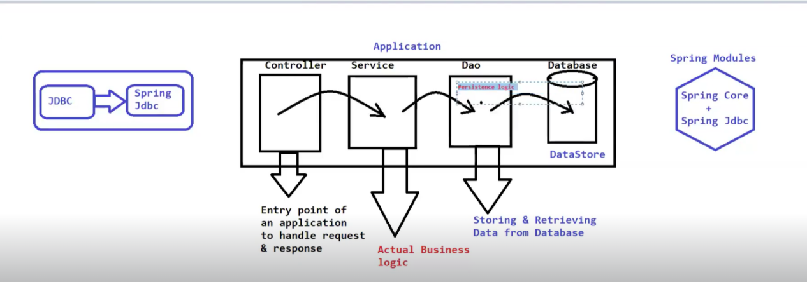

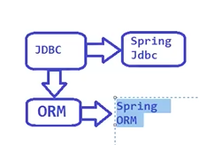

**Spring ORM is an extension of Spring JDBC.Spring JDBC module is an extension of JDBC.**

**ORM ==Object Relational Mapping. How we can map a Java object to Relational Database table**

**In normal JDBC , registering the driver and getting the database connection in the Java application ,Exception handling, resource clean up activity will be taken care by programmer.**

**To overcome above problems, Spring has provided some abstraction on above JDBC called Spring JDBC.**

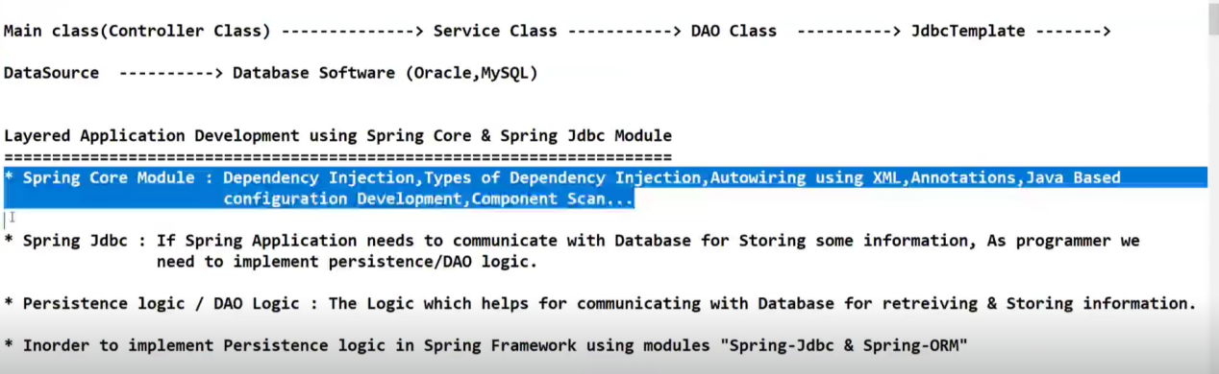

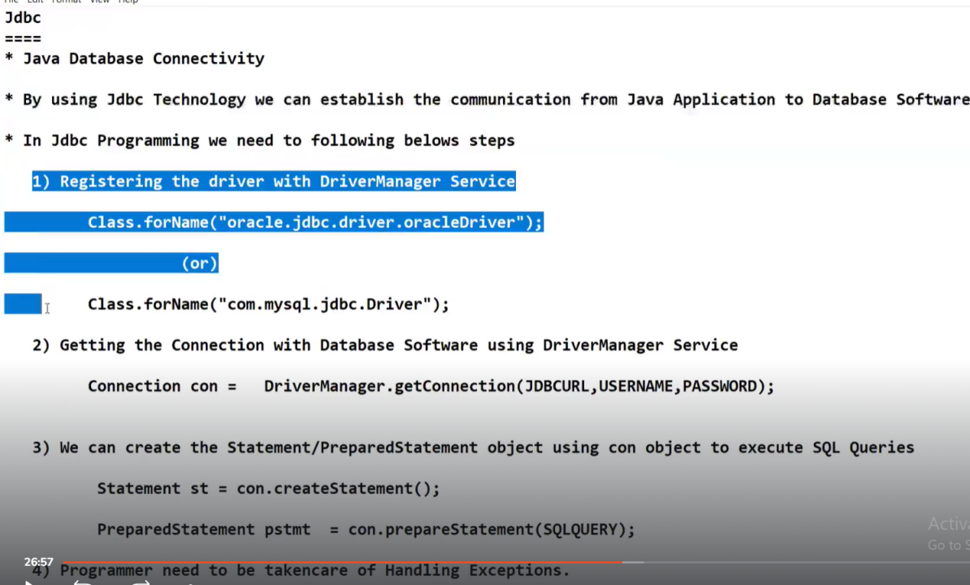

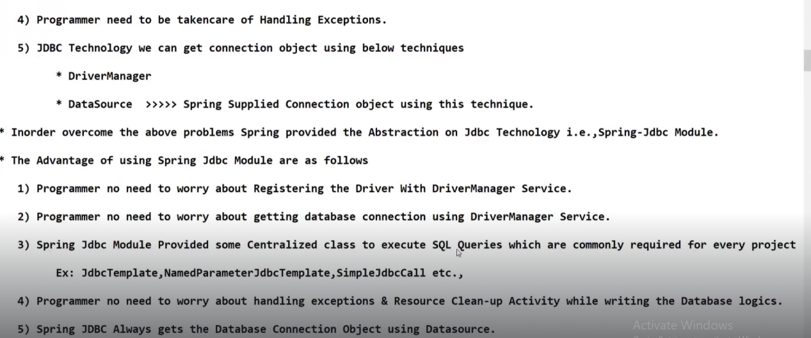

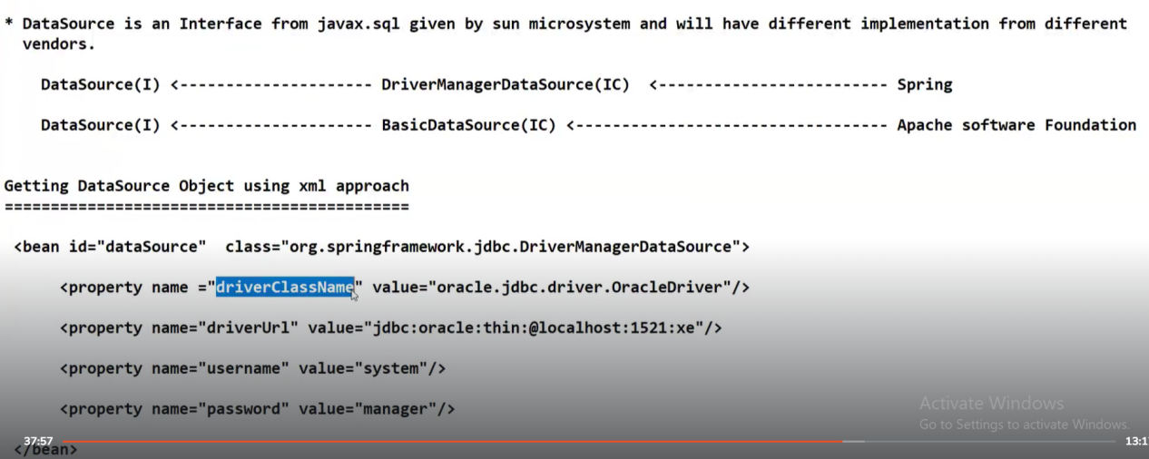

**IC means Implementation class.DriverManagerDataSource and BasicDataSource are the implementation classes from different vendors.**

**Using the above two implementation classes, we can obtain the database connection objects in the spring application.**

**We have to configure the datasource object as a spring bean in xml file and keys are fixed.You have to follow the case-sensitive rules for the keys.**

**DriverManagerDataSource is a one spring bean class which is having four simple properties**

**“driverClassName”, “driverUrl”,”username”,”password”**

**When we configure the above four properties, spring will take care of getting connection with the targeted database.**

**If our targeted database is Oracle server, then we supply oracle related information as values.**

**How to represent DriverManagerDataSource as Spring bean in Java based configuration?**

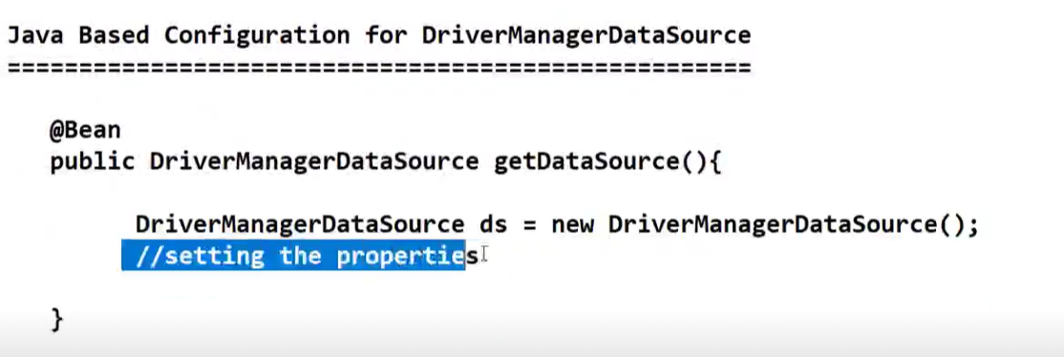

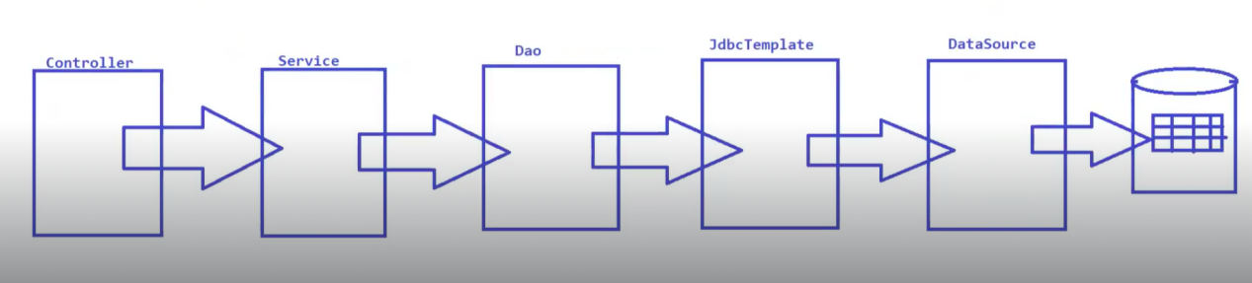

**JDBC template needs data source object.By using Setter injection, we can inject datasource object into JDBC template bean.**

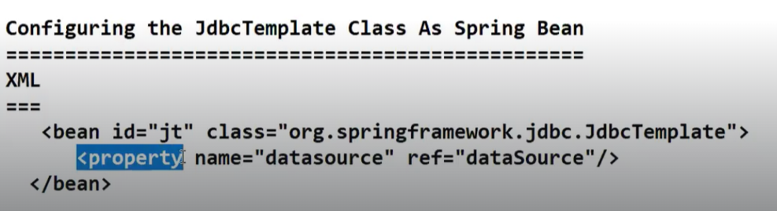

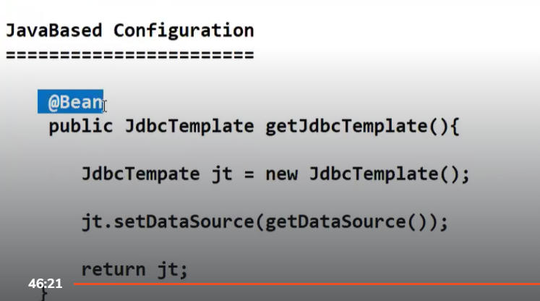

**SESSION-19**

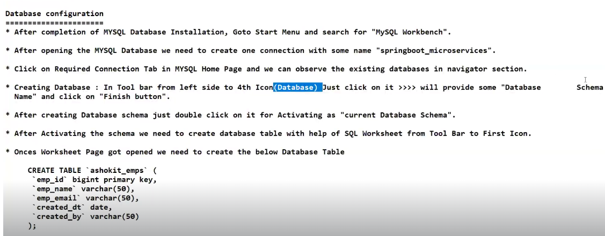

create table `niharika\_emps`(

`emp\_id` bigint primary key,

`emp\_name` varchar(50),

`emp\_email` varchar(50),

`created\_dt` date,

`created\_by` varchar(50) );

**Ctrl A(for selecting all lines) + ctrl shift F ( for formatting)**

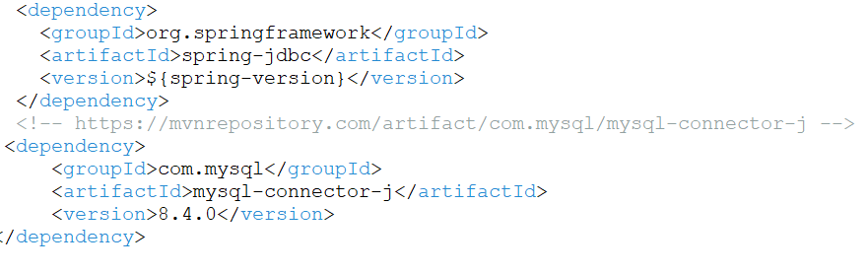

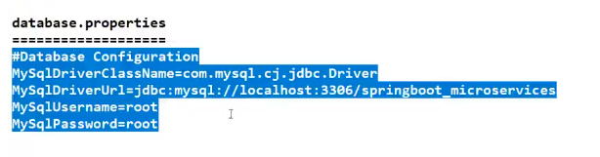

**SESSION-35**

**SPRING DATA JPA**

**SESSION-36**

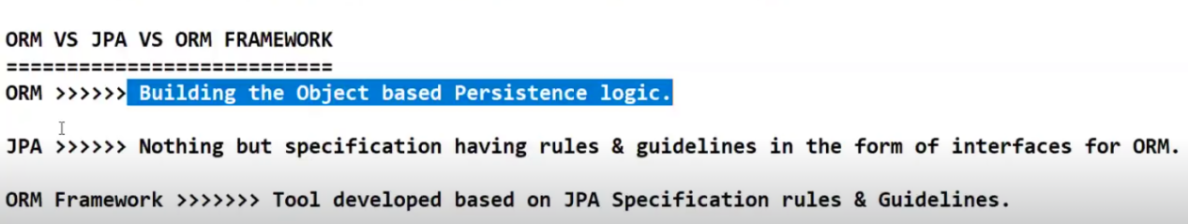

**We have different ORM tools like Hibernate from RedHat corporation, JPA from Sun Microsystems, Ibatis and JDO from Oracle corporation.These are different ORM tools coming from different vendors.**

**SunMicrosystems has given root interface in JPA specification and implementations will be provided by vendors.**

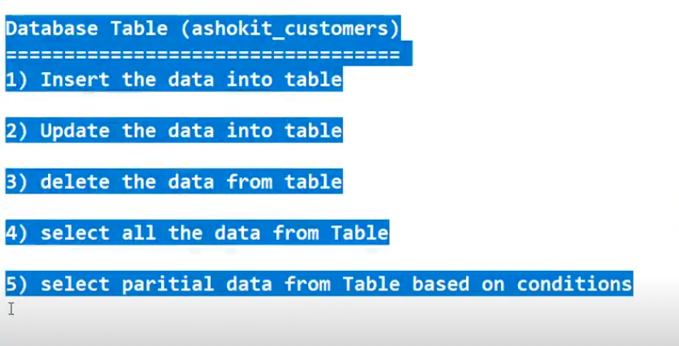

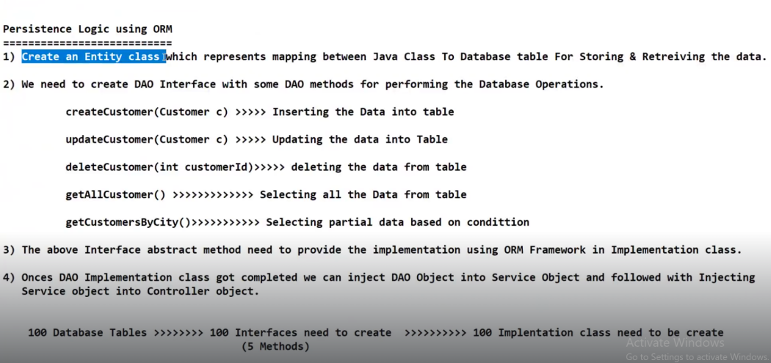

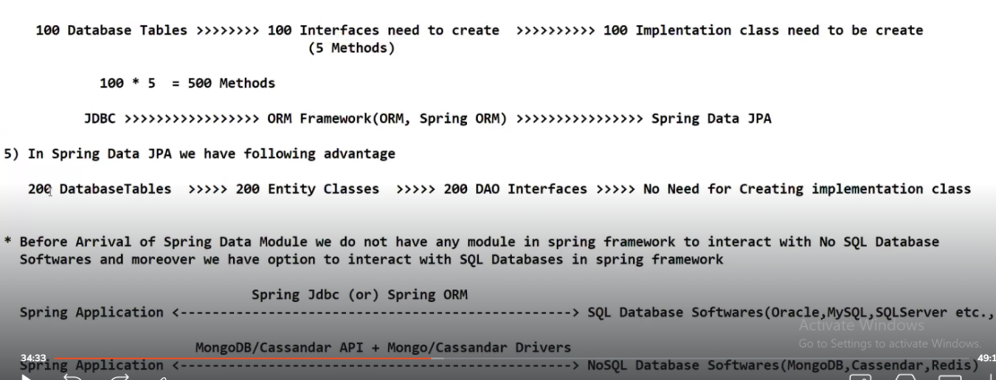

**In Spring Data JPA, there is no need of creating implementation classes.Spring Data JPA will take care of providing implementation classes for created DAO interfaces at run time**

**Developer no need to write logic for creating , inserting,deleting data**

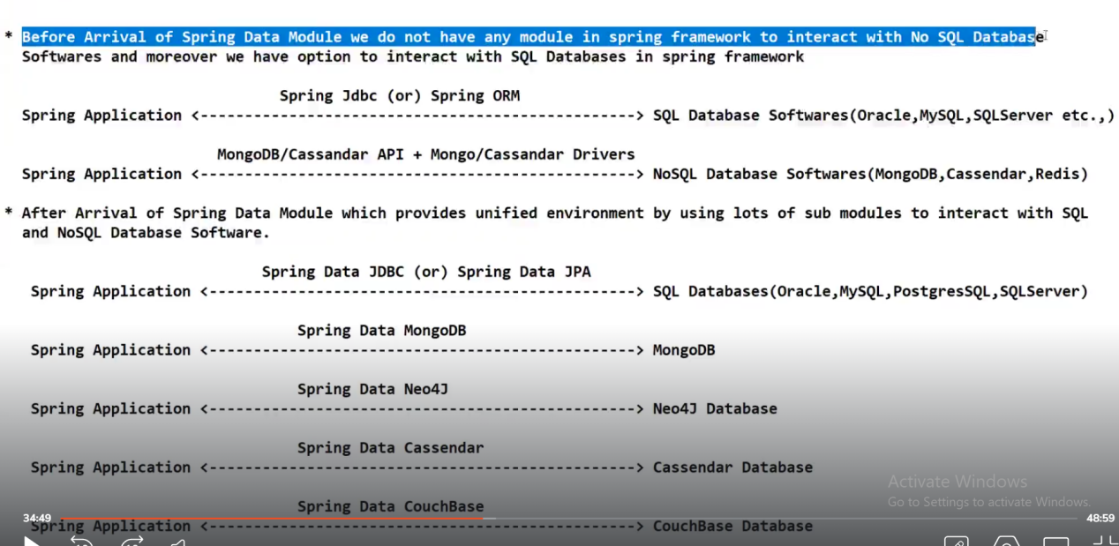

**Before arrival of Spring Data Module,if Spring Application wants to communicate with NoSQL Database software means(MongoDB, Cassandra or Redis) , developer has to get those libraries explicitly from database vendor itself to provide connection between Java application to NOSQL database.**

**Spring Data JPA, Spring Data MongoDB, Spring Data Neo4J, Spring Data Cassandra, Spring Data Couchbase are sub modules of Spring Data module.**

**Spring Data module is a sub module of Spring module.**

**Relational Database means SQL database, Non Relational Database means NOSQL database.**

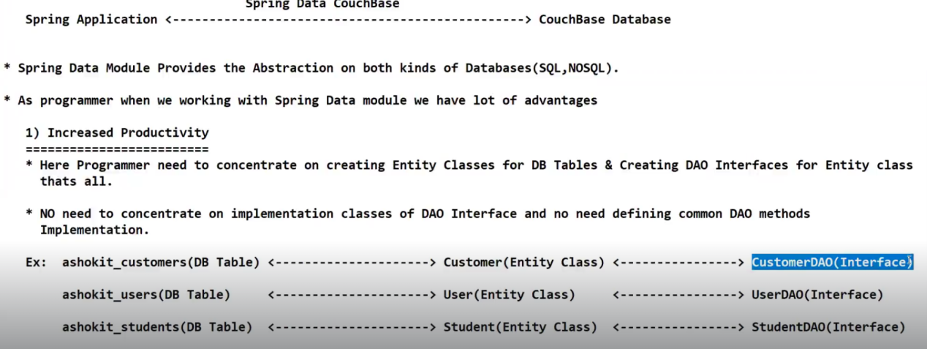

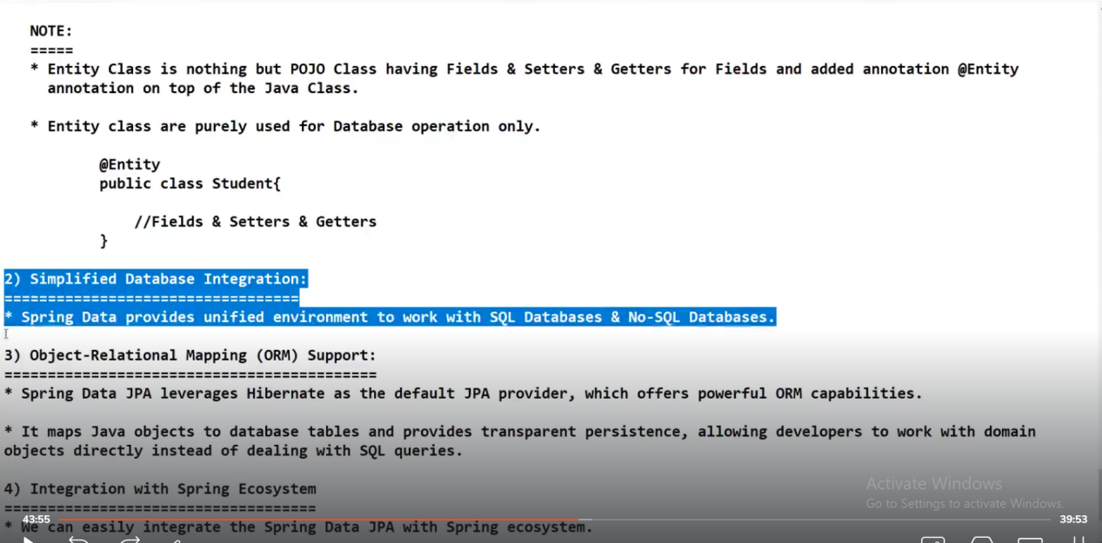

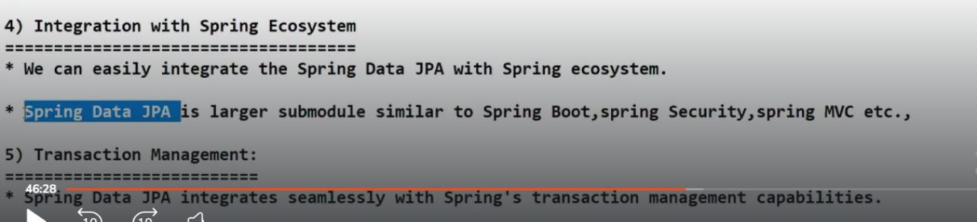

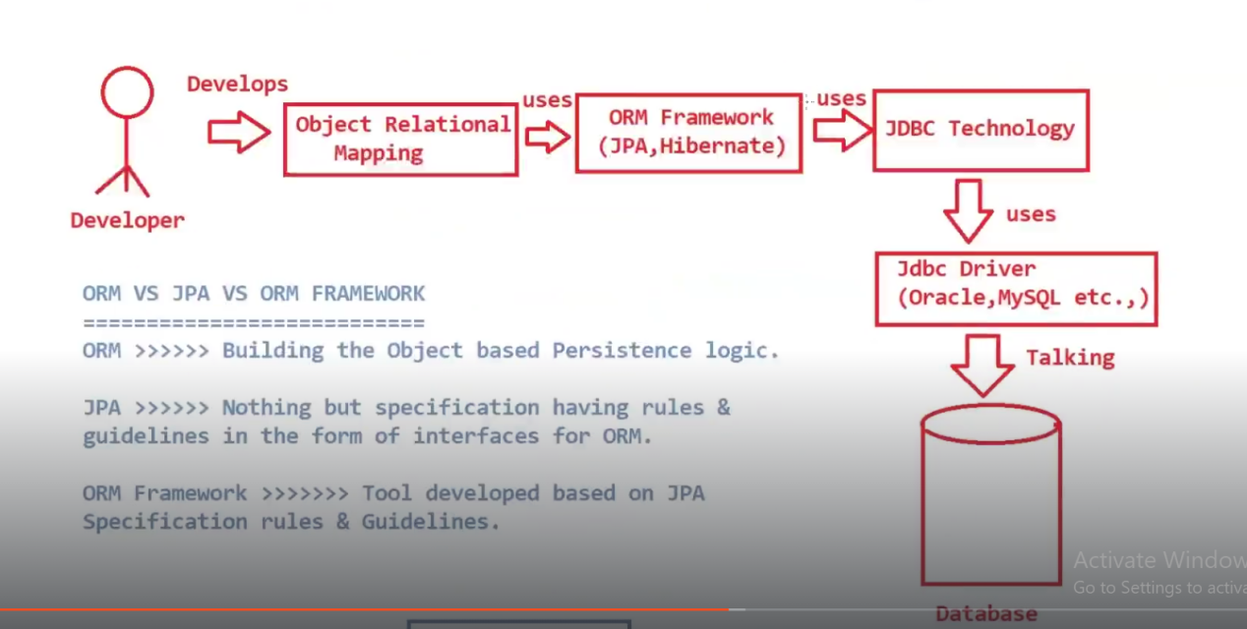

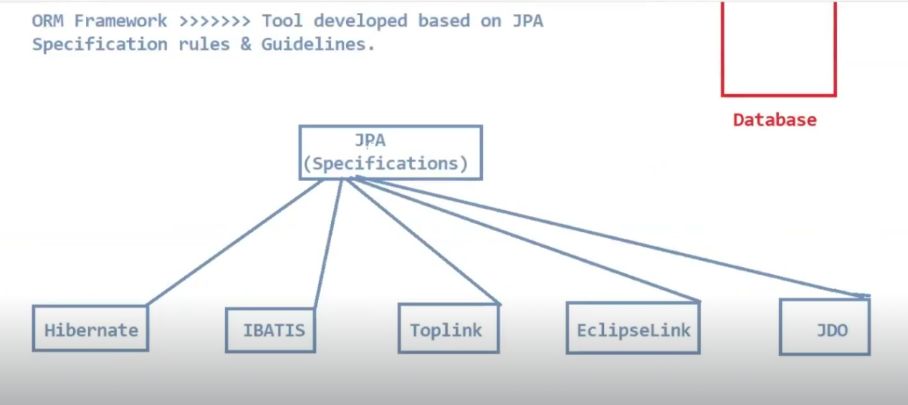

**Transaction Management: If you are having 10 SQL statements within a transaction, that transaction is said to be successful only if all those 10 SQL statements are executed successfully.**

**If anyone of the SQL statement is failed, then automatically it gets rolled back.**

**This is called Everything or Nothing Principle.**

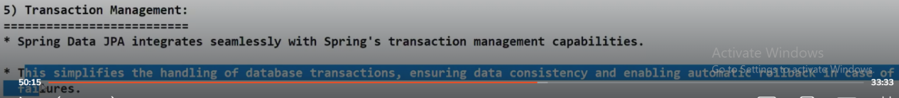

Difference between Hibernate and Spring Data JPA

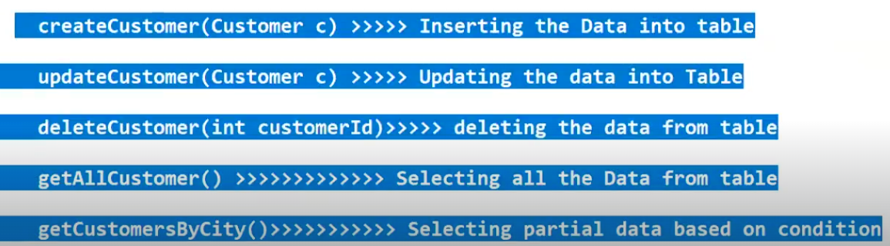

**The above methods are common DAO methods required for every Database table.**

**In Spring data JPA, we don’t have to provide Implementation classes where as in Hibernate we need to provide implementation classes and we need to also provide common DAO methods implementation as well.**

**How can you enable second level caching in Hibernate? ---Famous Interview question**

**SESSION-37**

**By using Spring Data JPA, we can work with only SQL or Relational Database software.We cannot with Non relational Database like Mongo DB.**

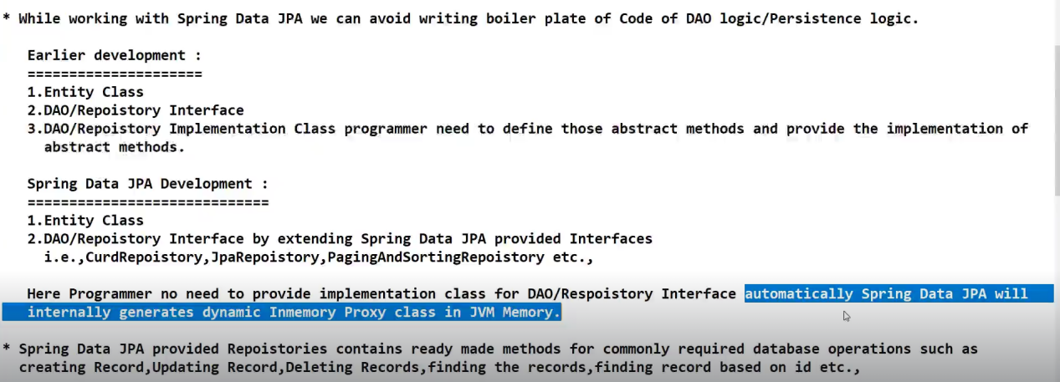

Cloneable and Serializable are Marker Interfaces in Java.Marker Interface does not have any methods in then.These two interfaces does not have any abstract methods in them but they provide some additional capability to objects like Cloning and Serialization

Repository is also a predefined Marker Interface in Spring Data JPA library.Repository also does not have any abstract methods in it but it provides some additional capability to DAO objects.

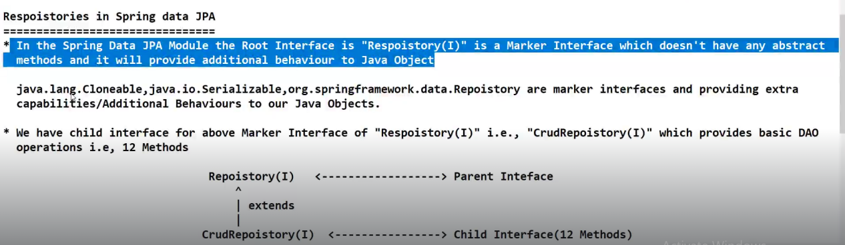

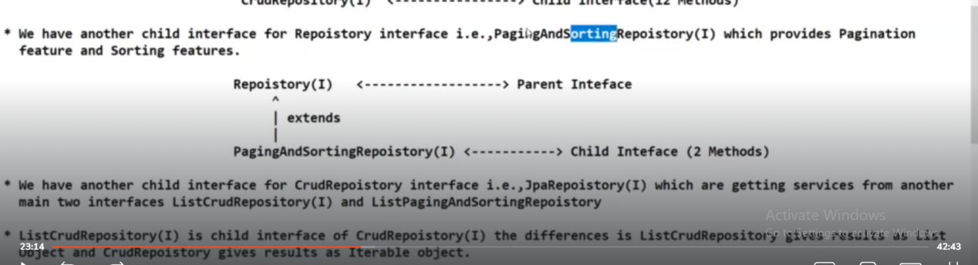

**Ctrl+Shift+T == open a pre-defined class from library**

**Ctrl+O == To get list of methods available in a Interface or a class**

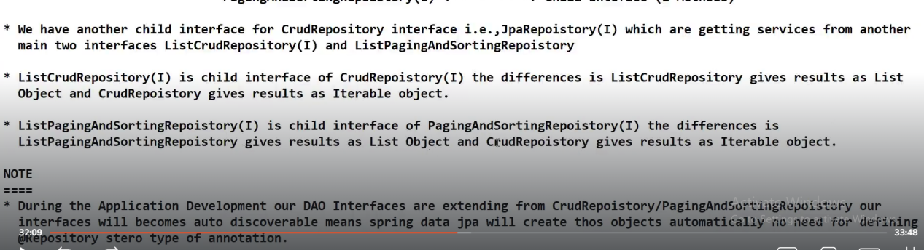

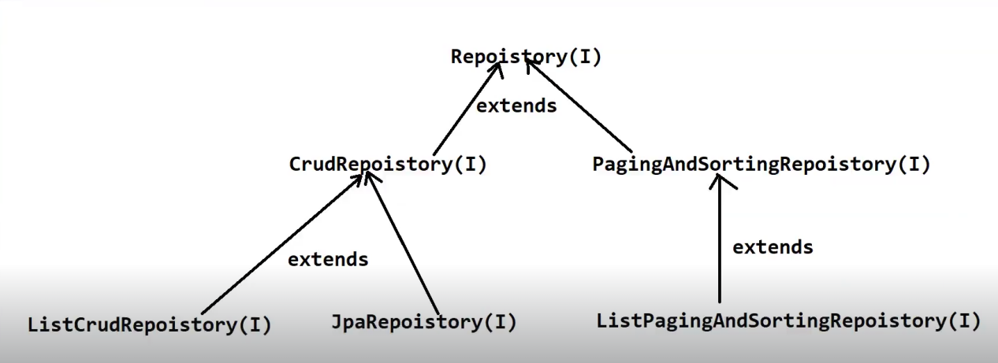

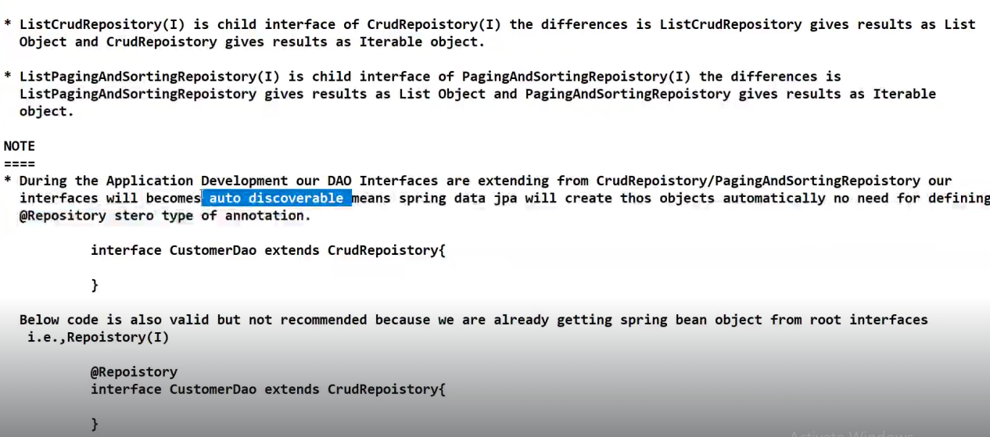

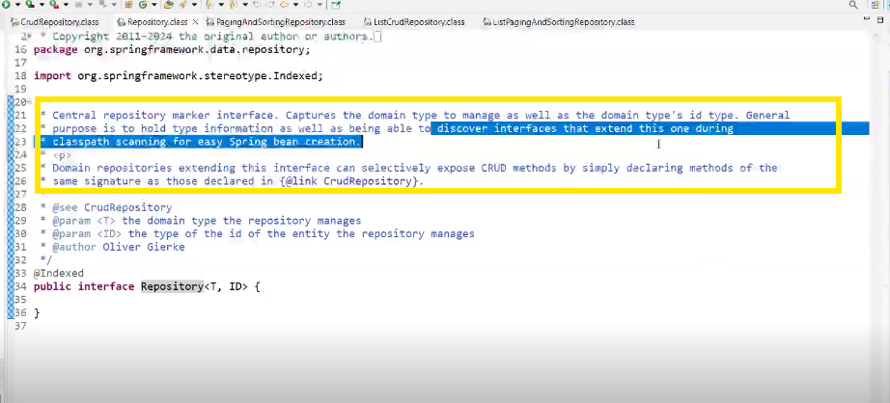

Default username of Oracle software is **system**

Password that use give during installation will be password

**Latest version of Oracle will take 30 GB of memory and its not recommended to install.There is a light weight version of Oracle software that you can install even though its old.**

**SESSION-38**

**Oracle username: system**

**Oracle password: York@222**

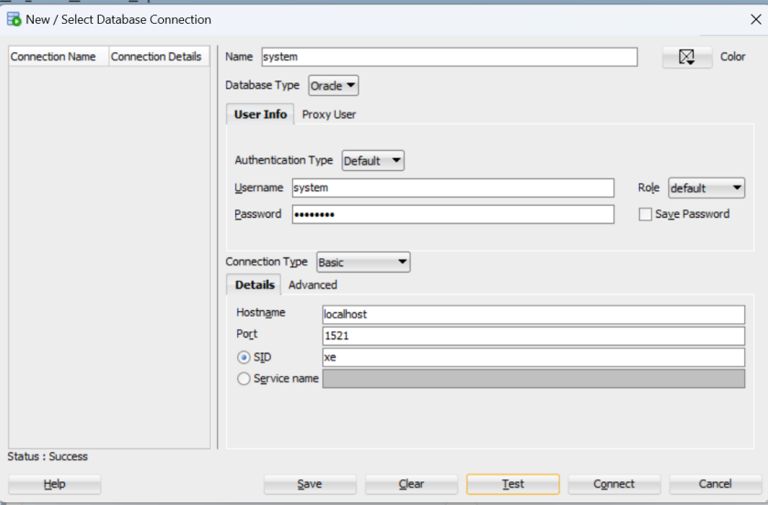

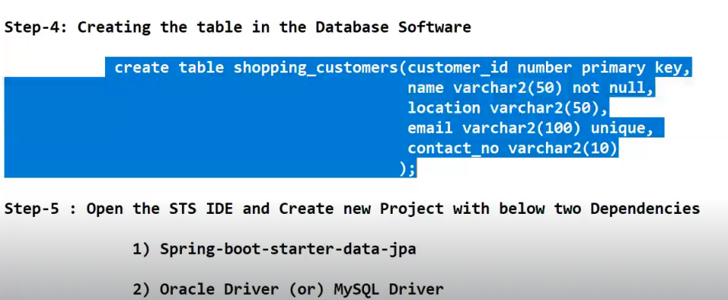

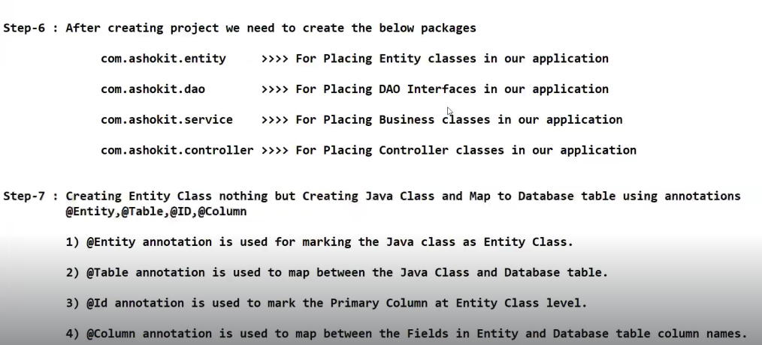

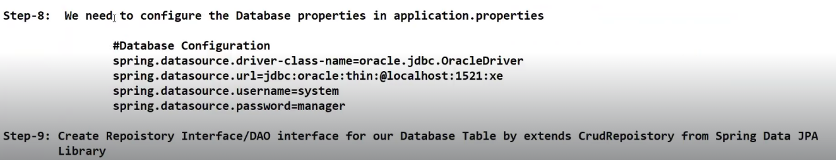

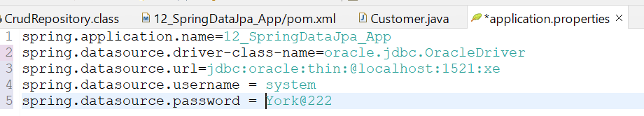

Java application wants to communicate with Oracle database using Application level protocol.

**jdbc:oracle:thin == these are application level protocols. They help us to provide connection from Java application to Oracle database using thin driver. thin represents pure Java driver**

**Since we have database on our own machine, we are giving local host.If database resides on remote machine, then we have to give IP address of that remote machine.Oracle database listener port number is 1521. xe is Global name(Xpress Edition)**

**Every database version will have some logical space**

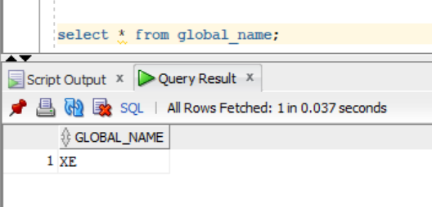

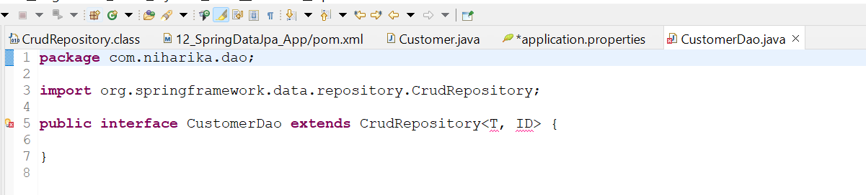

**When CustomerDao extends CrudRepository , we need to provide that this CRUDRepository is for which entity class and what would be the data type of the primary key column of the table.Based on these inputs Spring DataJPA will create an implementation class and provide implementation of those 12 abstract methods that are present in CRUD repository interface at runtime.** 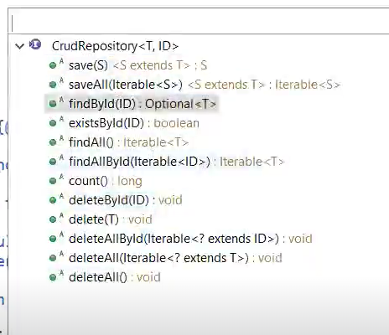**12 methods**

**@Repository annotation is optional because CRUD repository is internally having a Autodiscoverable feature to represent CustomerDao interface as a spring bean.**

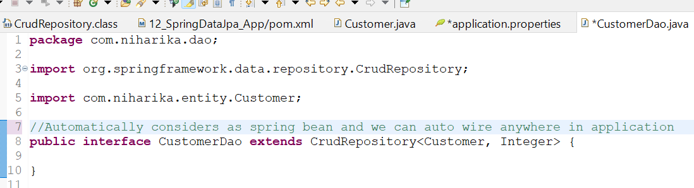

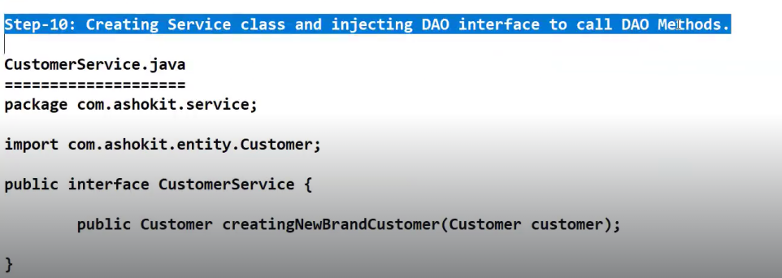

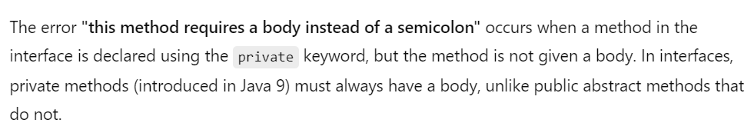

**Whenever you are auto wiring interfaces, it is going to inject the implementation class internally.**

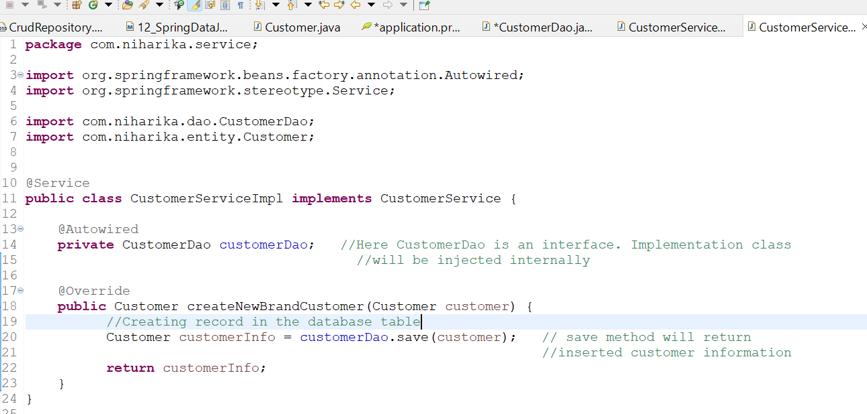

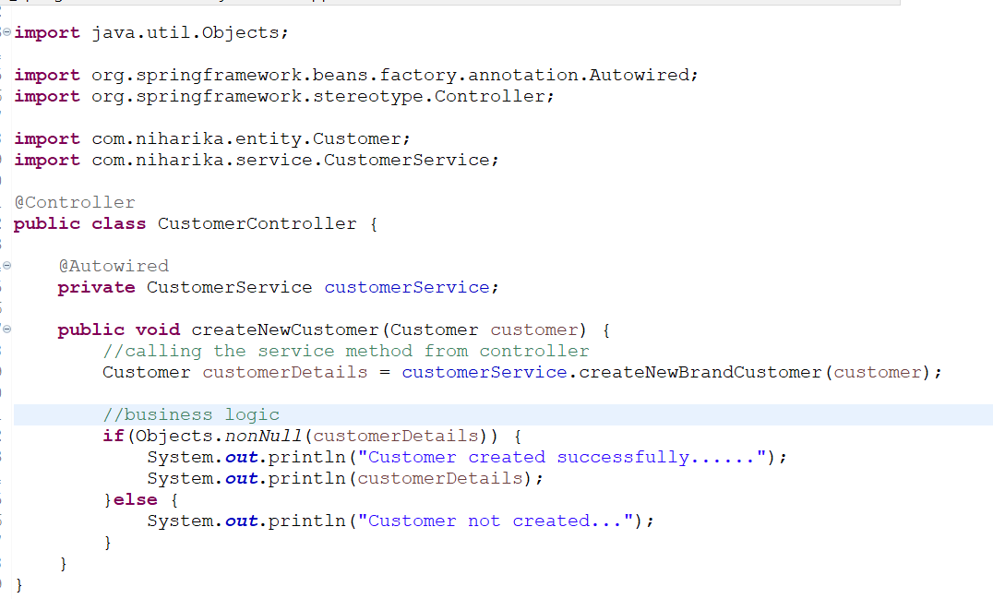

**Objects.nonNull() method internally checks if object is null or not. It is a utility method.**

**Whenever you want to check a Not Null condition , its better to use this utility method.This is one of the best coding practice.**

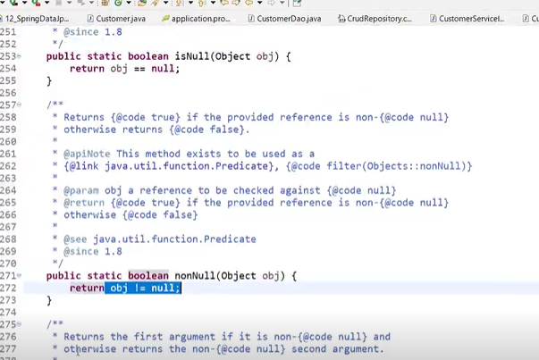

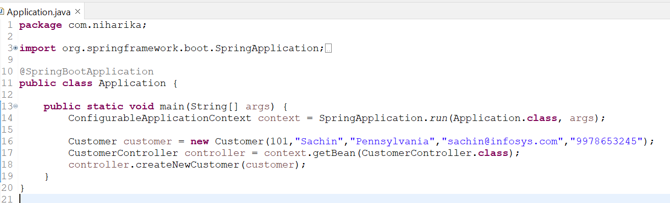

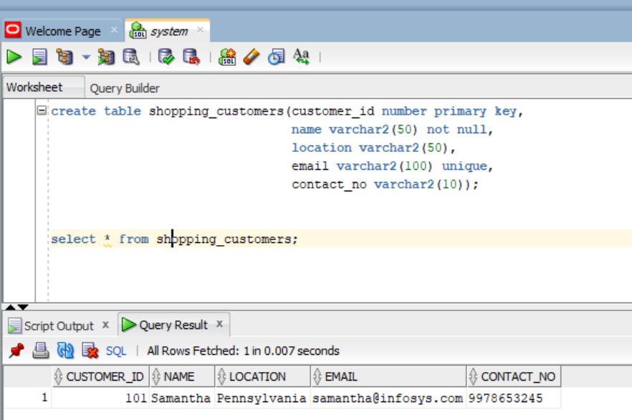

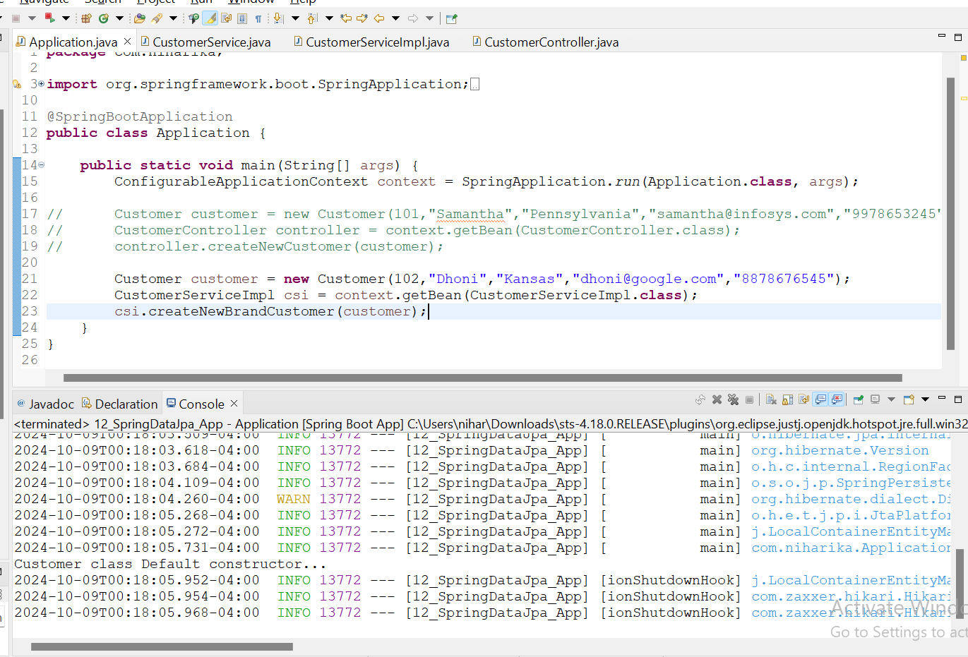

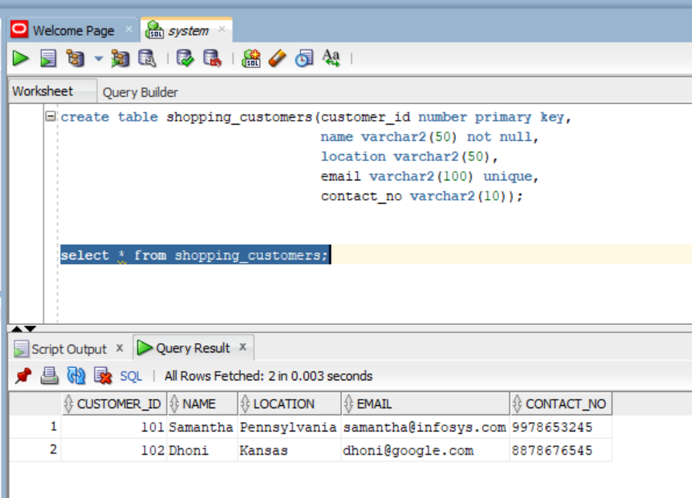

**SESSION-39**

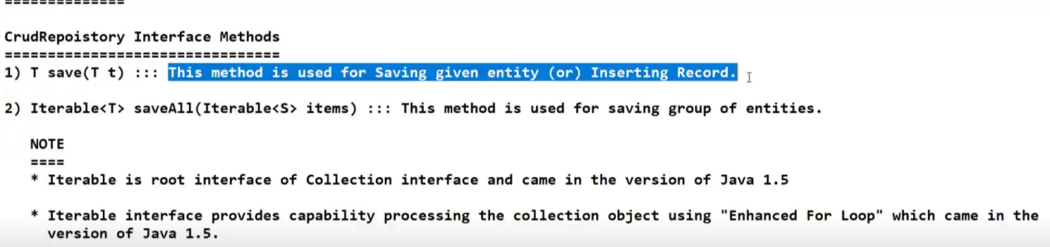

**T is typed parameter.**

Typed parameter means it can be of anything.It can be of Integer or String or Customer or anything

In Java 1.5, they introduced one important feature called **Enhanced For loop.They want to make this enhanced for loop feature applicable for all collection related classes. Therefore they made Iterable Interface as root interface for all Collection interfaces**

**Ctrl+1 ===>Assign statement to a new local variable**

**Place cursor at end of line customerDao.saveAll(customers) and you will get suggestions**

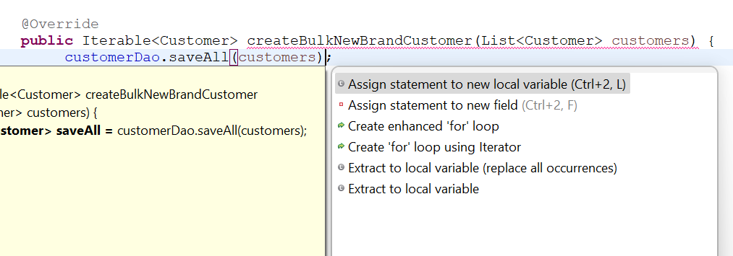

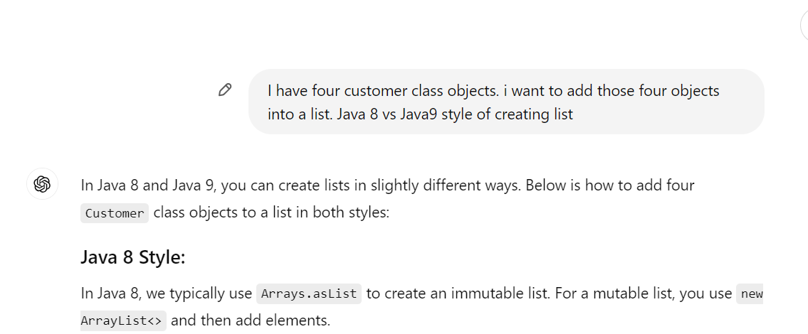

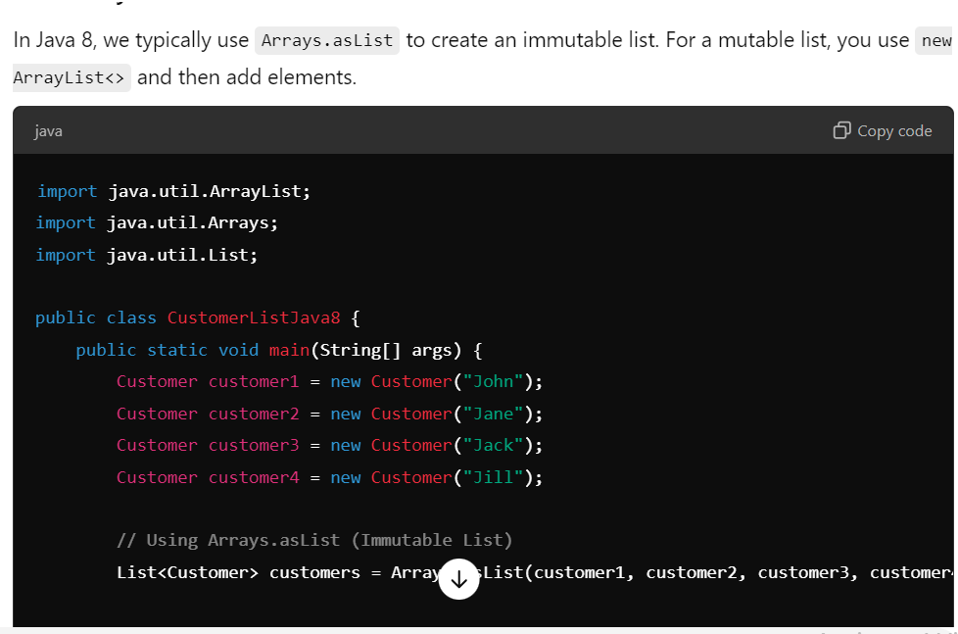

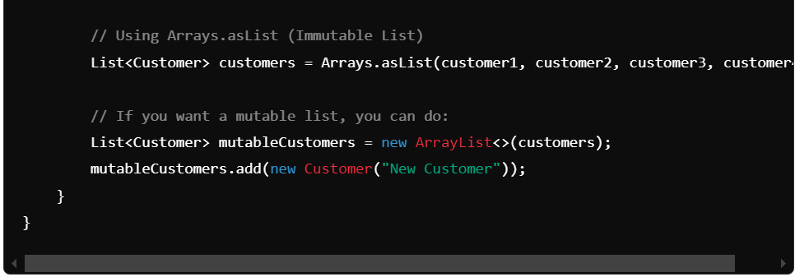

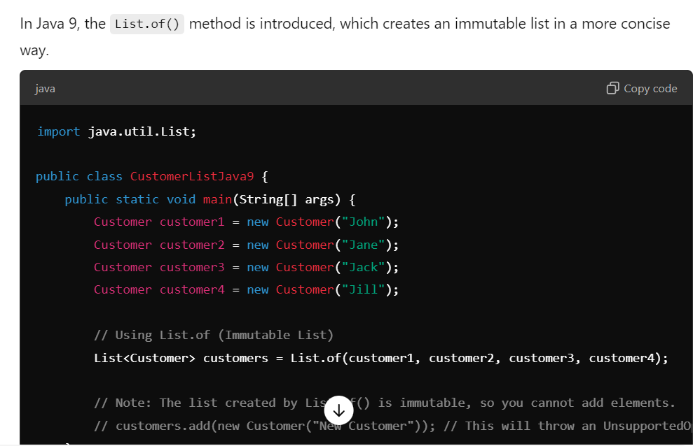

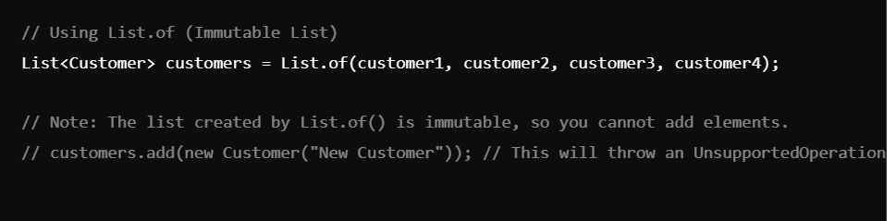

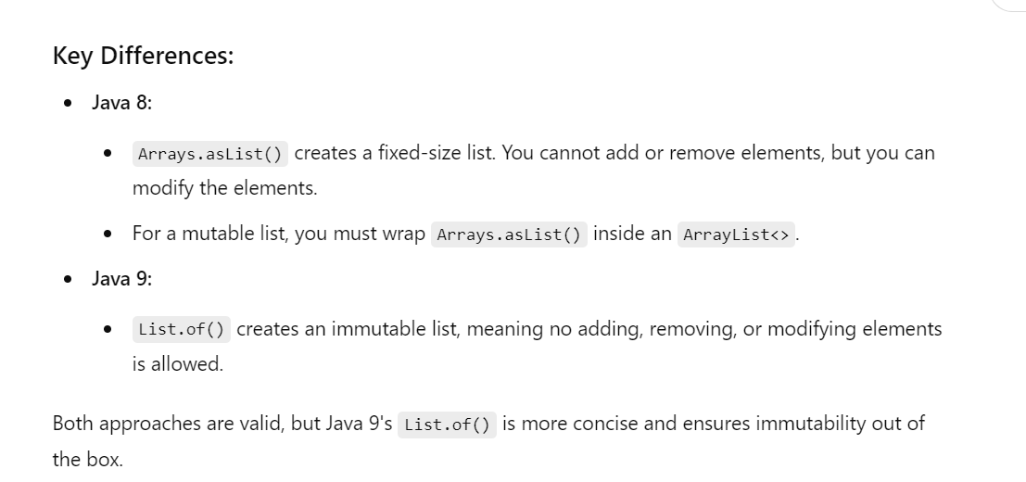

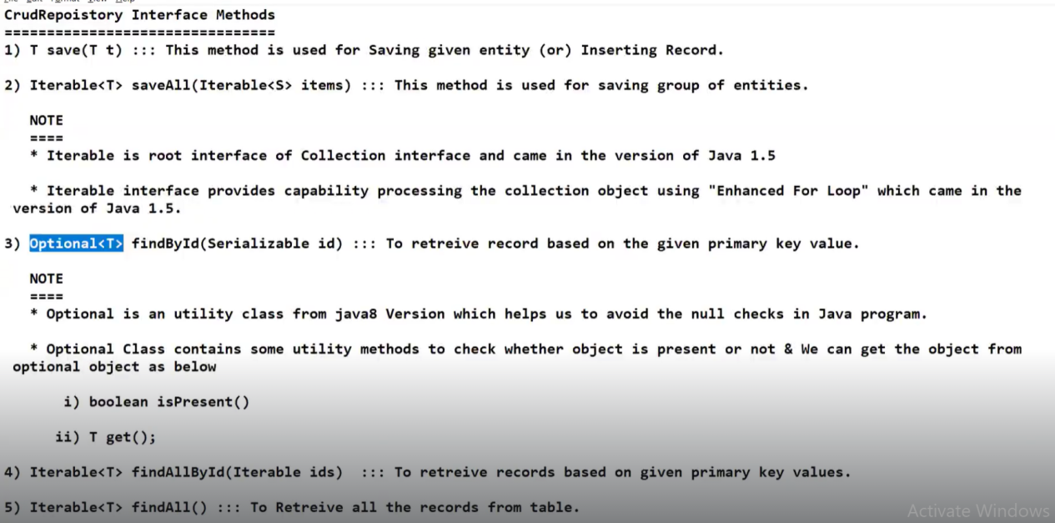

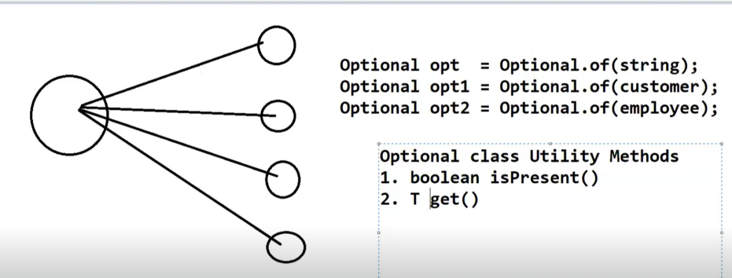

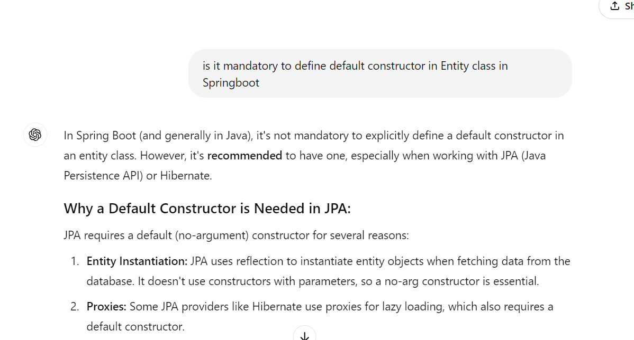

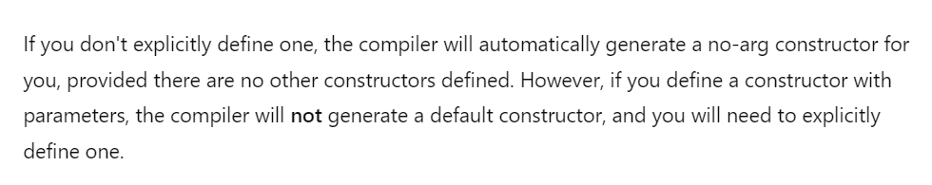

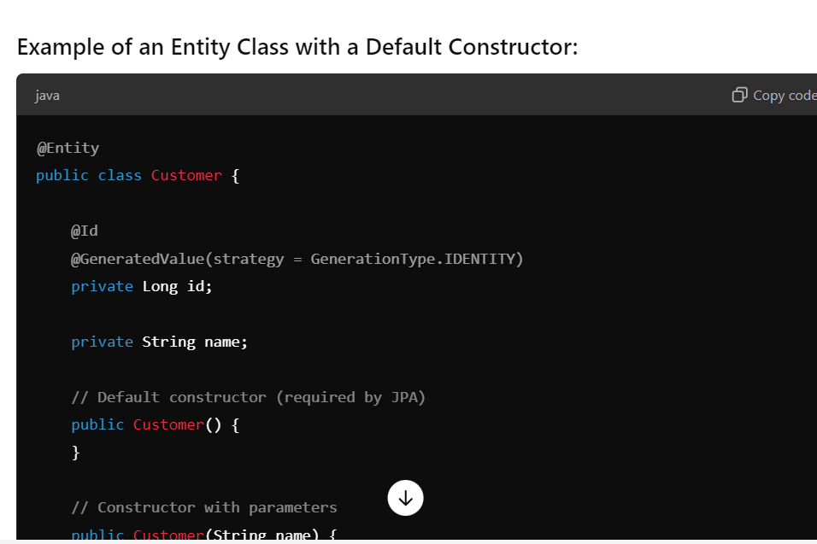

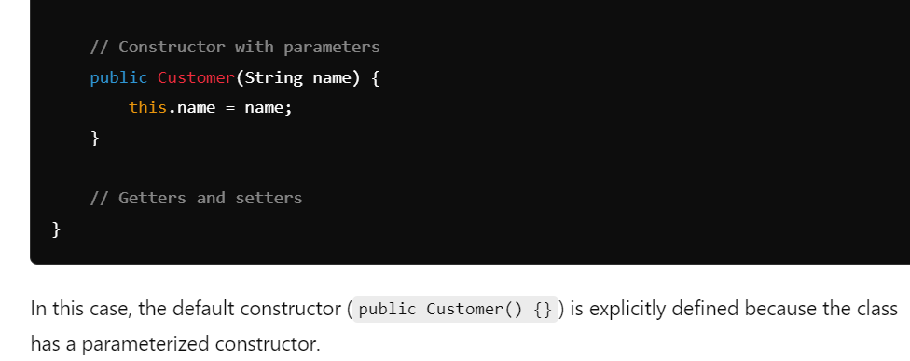

When you delete based on Entity, we should always pass the primary key in Entity that is to be deleted.Instead if you pass other attributes like name, city that are not primary, deletion will not happen.

**SESSION-40**

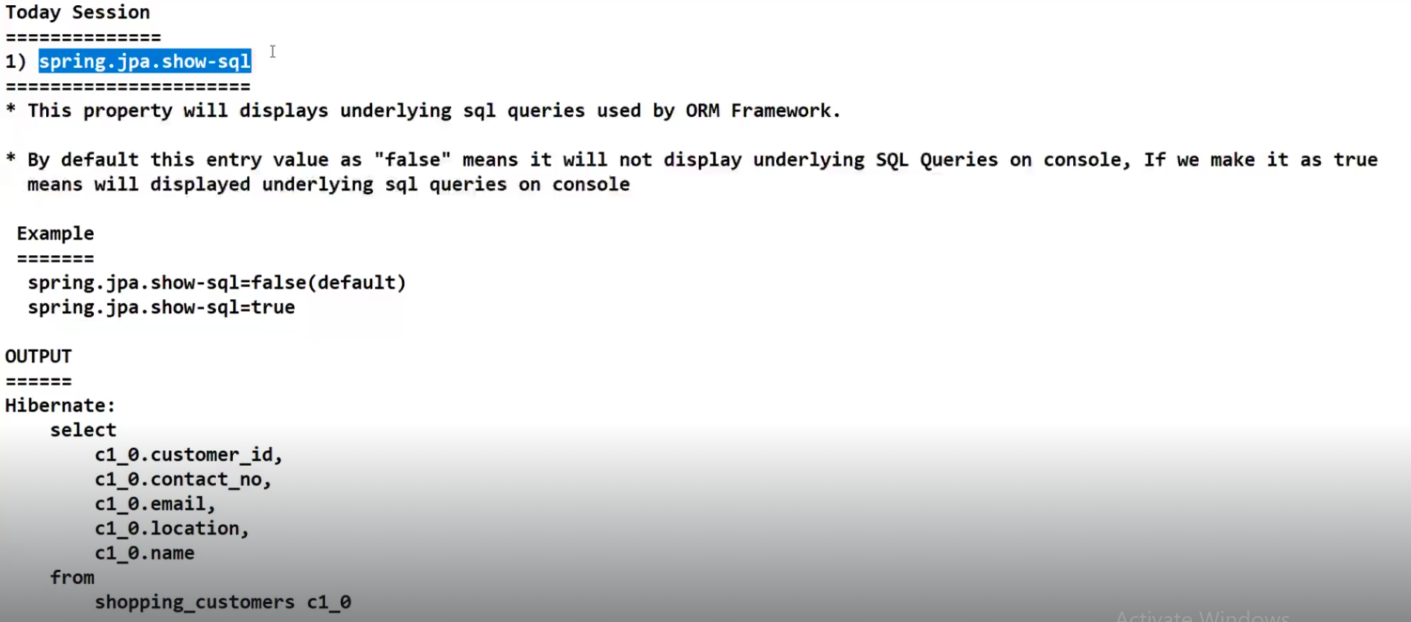

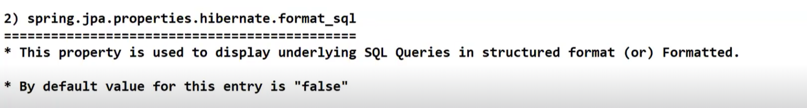

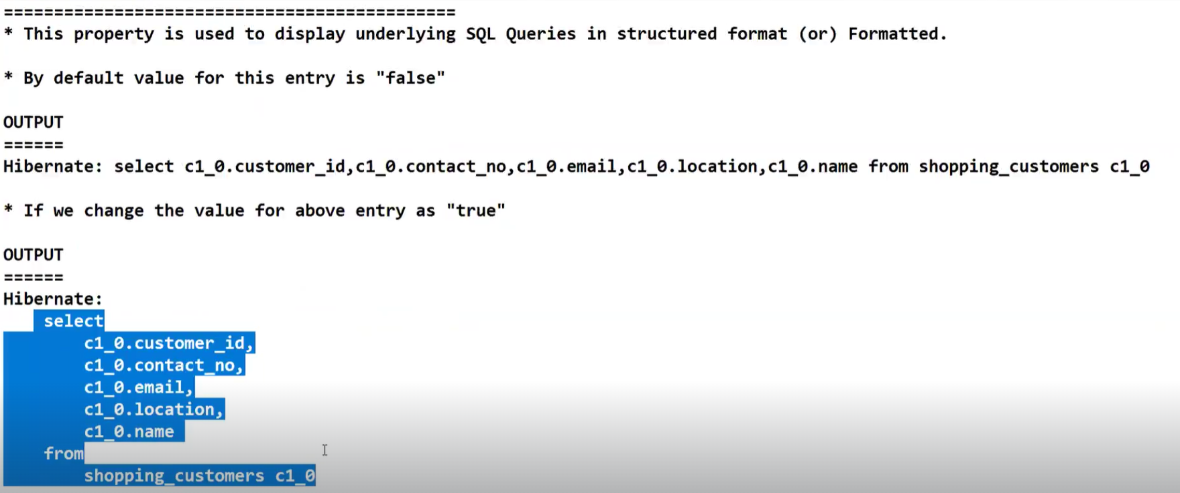

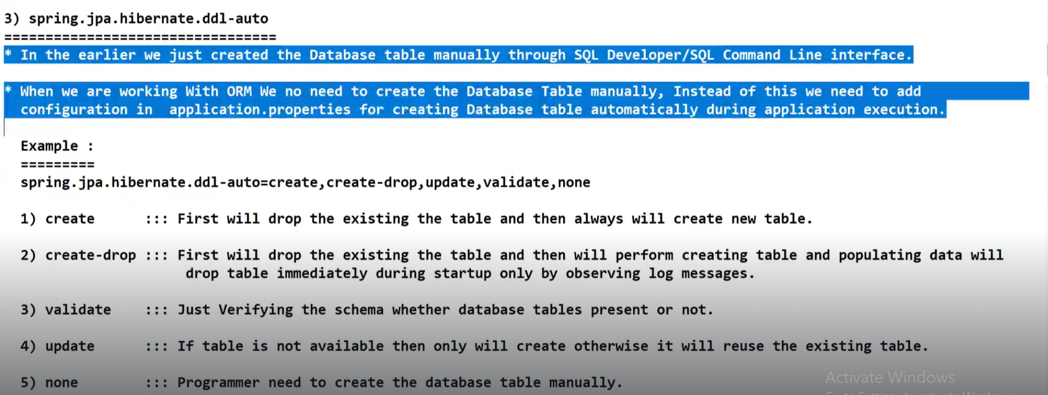

When we use **create,**

It will first drop existing table and then will create new table and then insert records

For example, yesterday in your table there are 6 records.Today you are inserting 3 more new records.If we use spring.jpa.hibernate.ddl-auto = create, it will first drop table and that means those existing 6 records are also deleted.And then it creates new table and inserts 3 new records.Therefore we have only those new records which are three.We don’t have previous 6 records.

When we use **update**,

It will first check if table is present or not.If there is no table present, then it will create new table and insert records.If table is already present, then it will directly make use of that table.In this way as per above scenario, we will have total 9 records.It will add new records to already existing records in the table.

**If we add a new column in the entity, then even that column will get updated at the table side.**

When we use **create-drop**

It will first drop existing table.Then creates new table, inserts data into that table and then drops that table.By end of the application, we will not have any table in database.

**Create and create-drop are mostly not recommended for real time applications**

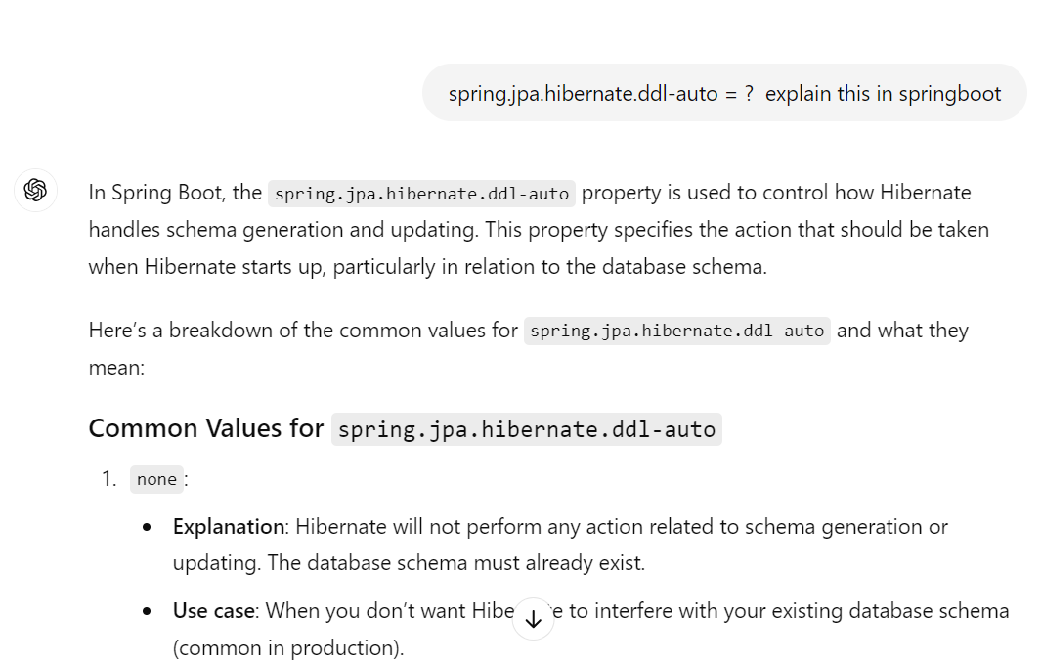

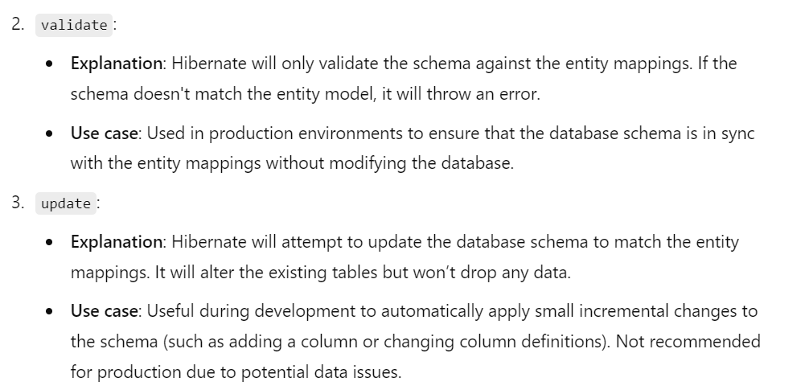

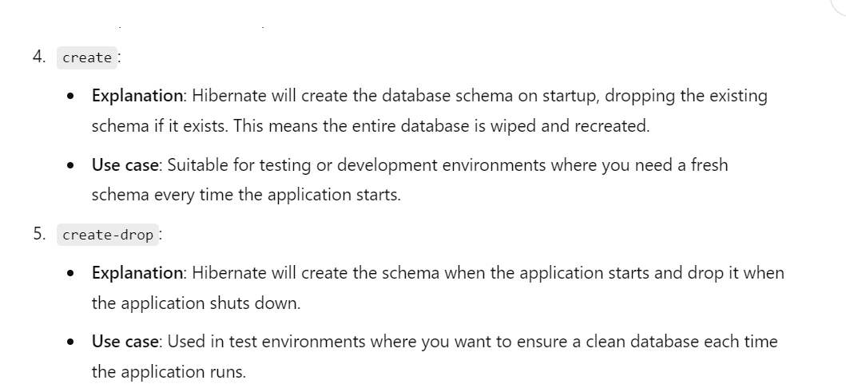

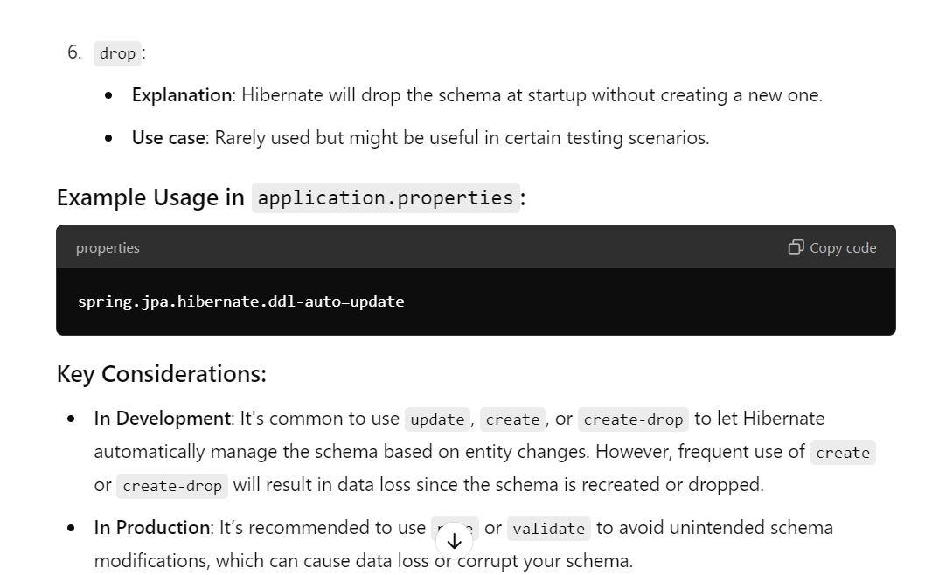

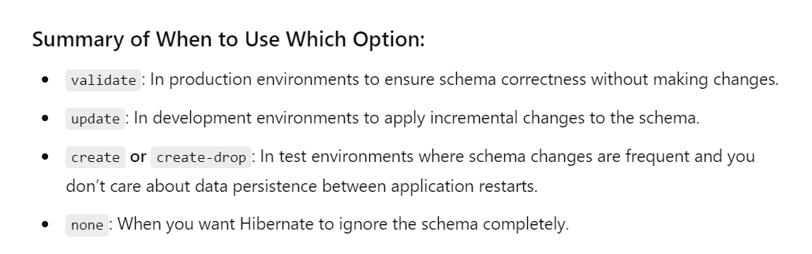

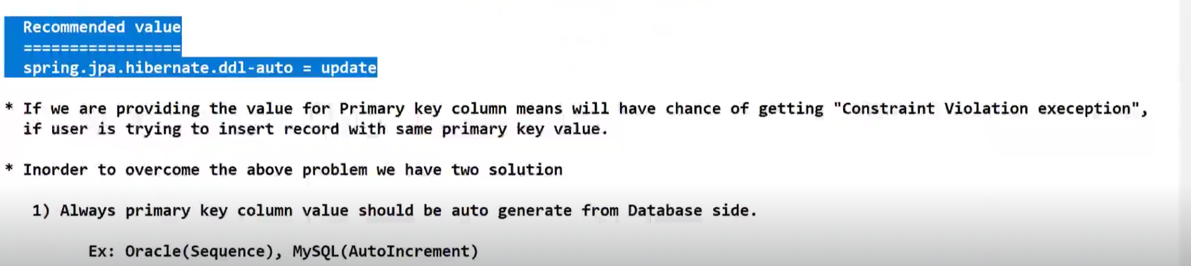

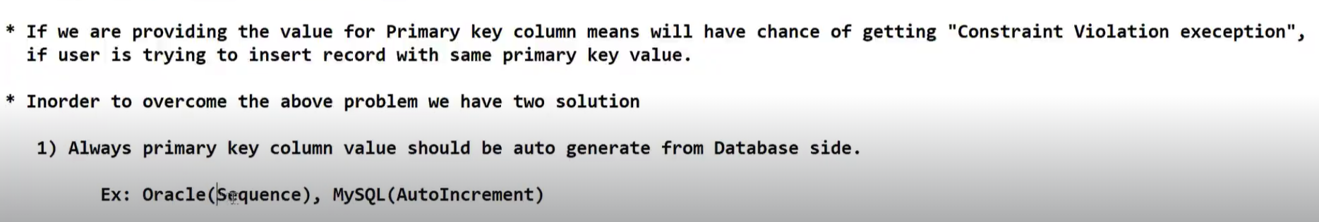

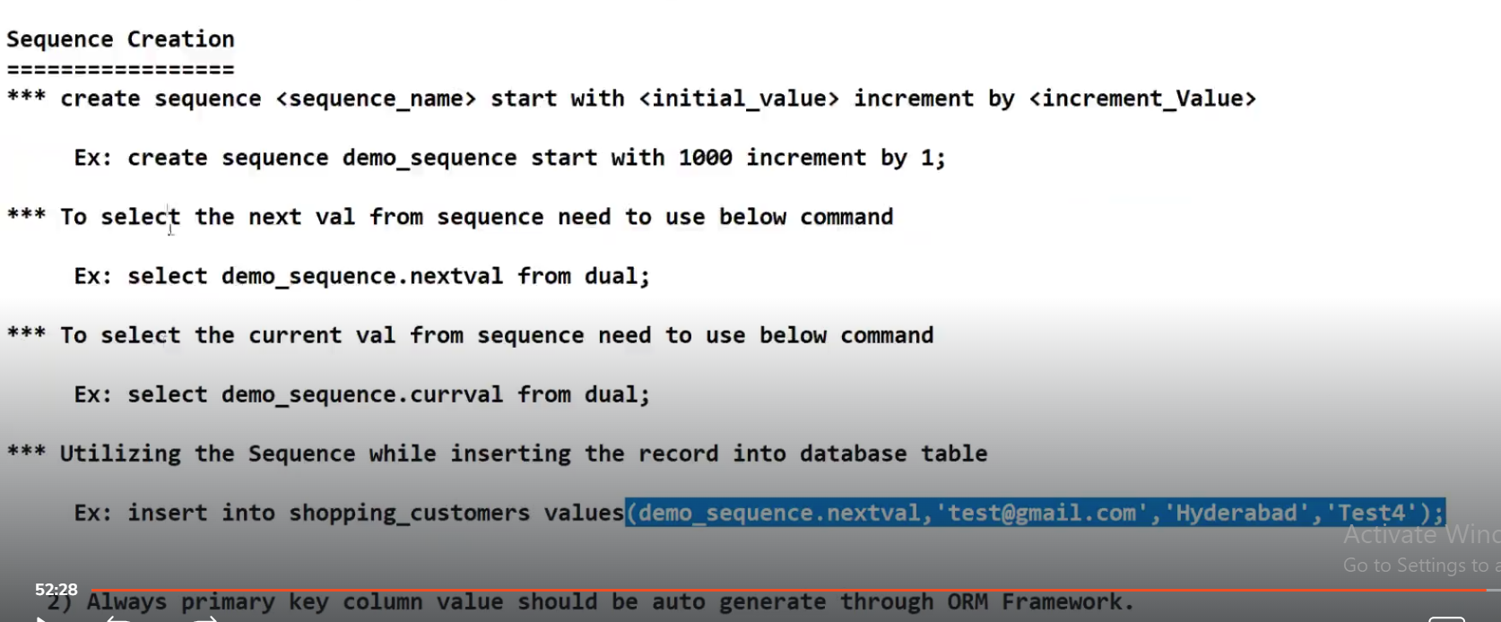

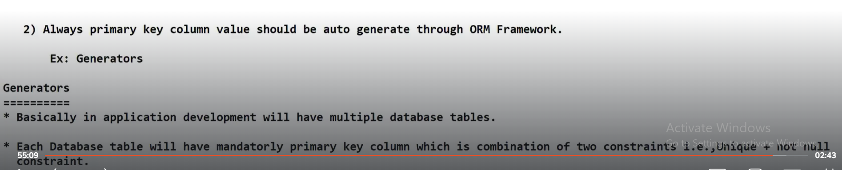

**SESSION-41**

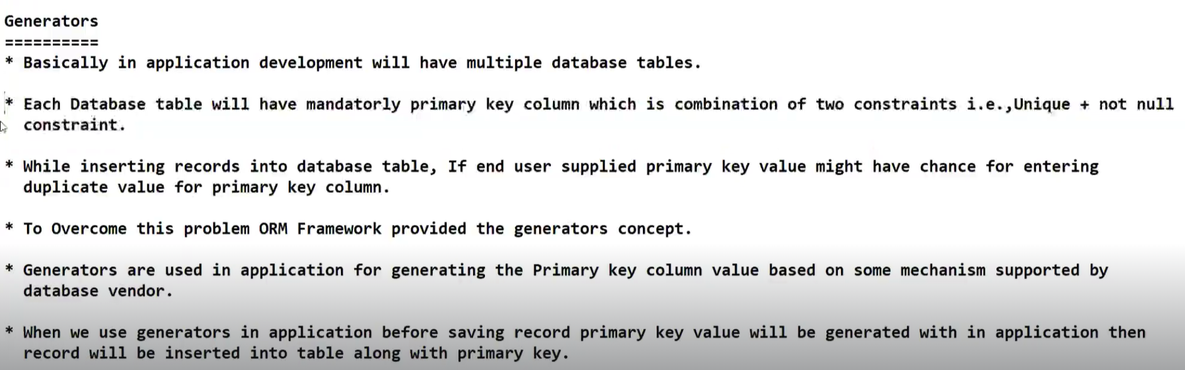

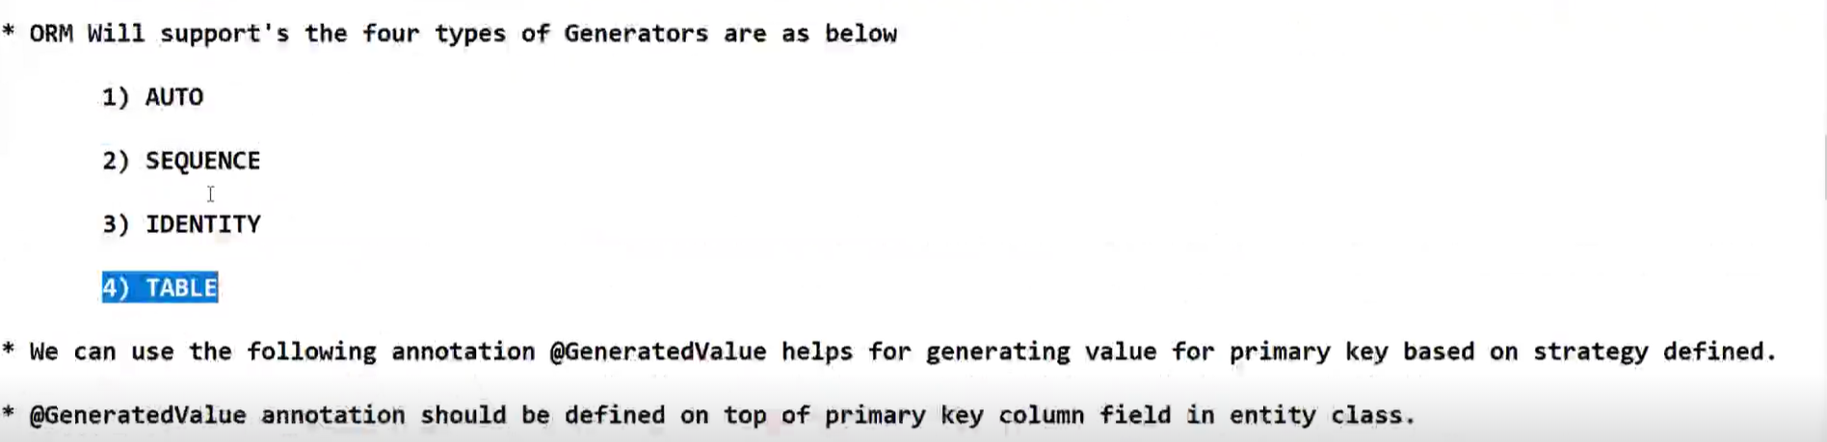

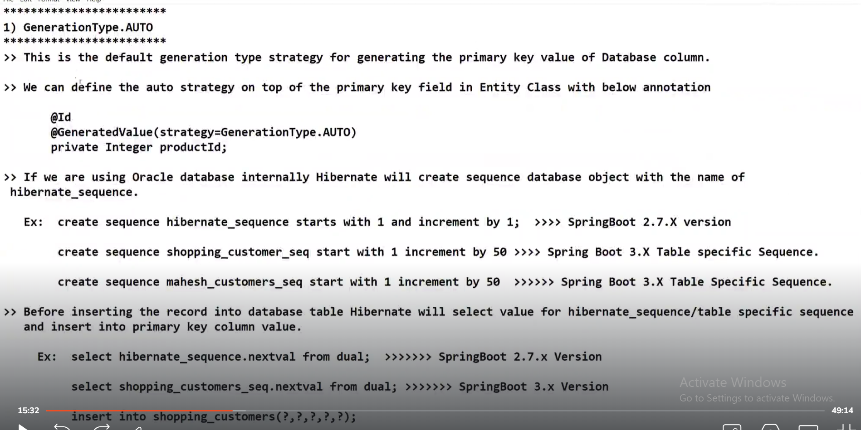

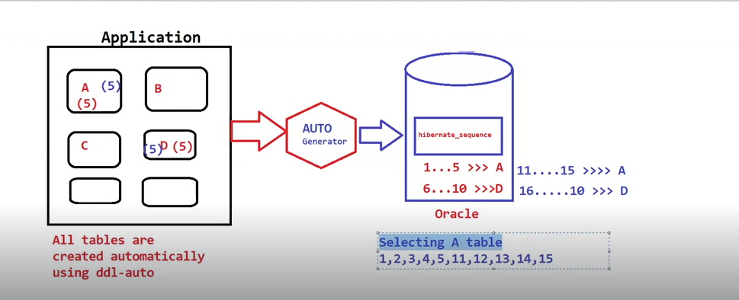

Untill SpringBoot 2.7.x version, hibernate\_sequence was used.The problem with this sequence is it is commonly used by all database tables and there is data inconsistency.

From SpringBoot 3.x version, table specific sequence got generated.

**@GeneratedValue() === if we don’t specify any value, then default will be AUTO**

@GeneratedValue(strategy = GenerationType.***AUTO***)

**When we run the application, sequence corresponding to that table gets generated on the database side.**

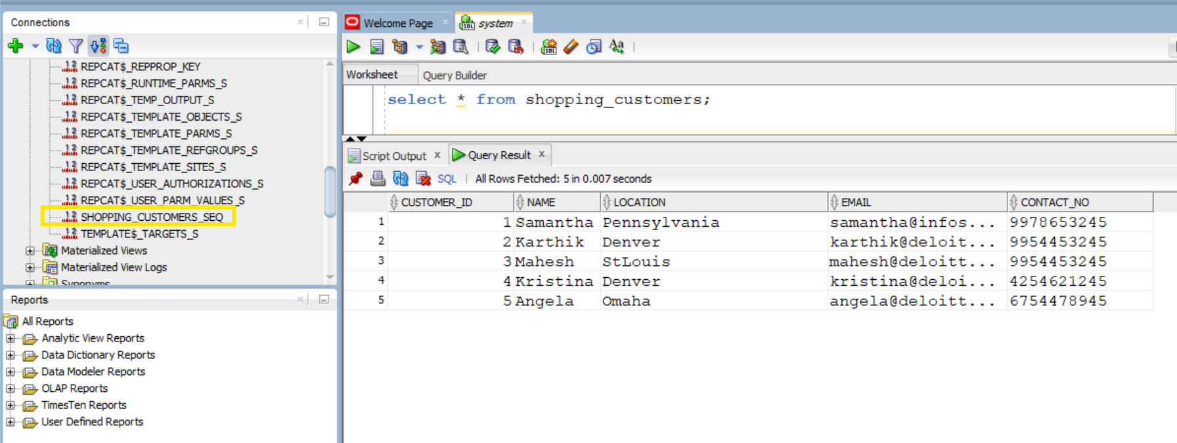

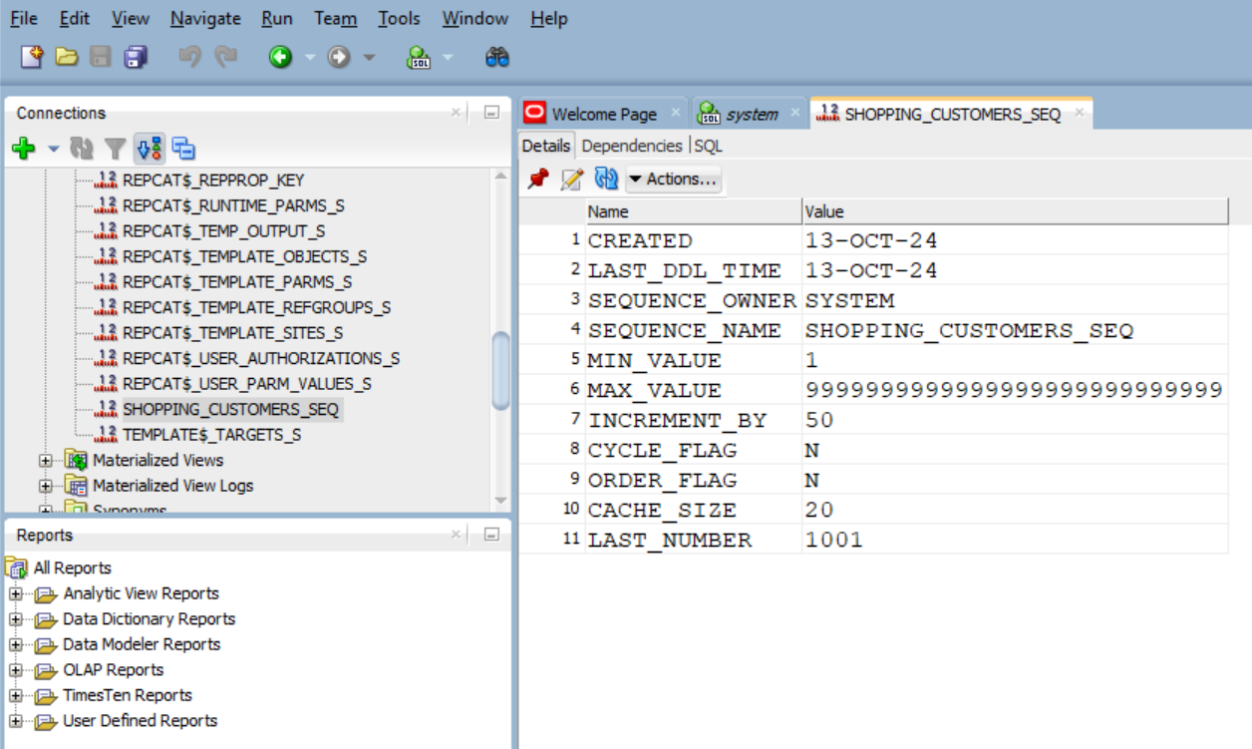

**SESSION-42**



**Sql database does not support concept of Sequences. It is specific to only Oracle database.**

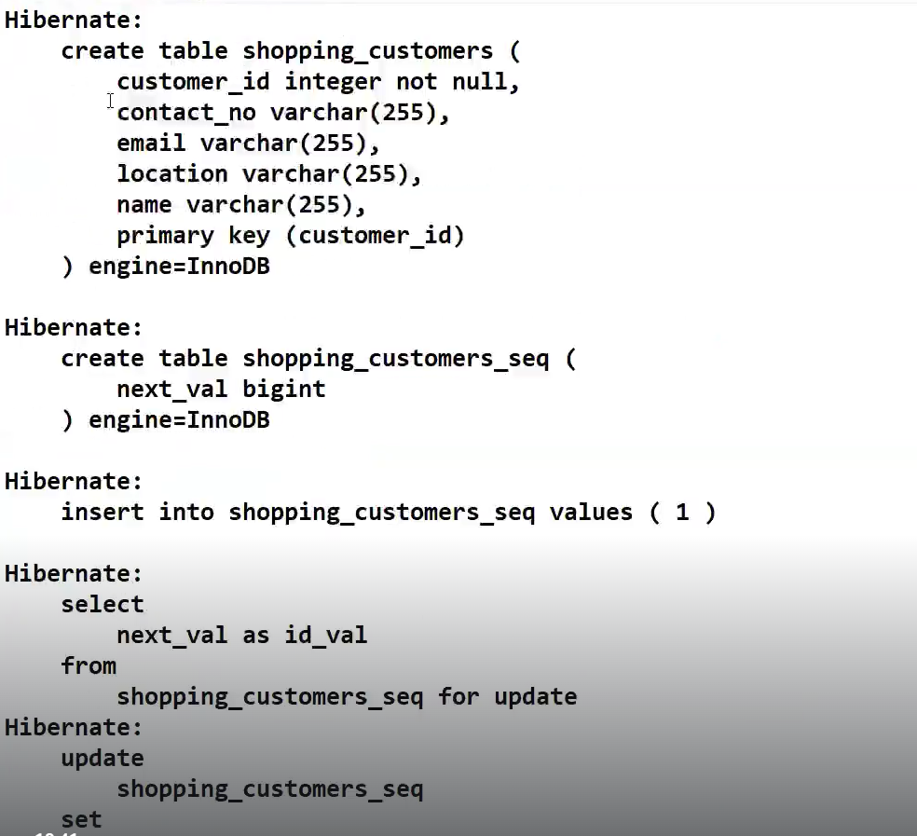

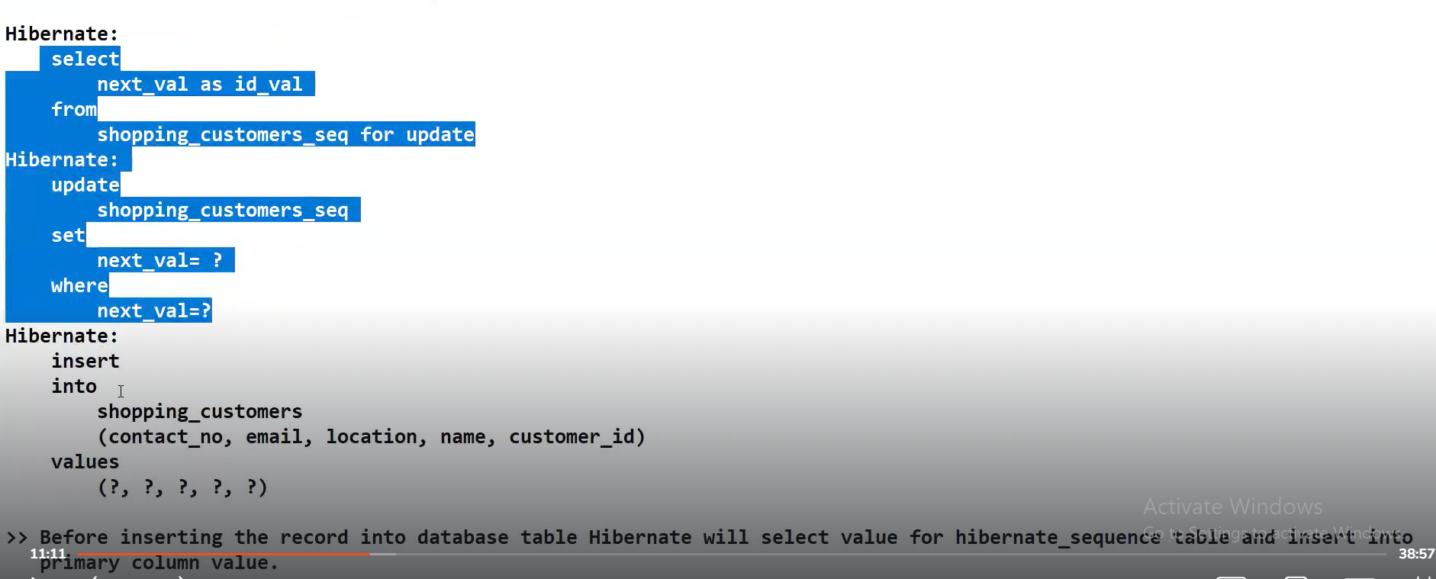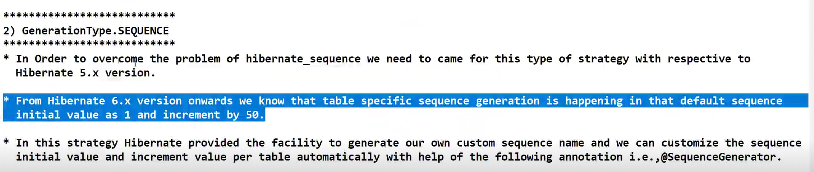

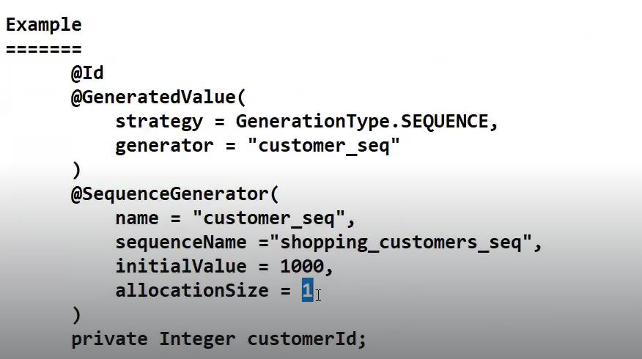

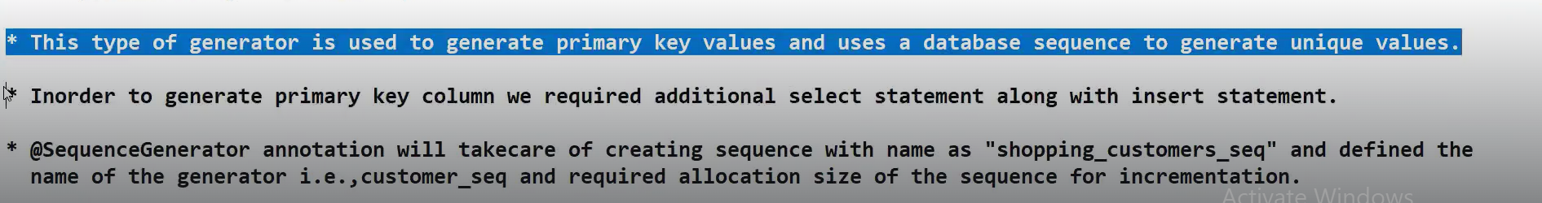

**SESSION-43**

**AUTO strategy and SEQUENCE strategy works for both MYSQL and Oracle databases.**

**Identity strategy works only for Mysql application.**

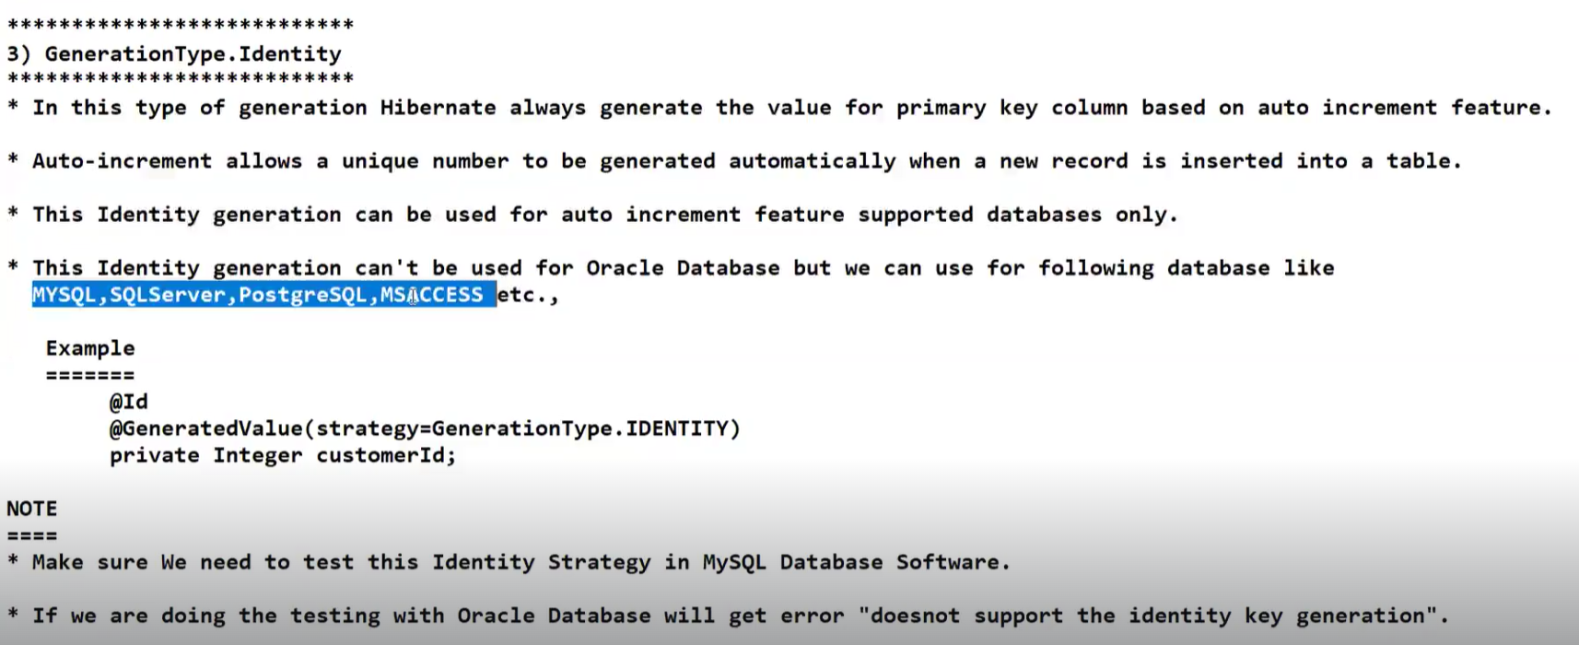

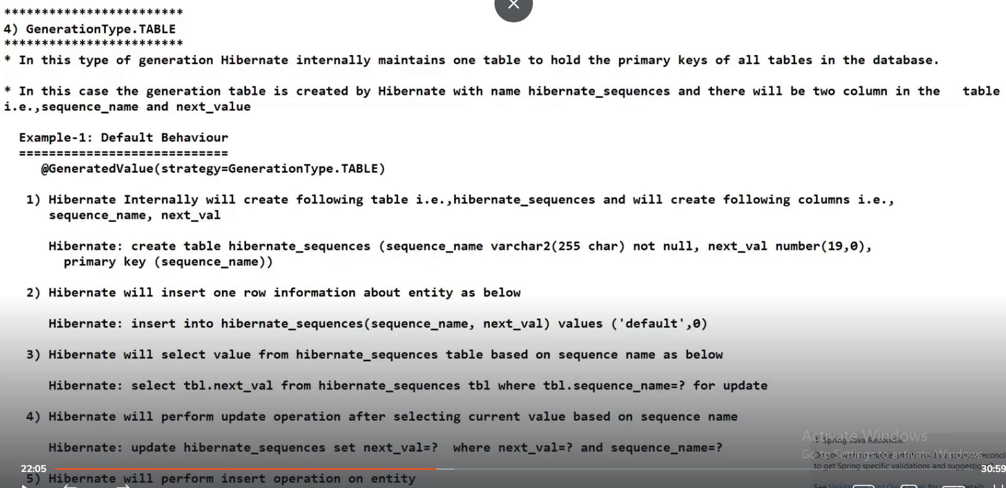

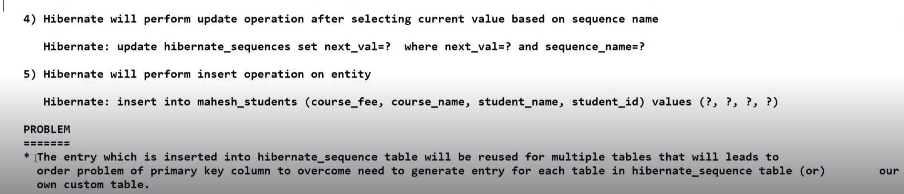

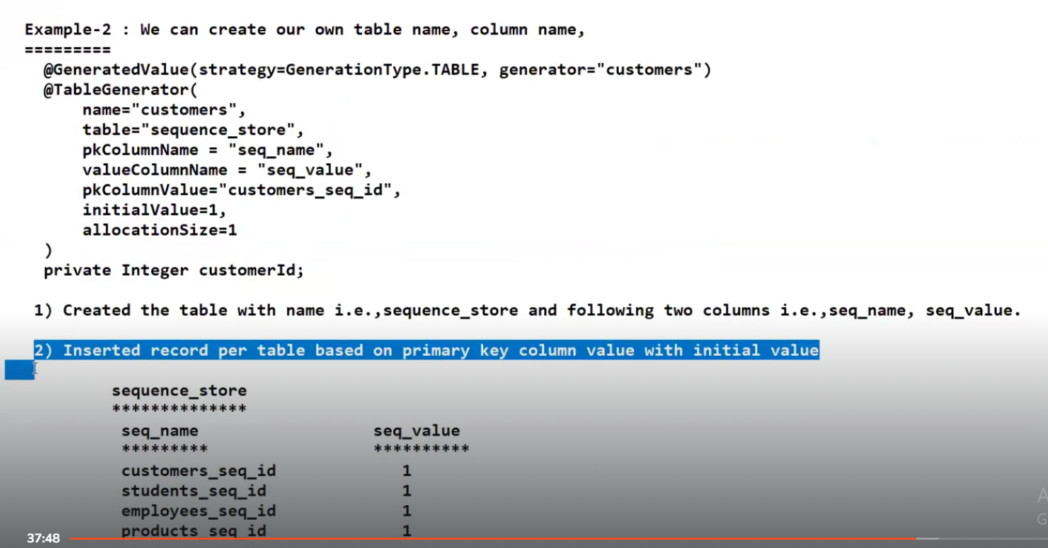

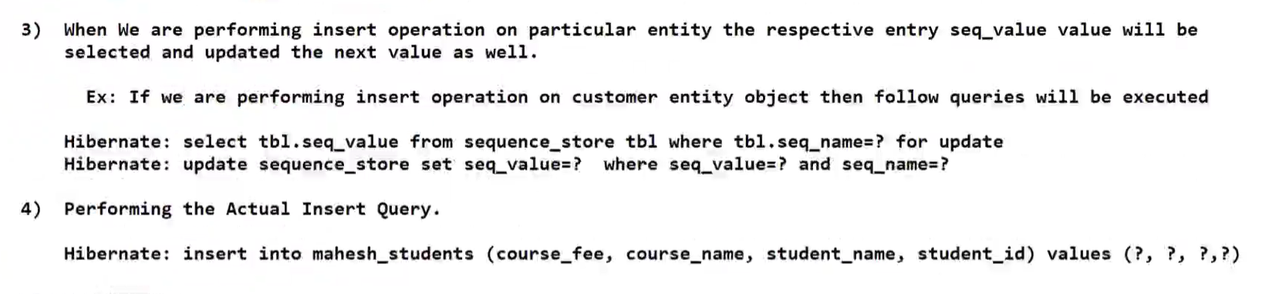

**SESSION-44**

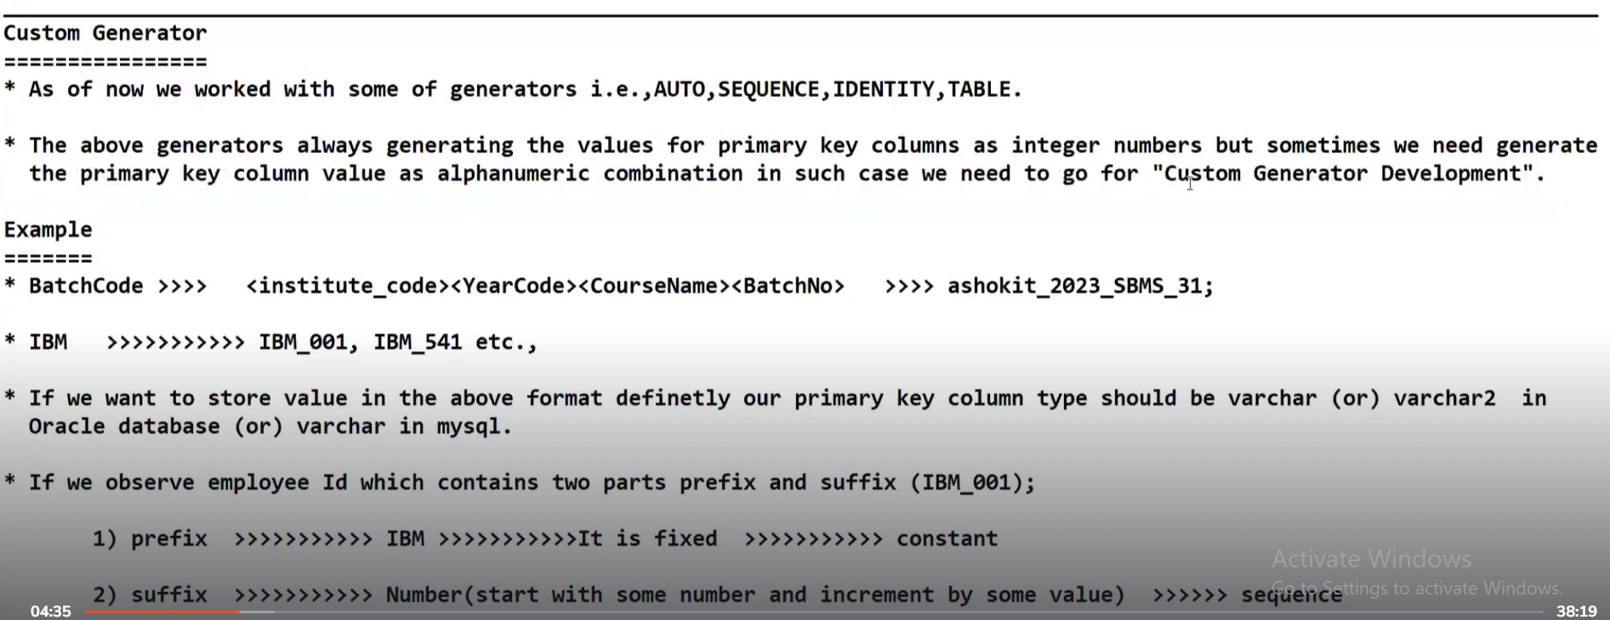

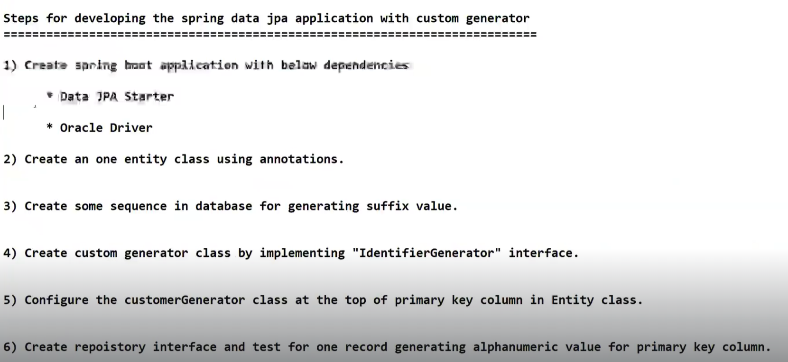

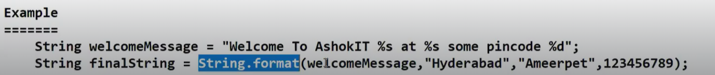

**SESSION-45**

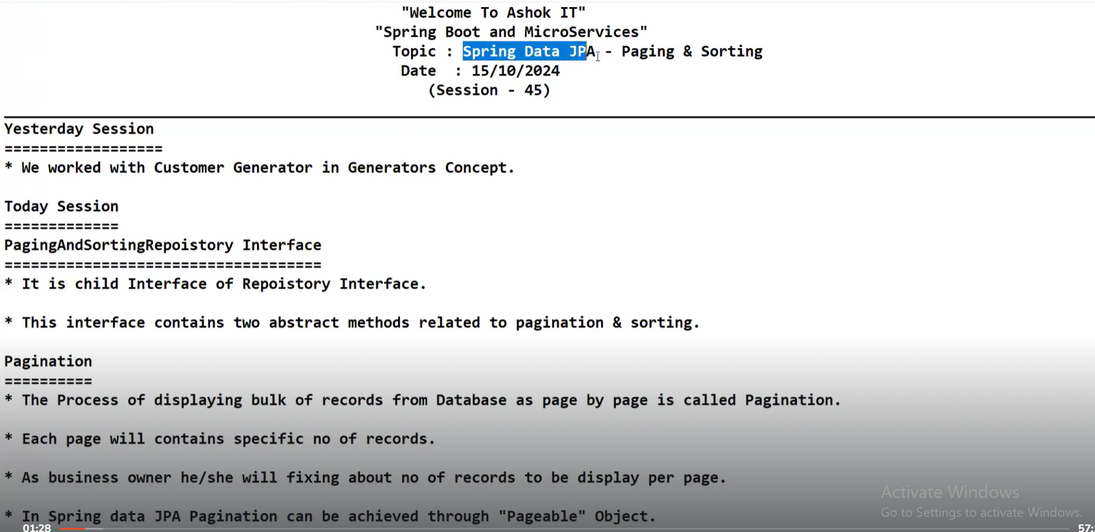

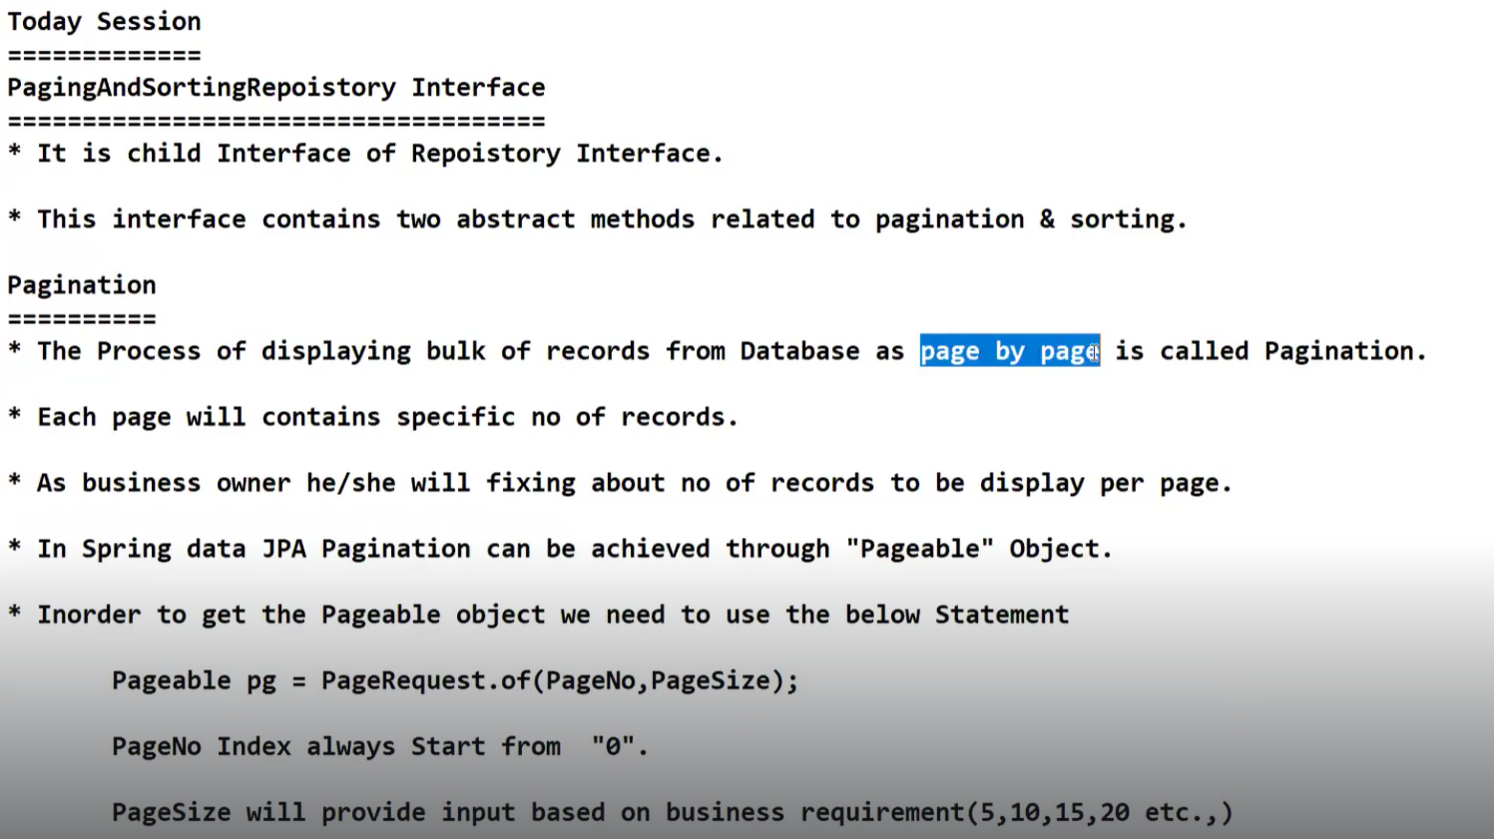

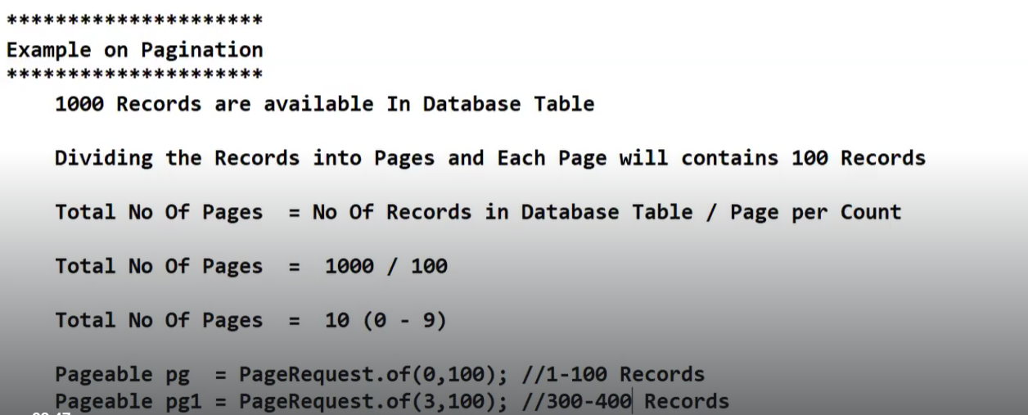

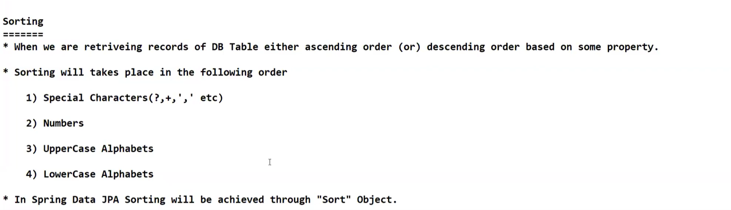

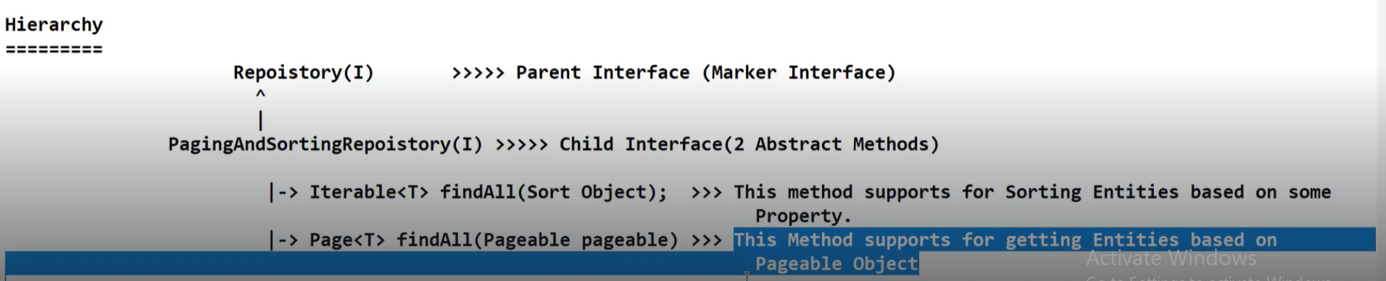

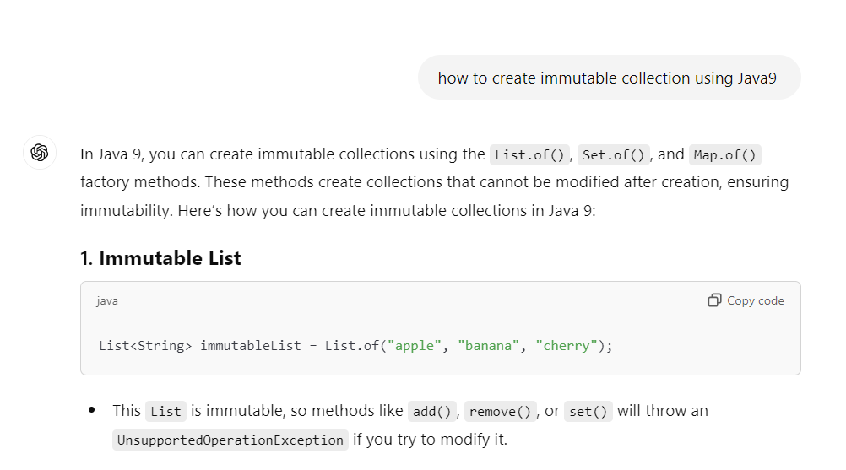

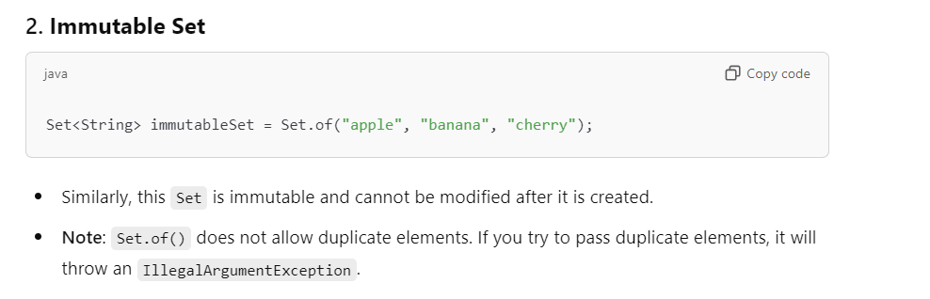

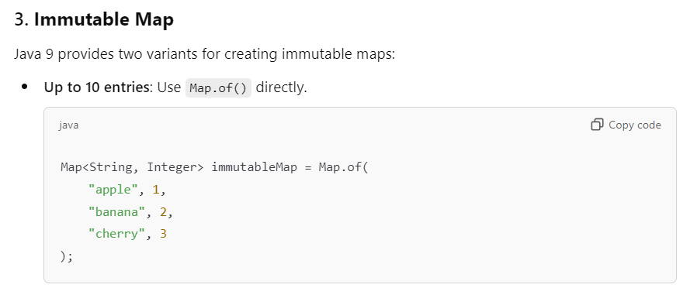

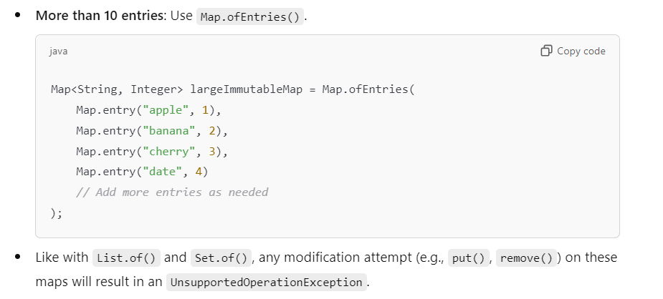

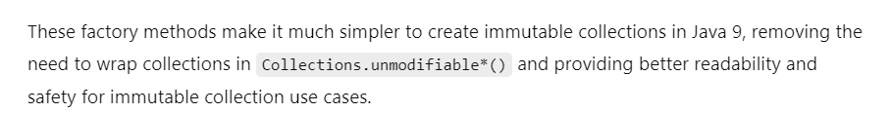

**SESSION-46**

In PagingAndSorting repository there are total 14 methods available.

In CRUD Repository we have 12 methods available.

Interview question:

We have huge number of records of data.How do we display that data on UI?

Answer: Pagination

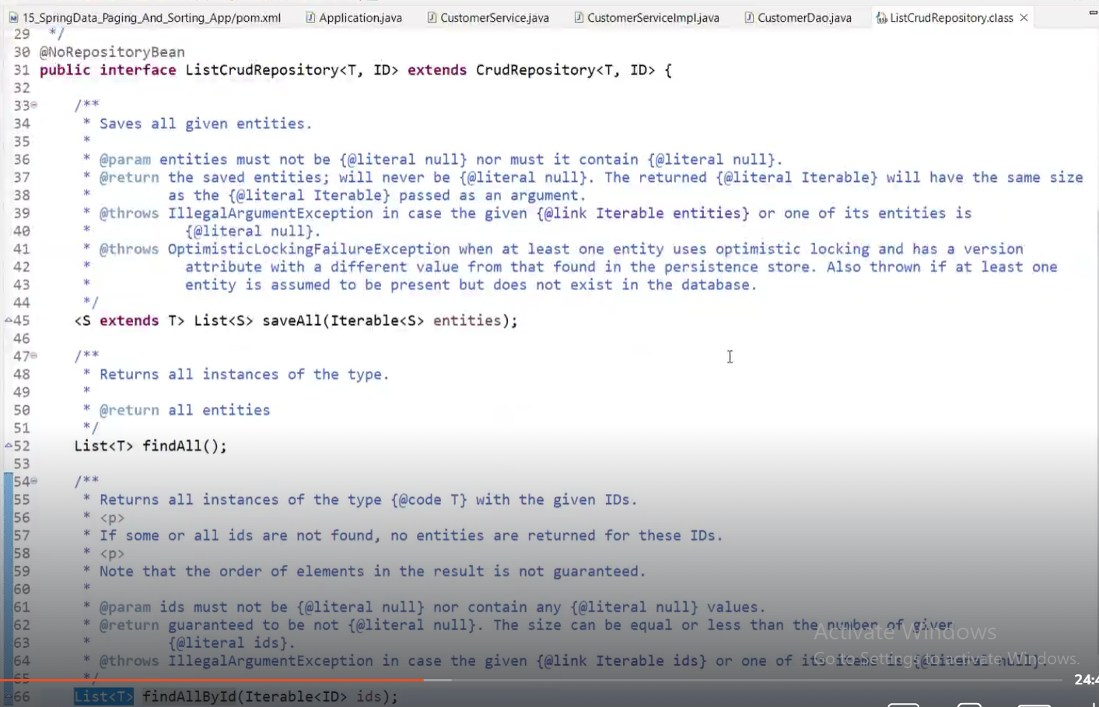

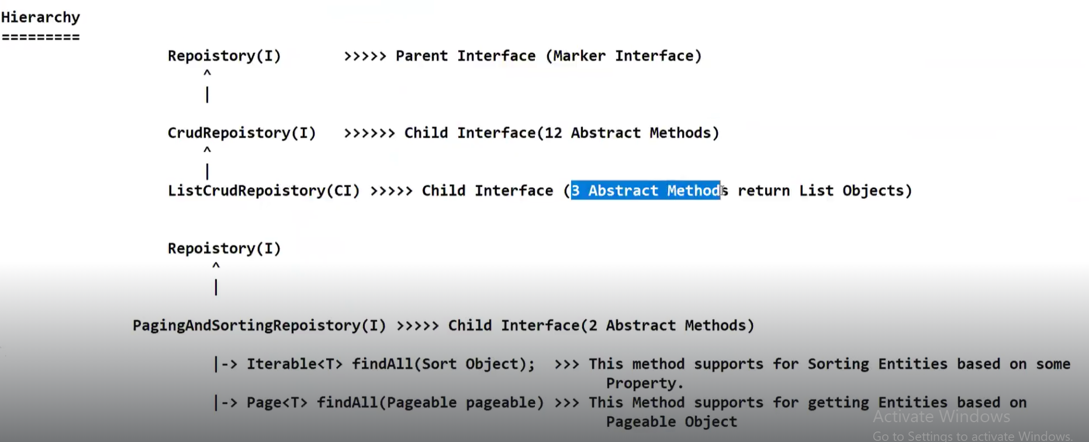

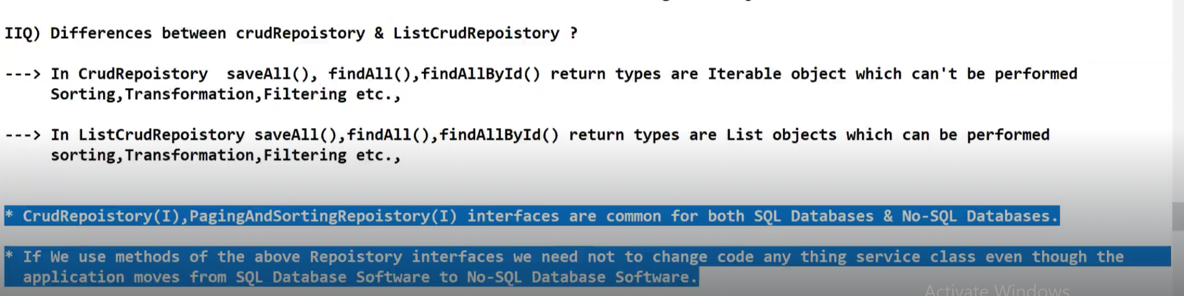

**JPA Repository**

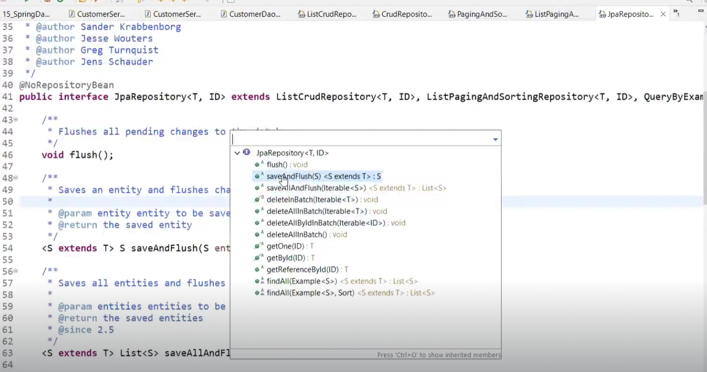

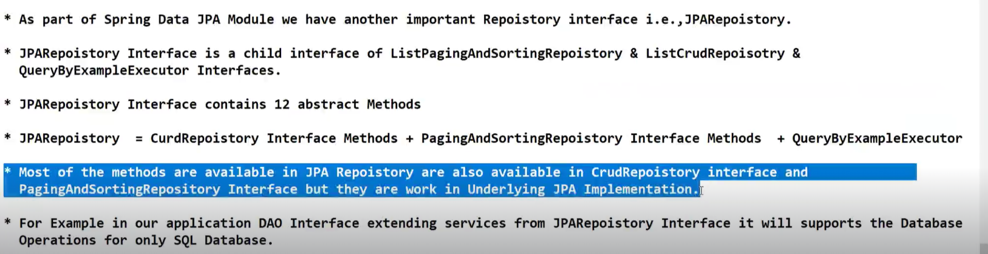

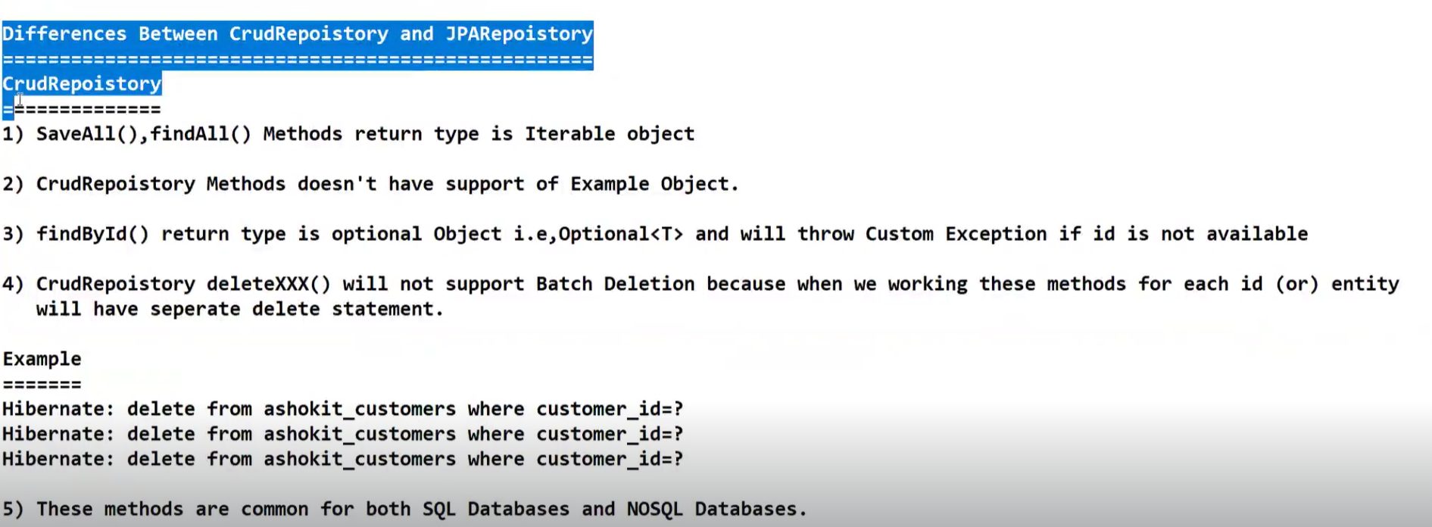

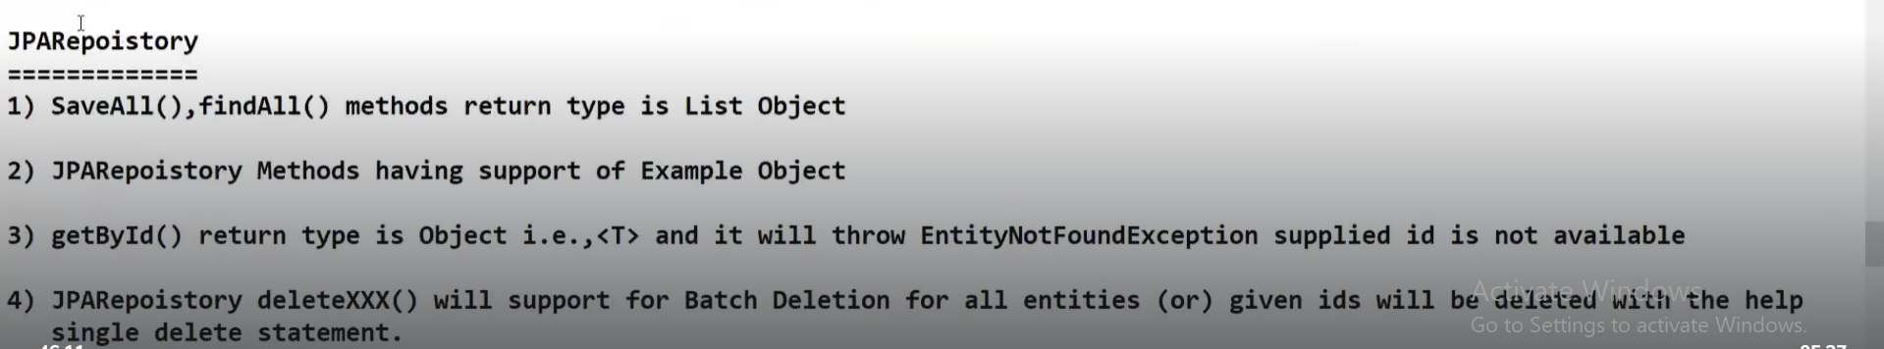

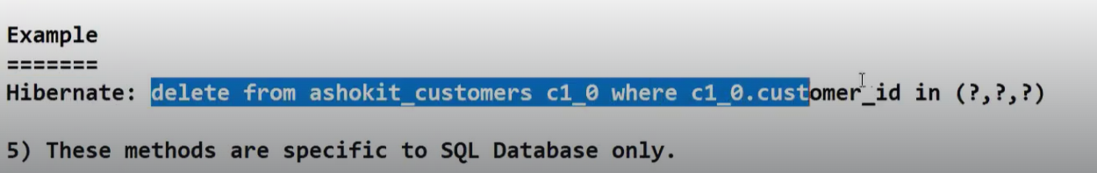

**SESSION-47**

When you are working with JPA repository, you need to add below highlighted one in application.properties file

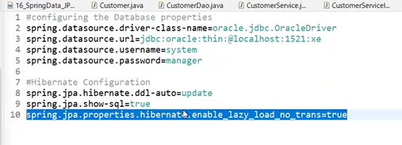

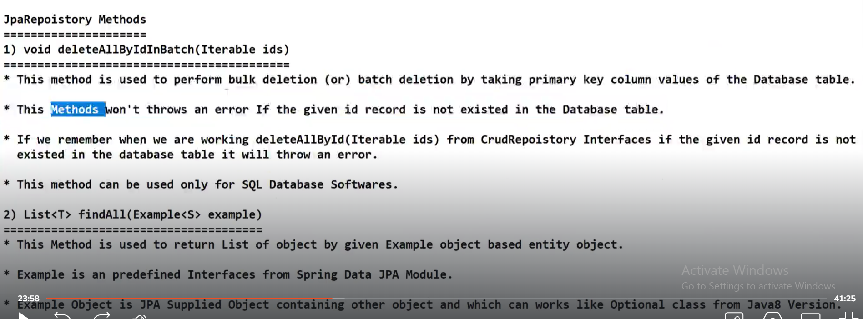

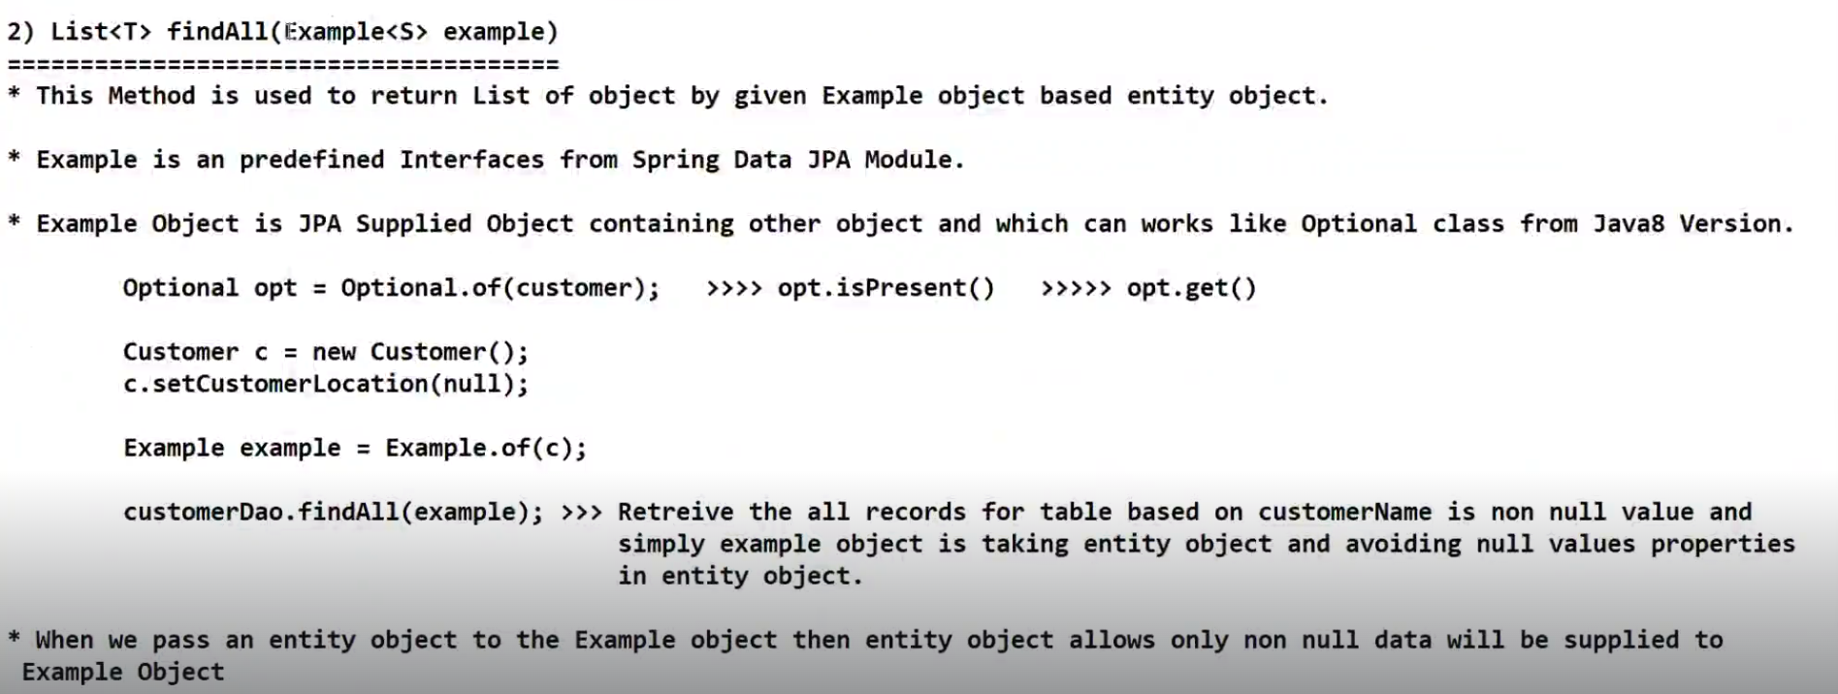

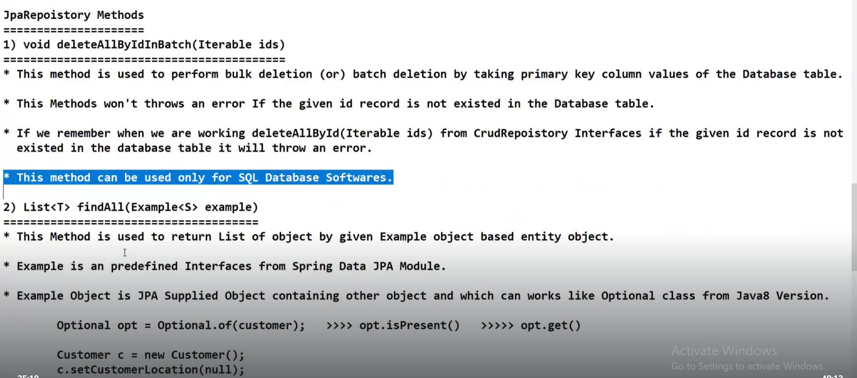

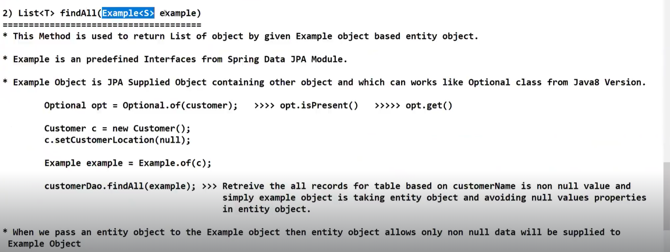

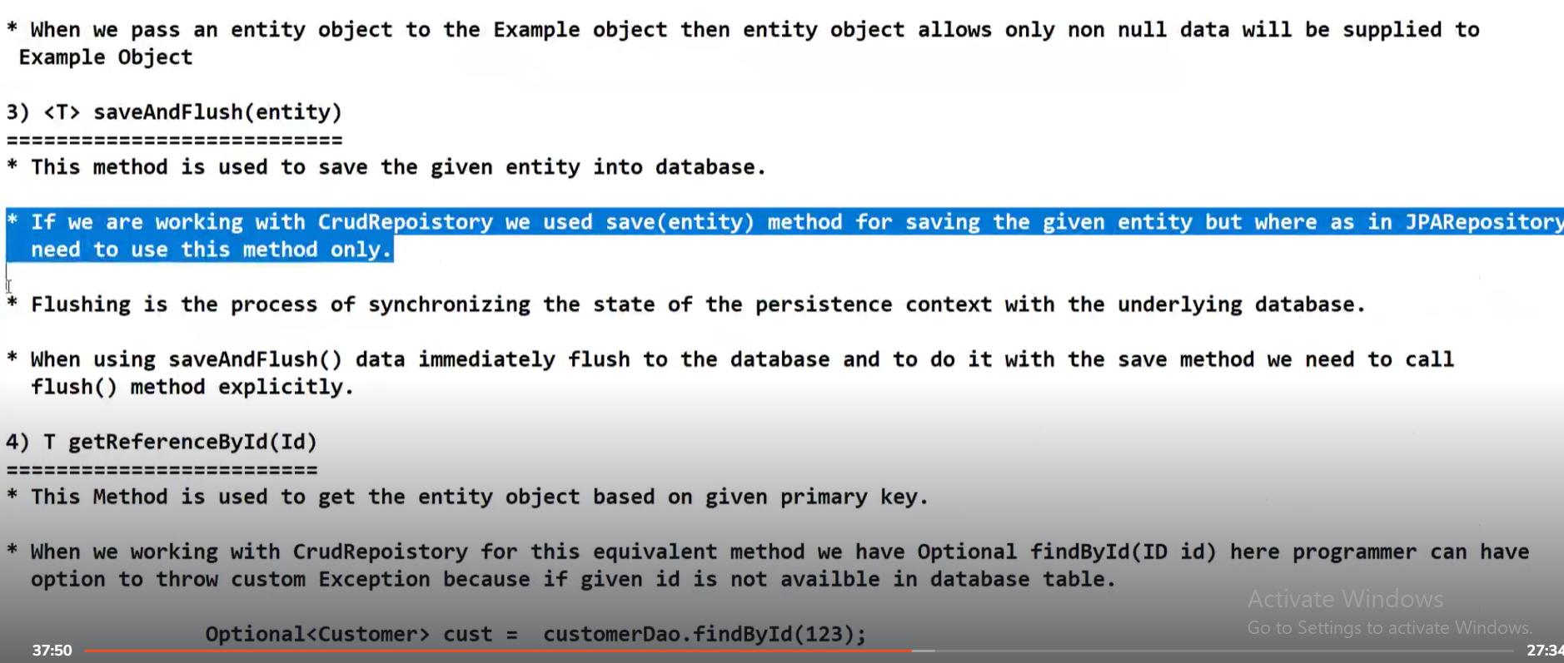

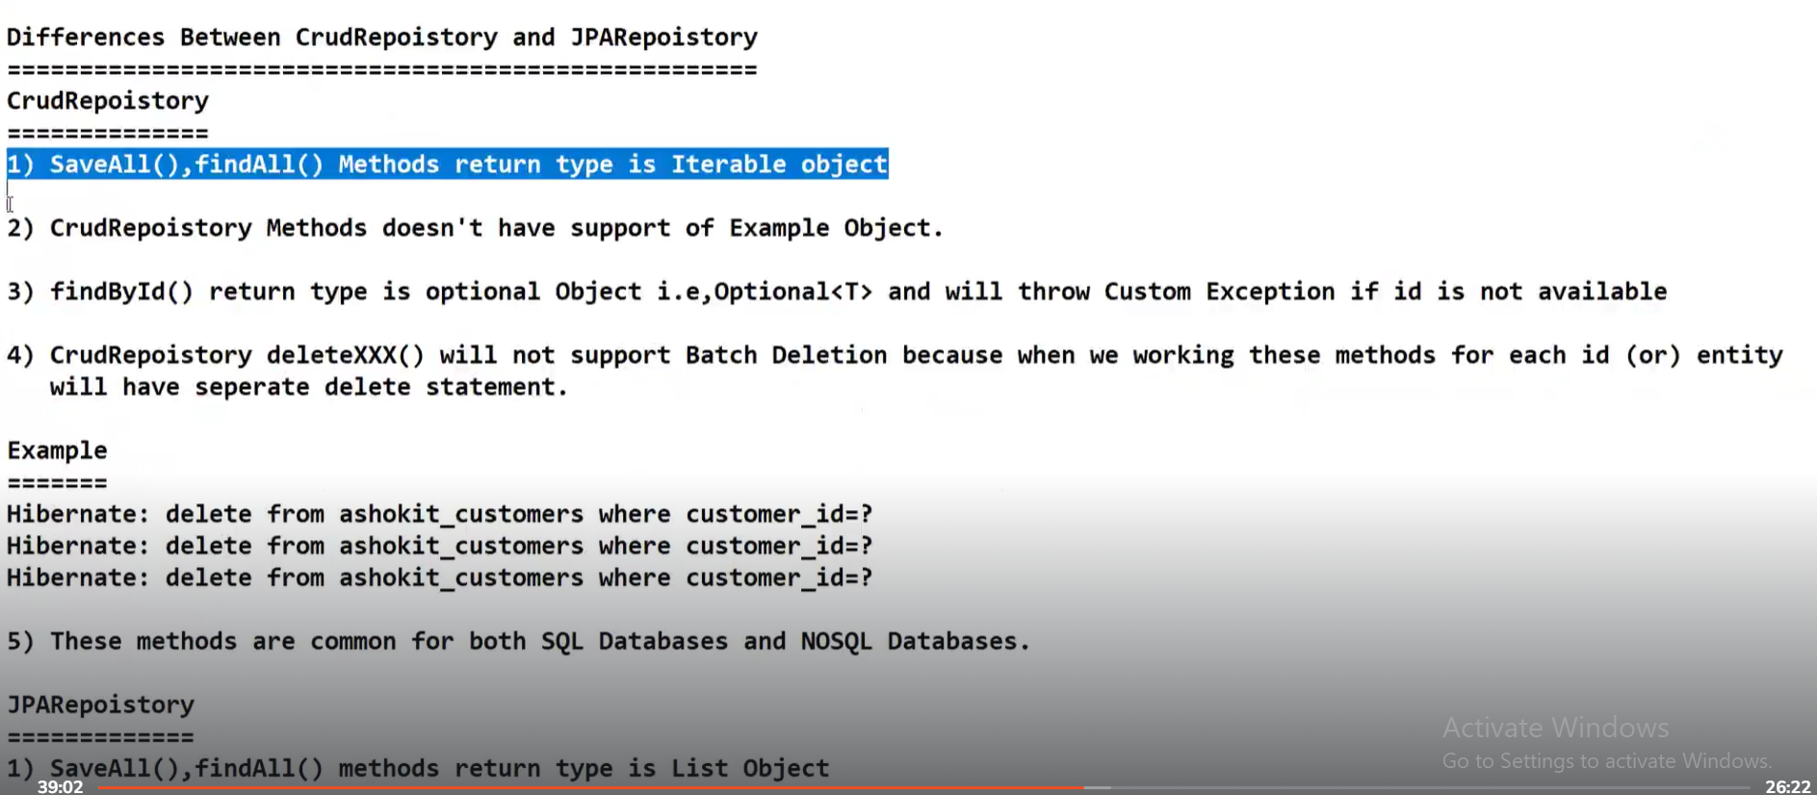

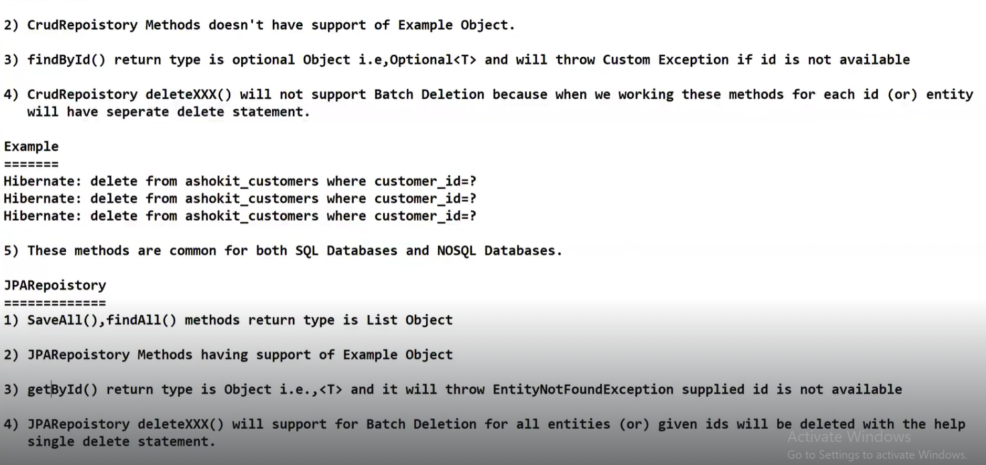

**SESSION-48**

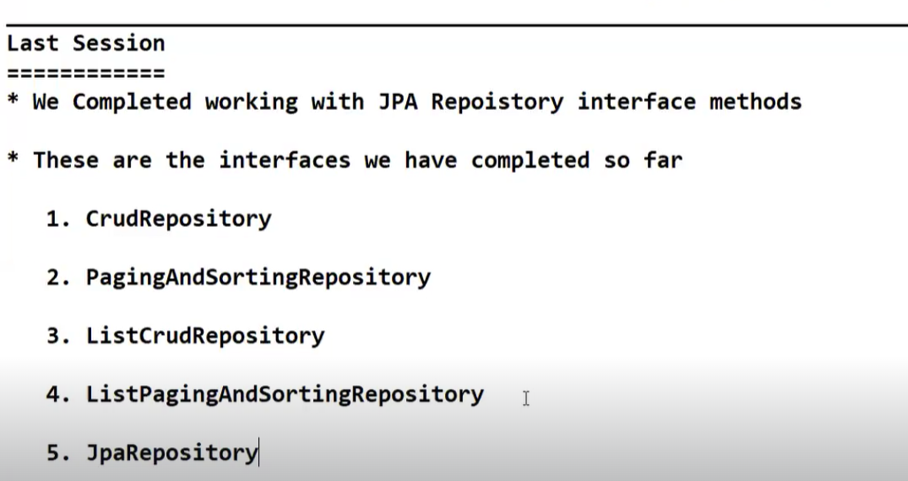

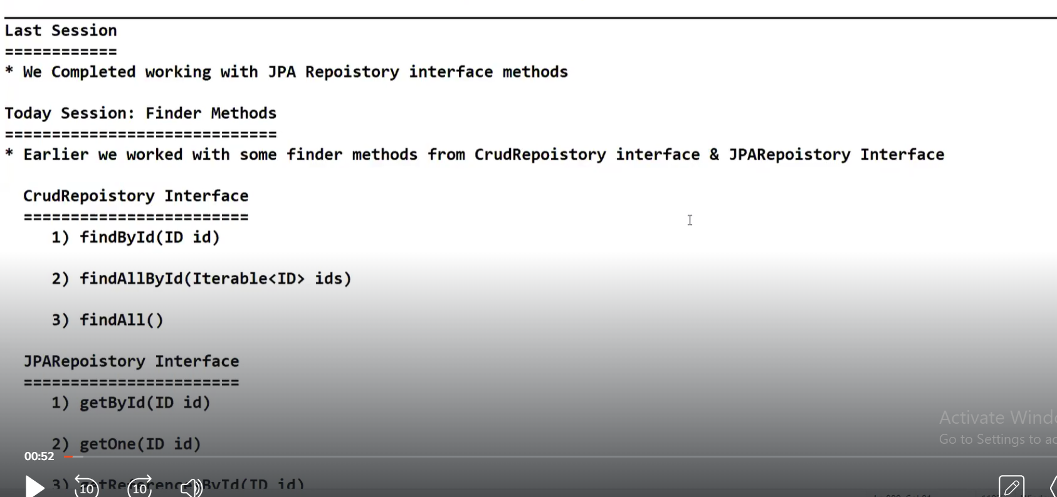

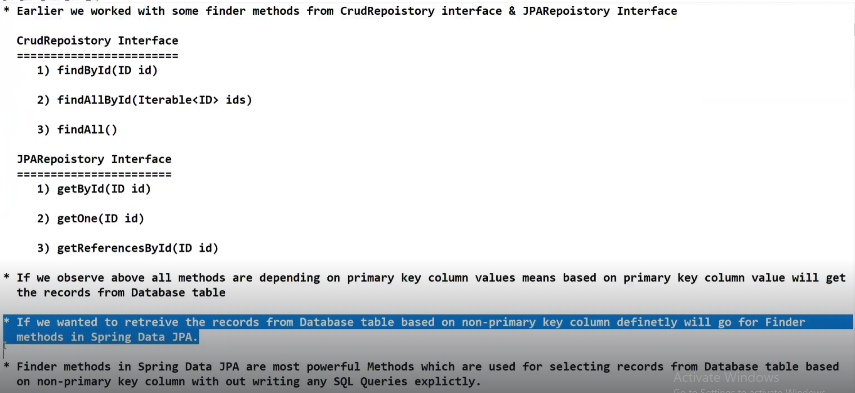

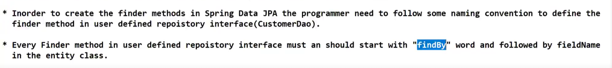

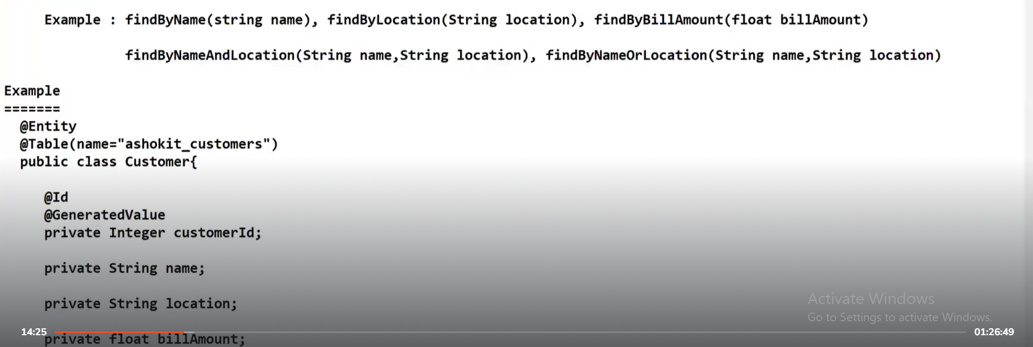

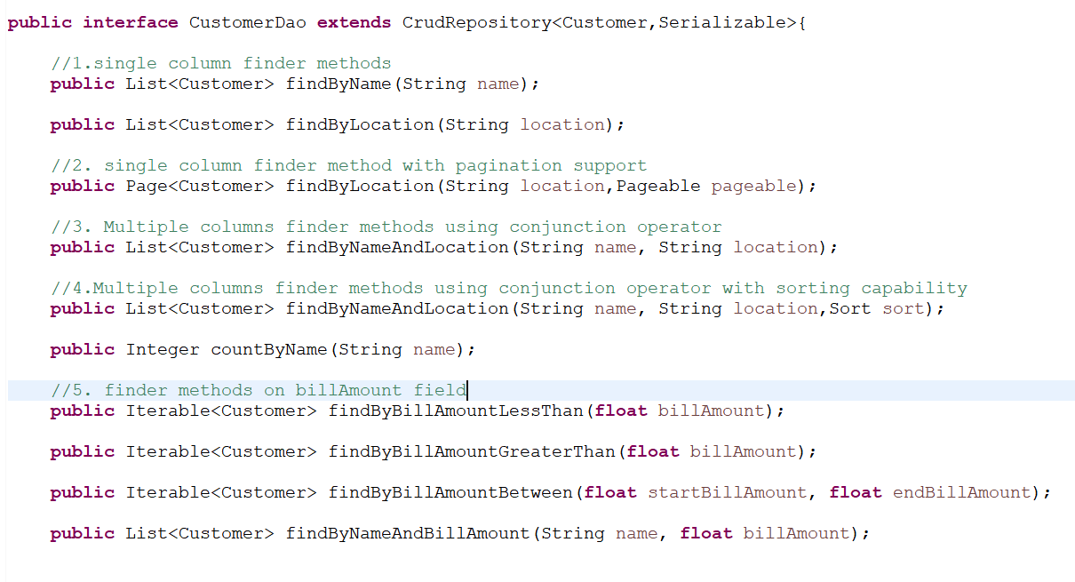

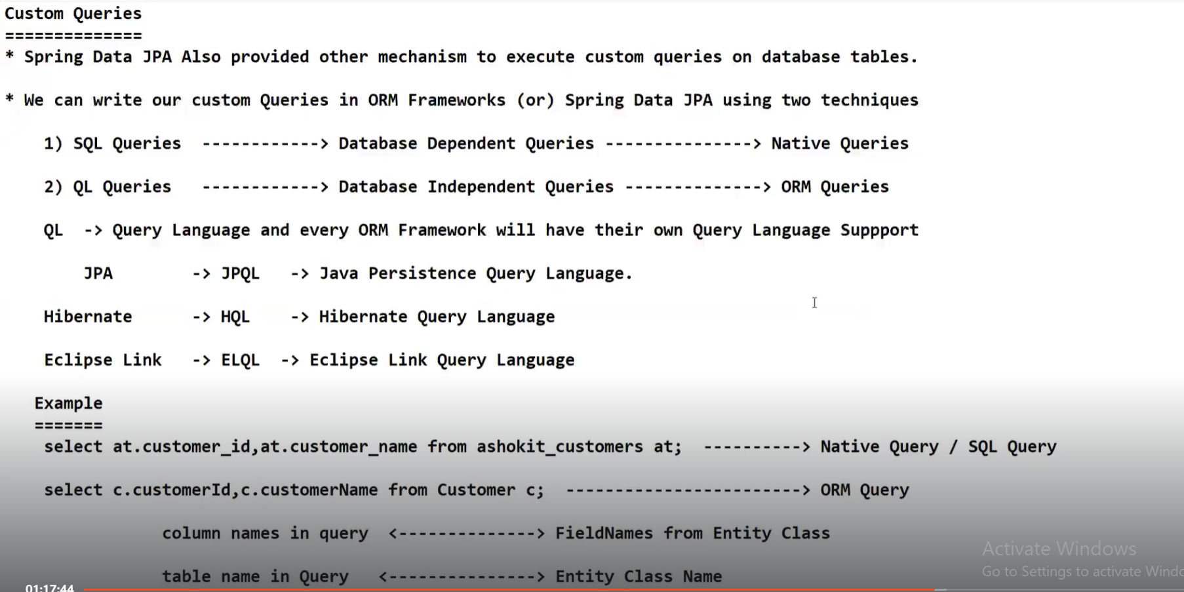

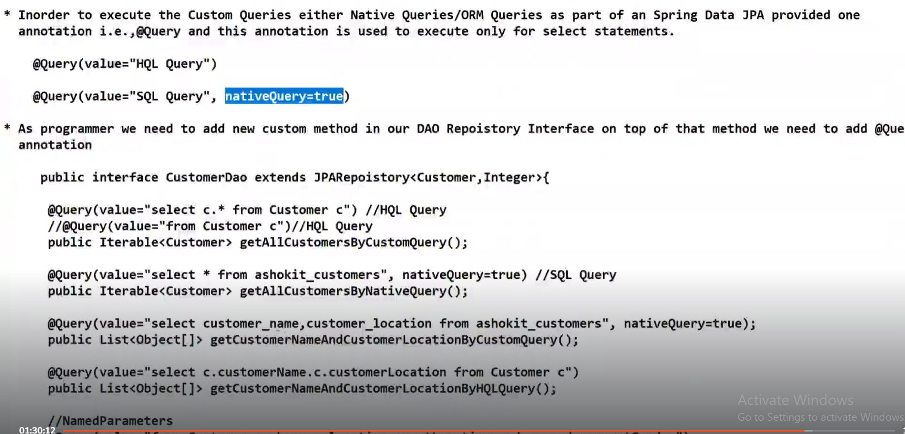

**SESSION-49**

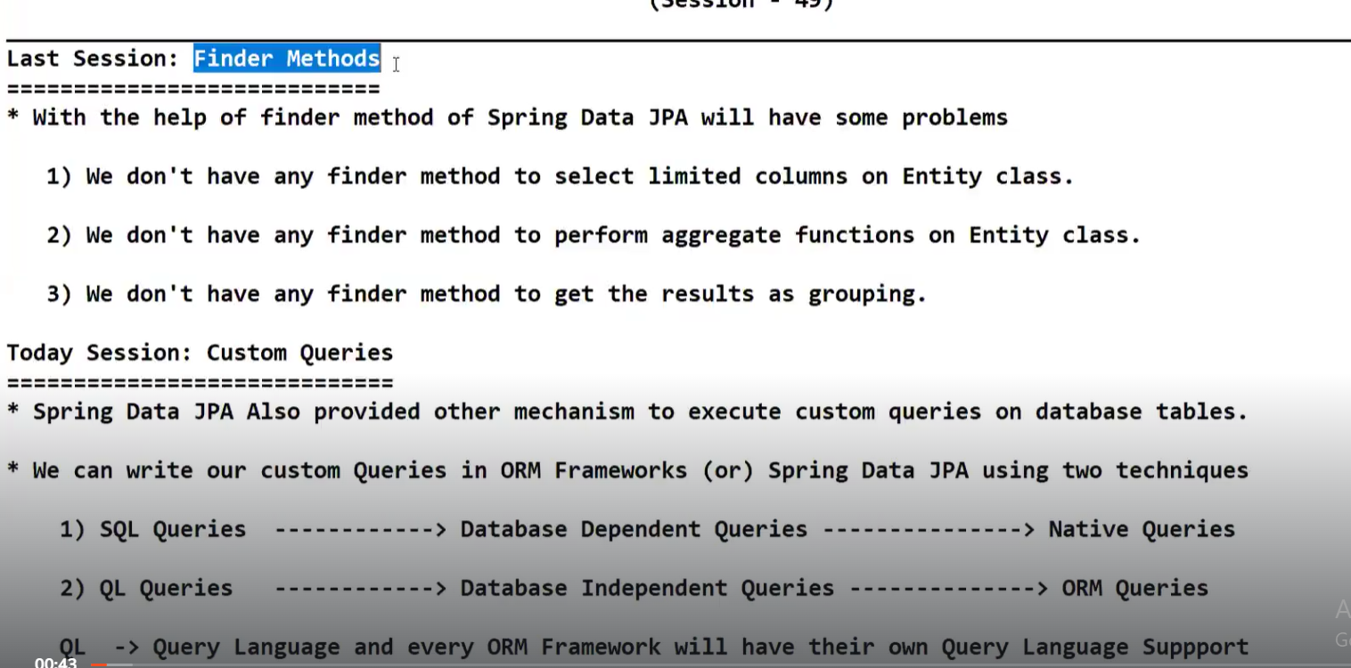

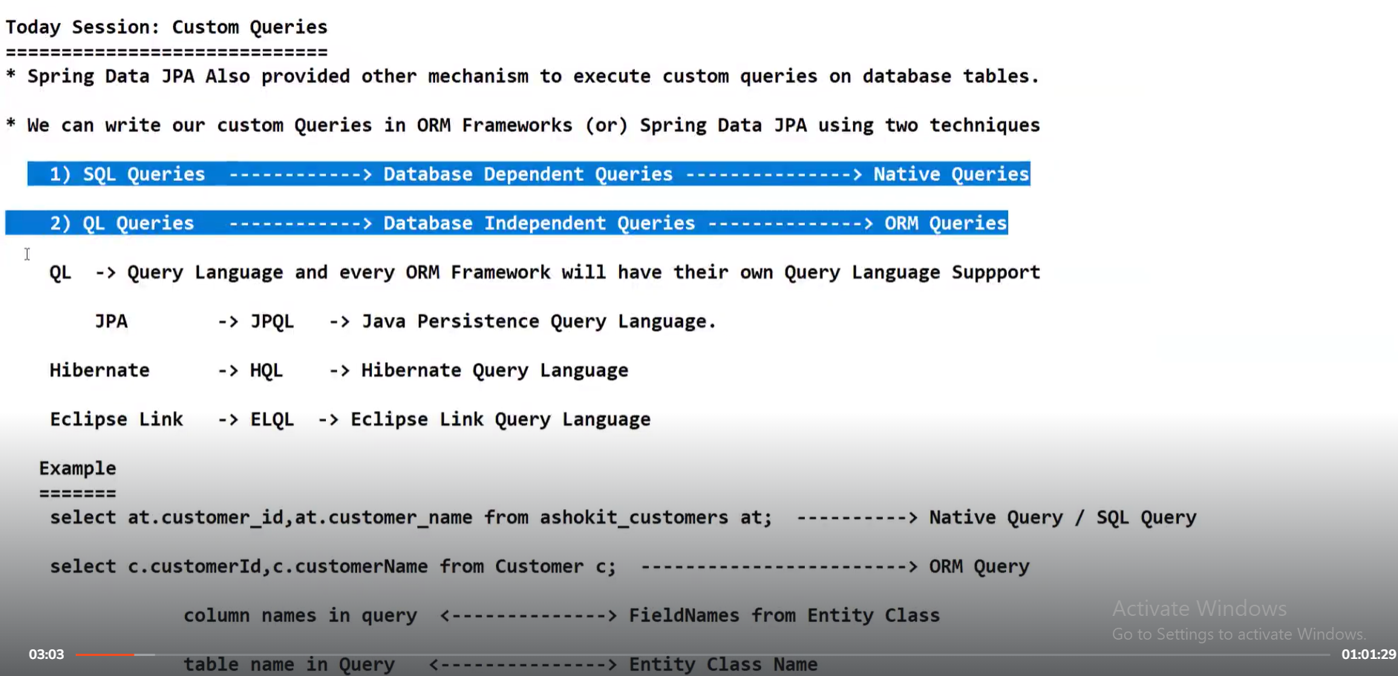

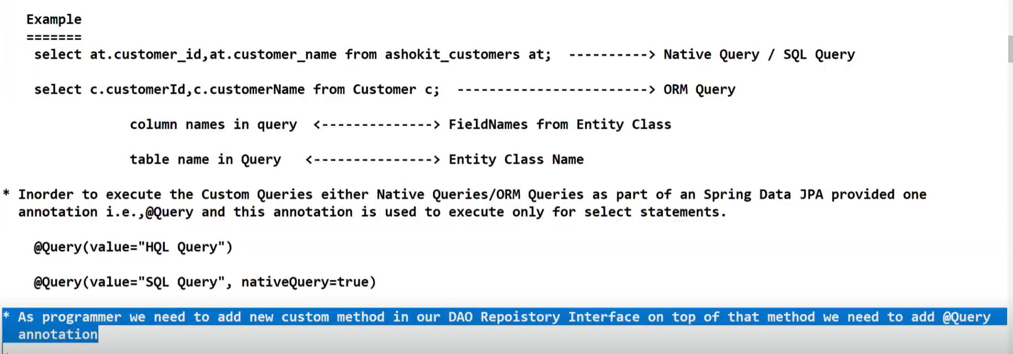

With Iterable object, you cannot perform any sorting, filtering , transformation operations.Using Iterable, you can only process and display objects

With List object, you can perform sorting , filtering, transformation operations

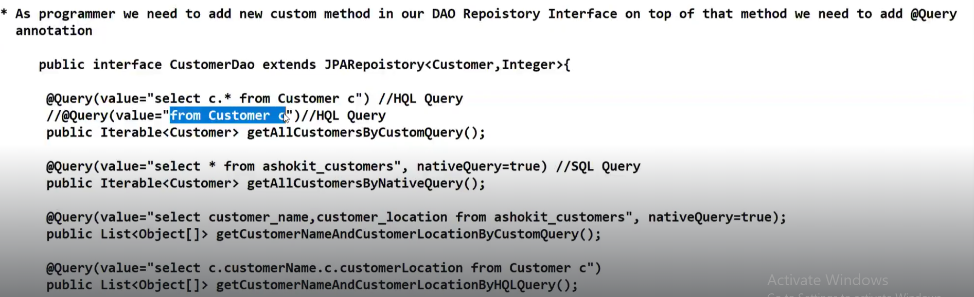

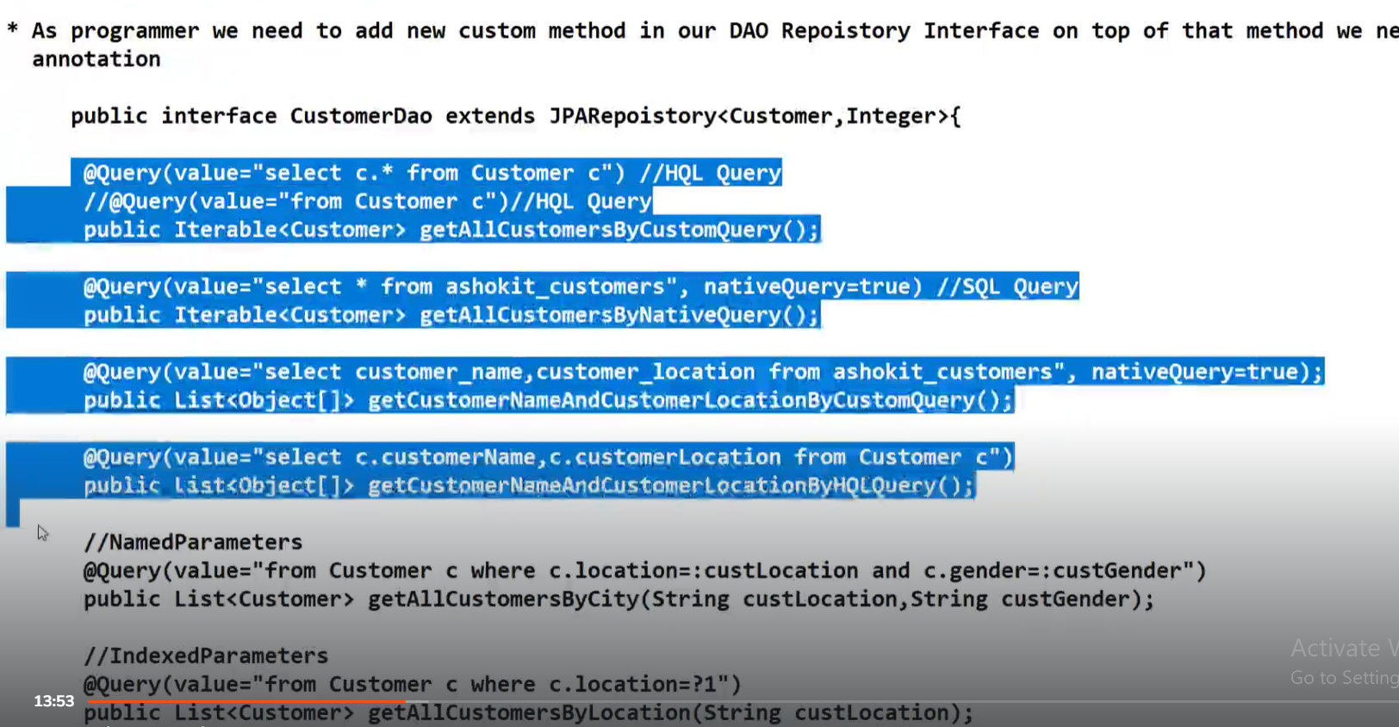

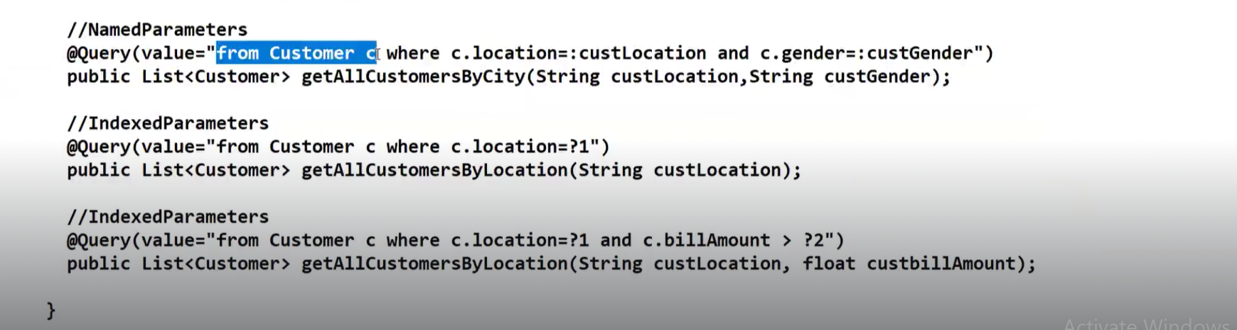

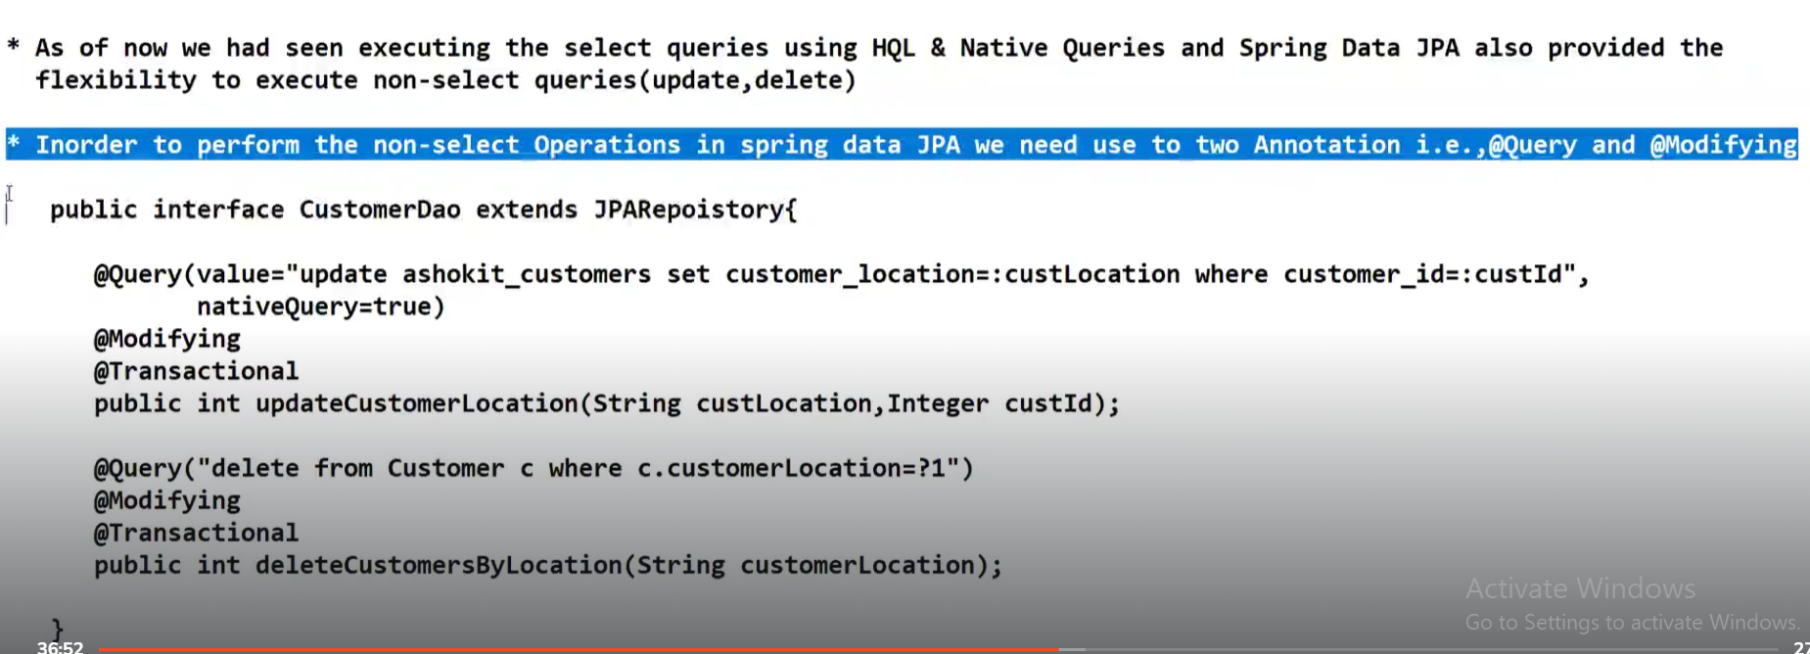

**@Transactional means == Do everything or Do nothing**

**SESSION-50**

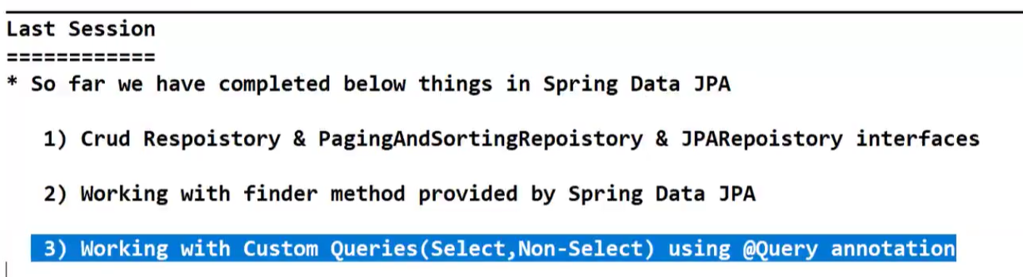

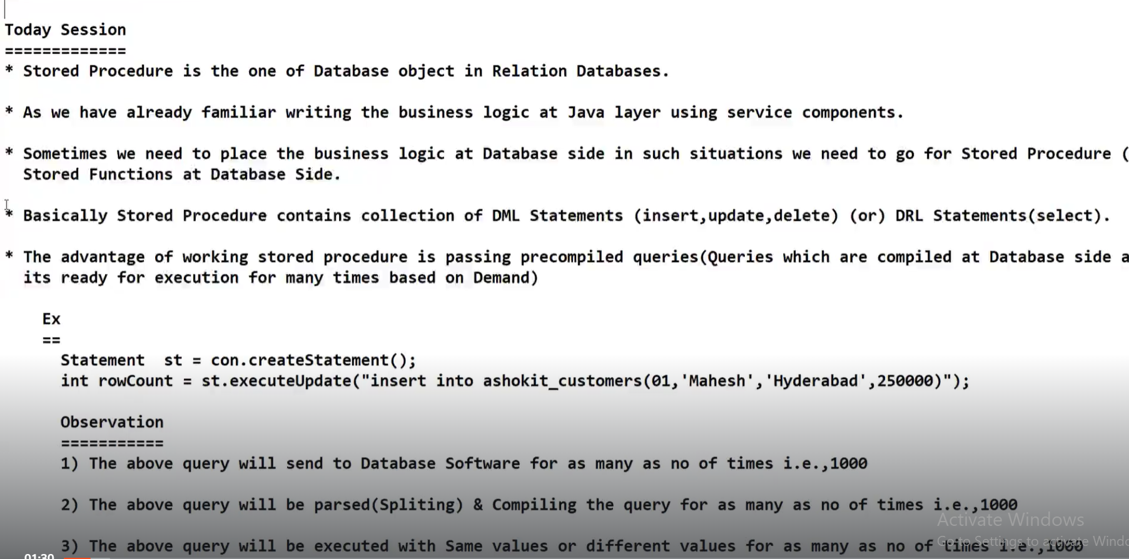

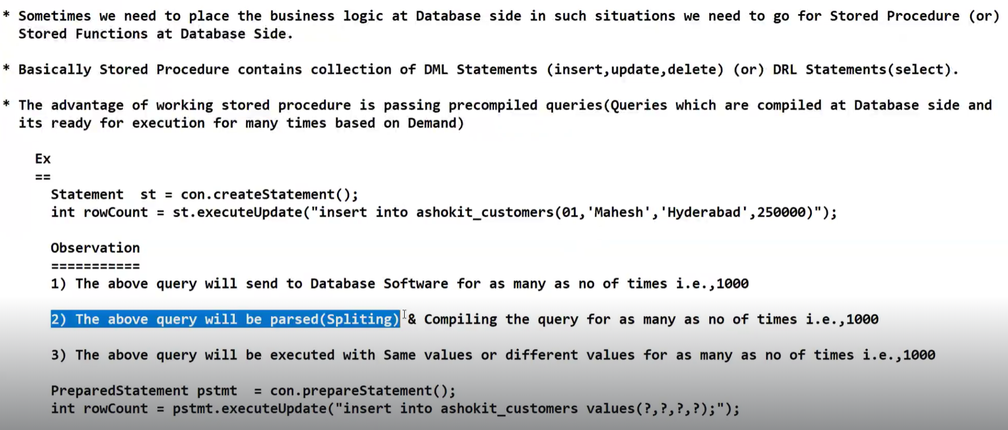

The SQL statements which are passed through Statement object are not pre-compiled queries.

The SQL statements which are passed through Prepared Statement object are pre-compiled queries.

**EVENT DRIVEN ARCHITECTURE IN MICROSERVICES**

**What is mean by Event Driven Architecture?**

**Developer will write code and this code will be executed through an event ===>Event Driven**

**Button Click,Drop Down Change,Page Load,Radio change,Reload**

**Can we apply Event-Driven in Micro service? If so what is advantage?**

**Use case:**

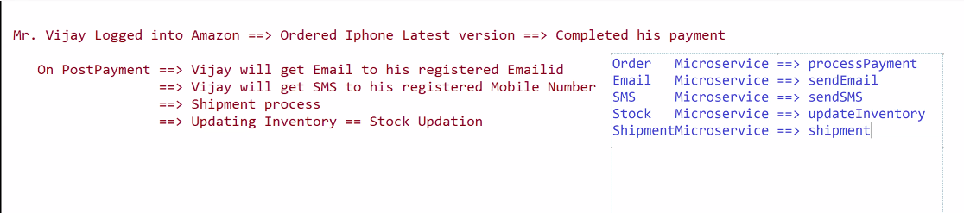

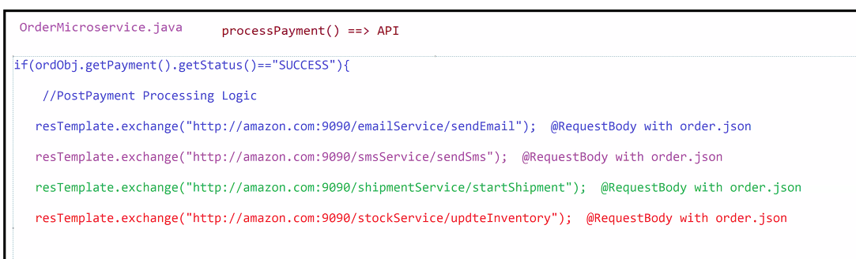

**What are the benefits if we use Event Driven Architecture in your project?**

**What are the drawbacks if we don’t use Event Driven Architecture in your project?**

**EXCEL EXPORT USING SPRINGBOOT || APACHE POI API IN JAVA**

**https://www.youtube.com/watch?v=qe\_NrRRsuVg**

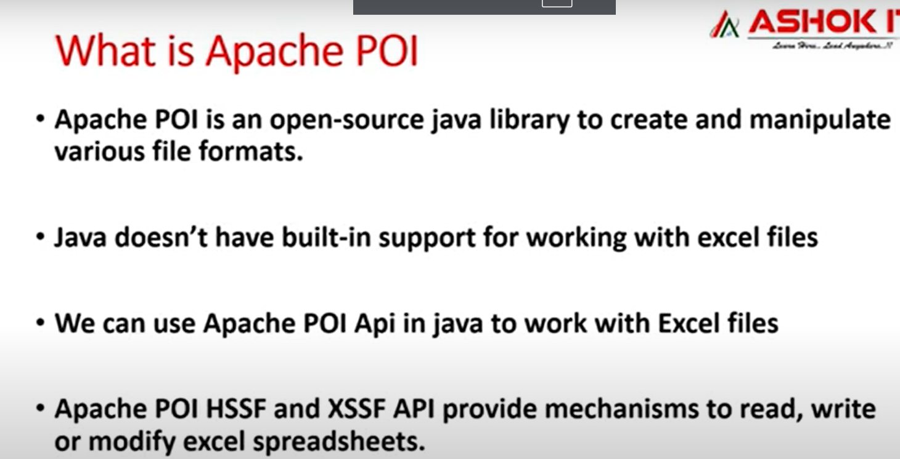 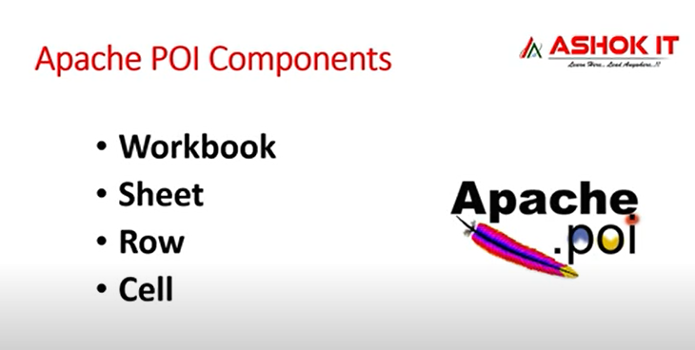

**AWS RDS WITH SPRINGBOOT**

**You tube link:**

**https://www.youtube.com/watch?v=GSu1g9jvFhY**

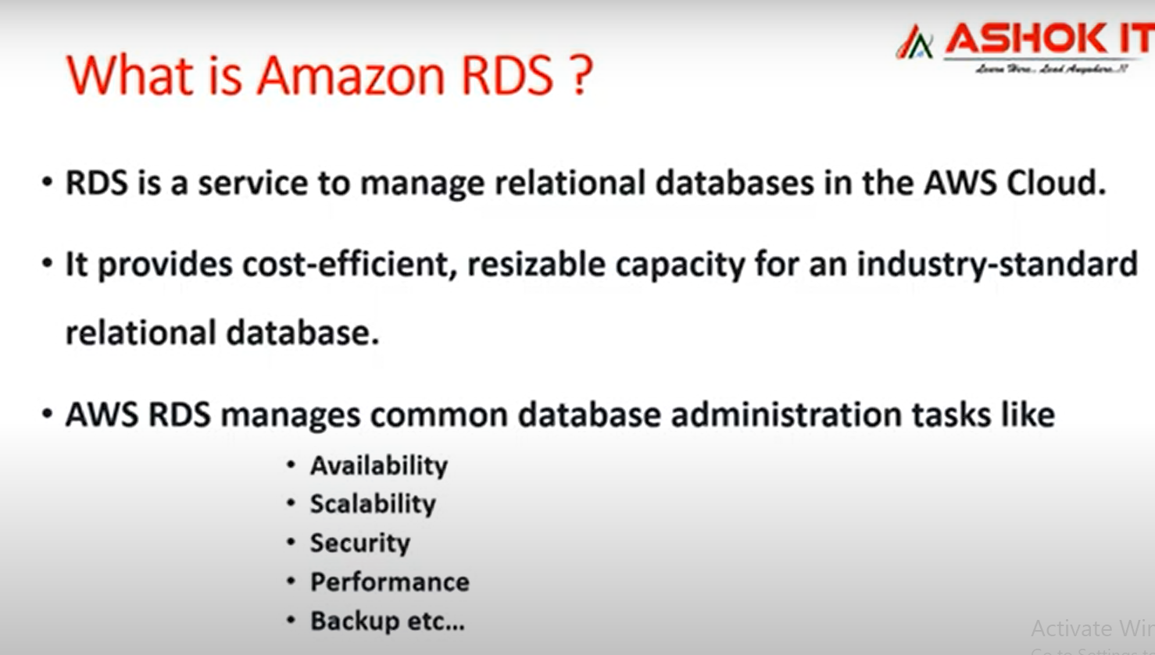

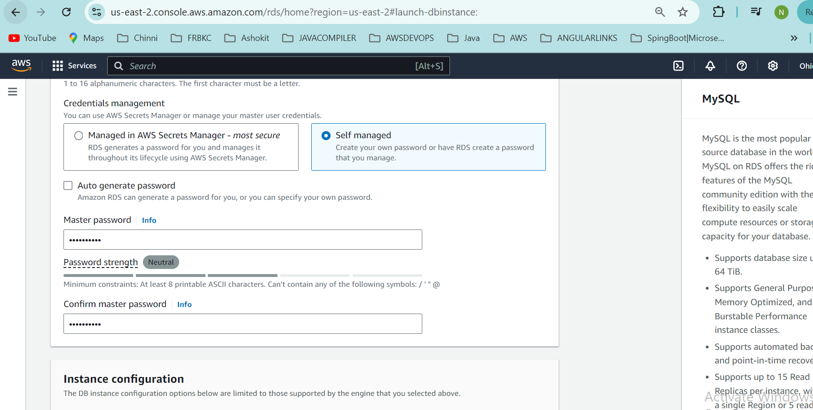

In the above screenshot Master Password is **Chinni1995**

**Master username: admin || Master password: lCe3UUyJ1h18N8LBzNnw**

**For mysql database, default port number is 3306**

**Spring Boot Redis**

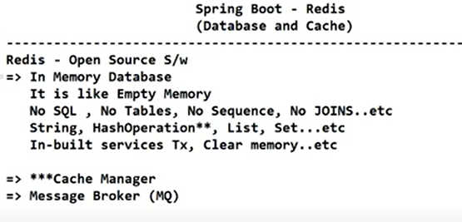

Suppose we have our Java application or Spring Boot application on a server and we want to connect our application with Redis, then we need driver class.Below are two driver classes.

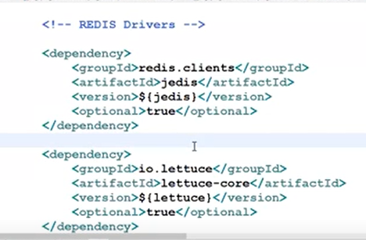

**Jedis is old driver and lettuce is new driver**

**Any one of the above driver we can use.Both are not required.Lettuce is fast compared to Jedis**

**In Real time,Redis is mostly used as Cache manager in Spring Boot applications than it is used as In memory database.**

**By default Redis runs on port number 6379**

**In order to make the Spring Boot app communicate with Redis database, we need below 2 things**

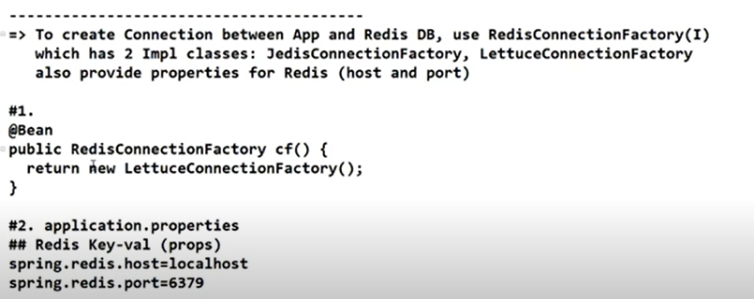

Go to this GitHub repository: [https://github.com/microsoftarchive/redis/releases](https://github.com/microsoftarchive/redis/releases" \t "_new).

<https://github.com/microsoftarchive/redis/releases/win-3.2.100>

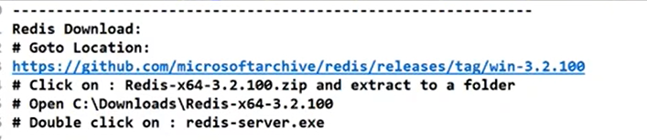

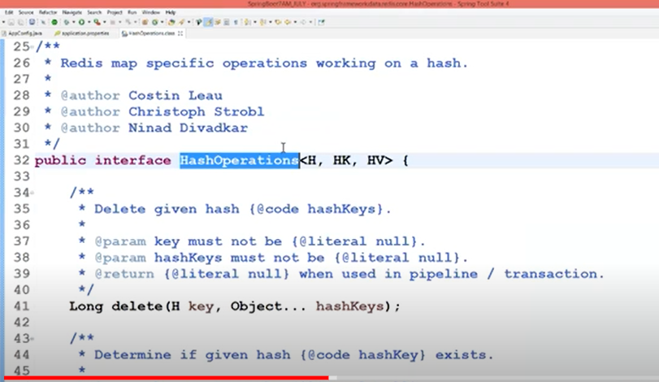

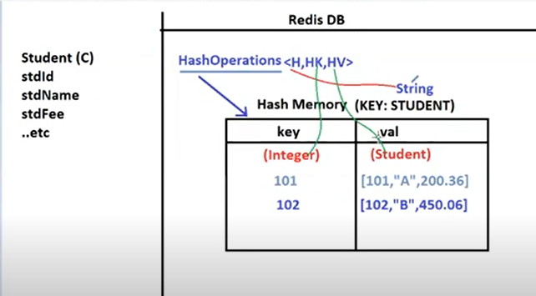

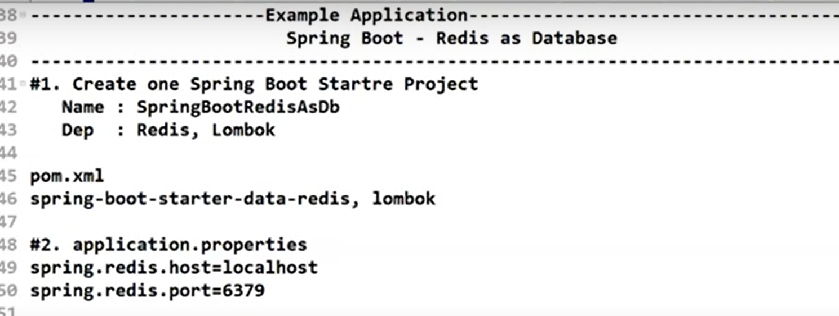

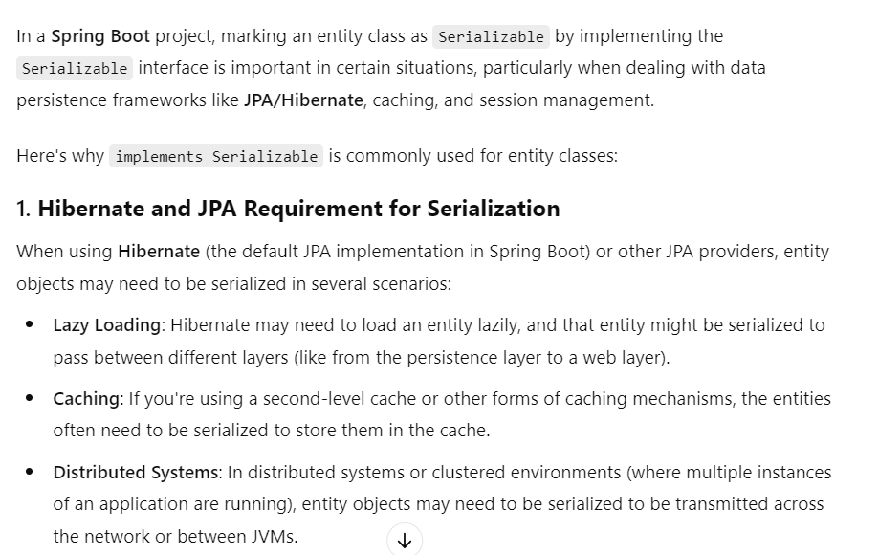

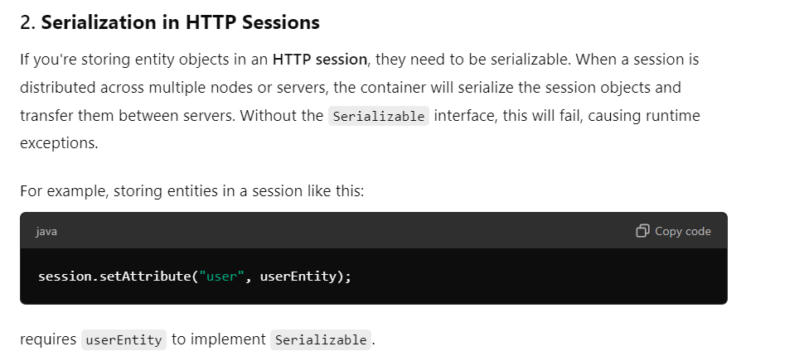

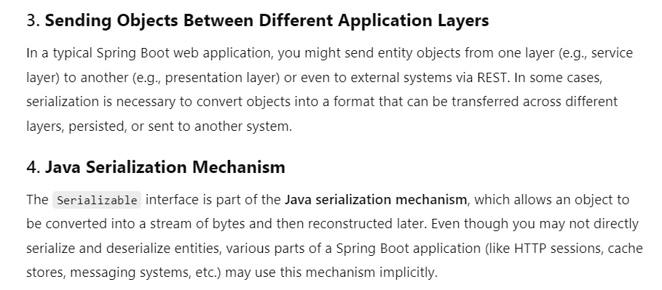

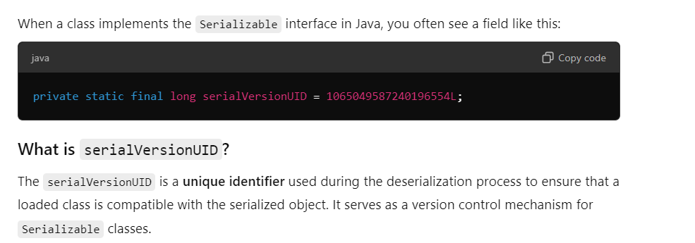

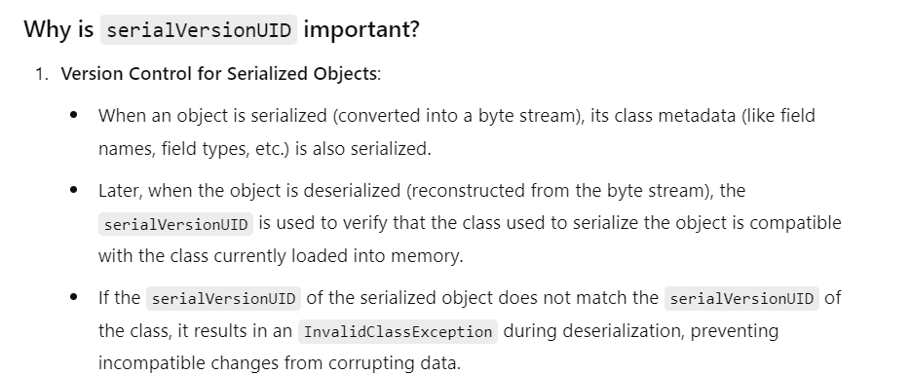

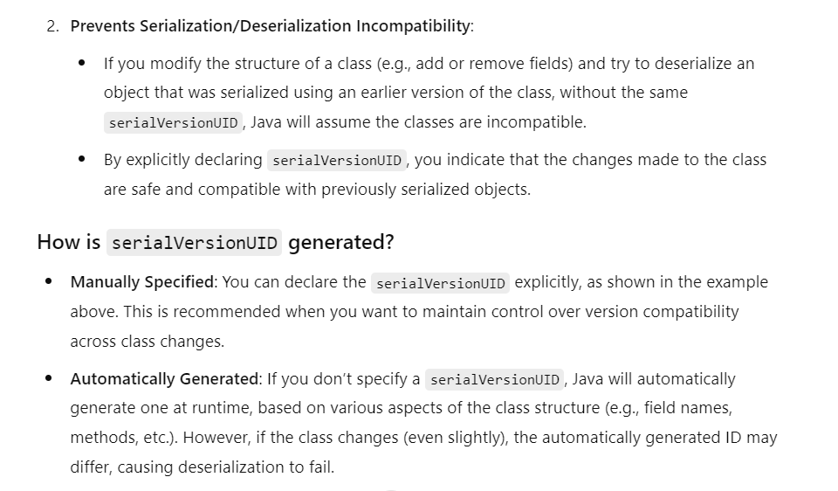

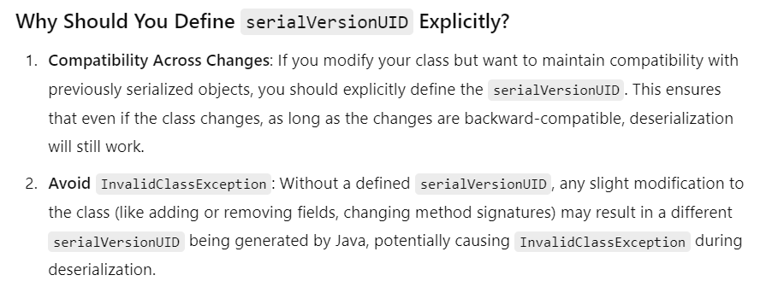

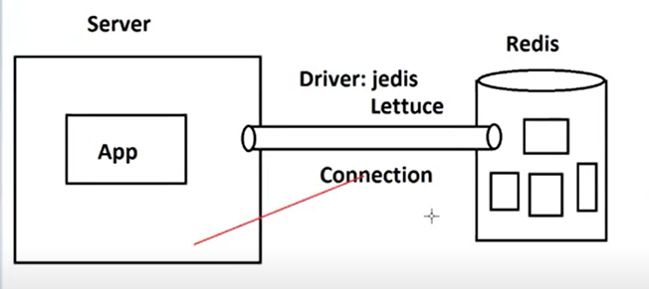

**To establish connection between App and Redis database, we are creating AppConfig file.**